Supplementary Materials for

**Modeling the evolution of the U.S. opioid crisis for national policy development**

Table of Contents

S1) Glossary 5

S1.a) Definitions of key terms 5

S1.b) List of acronyms 6

S2) Full Model Structure 7

S2.a) Overview of structure 7

S2.b) Stock & flow structure 7

S2.c) Major feedback effects 10

S2.c.i) Social influence 11

S2.c.ii) Perceived risk 12

S2.c.iii) Availability 13

S2.c.iv) Inclusion & exclusion of specific feedback effects 14

S2.d) Additional model sectors 15

S2.d.i) Opioid supply & availability 15

S2.d.ii) Treatment 18

S2.d.iii) Overdoses, naloxone, and synthetics 24

S3) Data Sources 27

S3.a) Main drug use states & transitions 27

S3.a.i) Prescription opioid misuse 28

S3.a.ii) Prescription opioid use disorder 28

S3.a.iii) Non-disordered heroin use 29

S3.a.iv) Heroin use disorder 30

S3.a.v) Initiating prescription opioid misuse 31

S3.a.vi) Initiating heroin use 31

S3.a.vii) Heroin use adjustments 31

S3.a.viii) Total population 32

S3.b) Opioid prescribing, supply, and price data 32

S3.b.i) Prescription opioid supply 32

S3.b.ii) Prescription opioid demand 35

S3.b.iii) Heroin price 35

S3.c) Treatment & remission 36

S3.c.i) Treatment receipt 36

S3.c.ii) Treatment-seeking and barriers 36

S3.c.iii) Treatment capacity 38

S3.c.iv) Treatment duration, outcomes, and effects 40

S3.c.v) Remission 41

S3.d) Overdoses, naloxone, and synthetics 42

S3.d.i) Overdose mortality data 42

S3.d.ii) Synthetic death allocation structure 42

S3.d.iii) Fentanyl penetration 43

S3.d.iv) Naloxone distribution 44

S3.d.v) Intervention Probabilities 45

S3.e) Literature sources for parameter estimates 45

S3.f) Expert consultation process 47

S4) Model Estimation 48

S4.a) Overview 48

S4.a.i) Likelihood function for historical data 48

S4.a.ii) Penalty terms for key point observations 49

S4.b) Data used in estimation 49

S4.c) Iterative estimation procedure 51

S4.d) Quantifying uncertainties 53

S4.d.i) Credible intervals for parameter estimates 53

S4.d.ii) Estimating measurement error 53

S4.e) Synthetic data validation 54

S4.e.i) Data generation and estimation 54

S4.e.ii) Synthetic data estimation results 54

S5) Full Results 56

S5.a) Full parameter estimates 56

S5.b) Fit to historical data 57

S5.c) Base case projections 59

S5.c.i) Full synthetic data estimation results 60

S6) Sensitivity Analyses 64

S6.a) Sensitivity of outcomes to parametric assumptions 64

S6.a.i) Parametric sensitivity results 65

S6.b) Feedback loop knockout analyses 67

S6.b.i) Loop knockout results 67

S6.c) Sensitivity of projections to exogenous input assumptions 72

S7) Model Equations 74

S8) References 75

List of Figures

**Figure S1.** Overview of model use states (stocks) and transitions (flows). 7

**Figure S2.** Overview of key feedback effects in model. 11

**Figure S3.** Use state populations driving each social influence effect. 12

**Figure S4.** Feedback effects actively or potentially influencing each transition. 15

**Figure S5.** Treatment engagement as a dual continuum of care. 19

**Figure S6.** Functional relationship between buprenorphine-waivered providers and marginal effective capacity added per new waivered provider. 21

**Figure S7.** Functional relationship between duration of treatment and treatment success fraction. 23

**Figure S8.** Functional relationship between naloxone kits distributed and probability of naloxone administration 25

**Figure S9.** Prescription opioid / heroin use state matrix with corresponding NSDUH data variables or model states 27

**Figure S10.** Observed patients per provider against number of waivered providers in historical data 39

[**Figure S11:** Allocation of overdose mortality by MECE categories to model data streams. 42](https://partnershealthcare.sharepoint.com/sites/FDAOpioidmodelingteam/Shared%20Documents/Opioid%20Model/Papers%20and%20conferences/FDA%20opioid%20model%20policy%20paper/Model%20paper/Appendix%20v7-Clean.docx#_Toc76460744)

**Figure S12.** Overview of iterative estimation procedure. 51

**Figure S13.** Theoretical vs. actual percentage of parameters contained within different credible intervals. 55

**Figure S14.** Comparison of simulated model output (blue) to historical data (grey) for all time-series data used in estimation. 58

**Figure S15.** Base case ('business as usual') projections for all time-series data used in estimation. 60

**Figure S16.** Estimated values & 95% credible intervals for all synthetic data parameters compared with ‘true’ values 63

[**Figure S17.** Model fit to data for loop knockout analyses, for all time-series data used in estimation 71](https://partnershealthcare.sharepoint.com/sites/FDAOpioidmodelingteam/Shared%20Documents/Opioid%20Model/Papers%20and%20conferences/FDA%20opioid%20model%20policy%20paper/Model%20paper/Appendix%20v7-Clean.docx#_Toc76460750)

**Figure S18.** Constant-assumptions case projections for all time-series data used in estimation. 74

List of Tables

**Table S1.** Main states, transitions, and feedback coefficients 9

**Table S2.** DSM-5 criteria for substance use disorder, compared to DSM-IV substance abuse & substance dependence criteria 29

**Table S3.** MME conversion factors for different opioid substances 33

**Table S4.** FDA-approved abuse-deterrent formulation opioids currently marketed in the US* 35

**Table S5.** Rates of treatment-seeking by use disorder and MOUD type, relative to total Tx-seeking rate for OUD (rUTR) 37

**Table S6.** Barriers to treatment engagement queried in NSDUH (with variable codes) 37

**Table S7.** Literature sources for parameter estimates 45

**Table S8.** Panel of time-series data used in model estimation 50

**Table S9.** Point data used as priors $ykt$ in model estimation 51

**Table S10.** Complete list of estimated parameter values & credible intervals 56

**Table S11.** Goodness of fit statistics for each estimated time series 59

**Table S12.** Simulated values for key point observations 59

**Table S13.** Sensitivity of key outcomes to ±10% changes in parametric assumptions. 66

**Table S14.** Sensitivity of key outcomes to loop knockout analyses. 69

**Table S15.** Exogenous inputs with alternative base case assumptions for projections 72

**Table S16.** Sensitivity of key projected outcomes to alternative base case assumptions. 73

# Glossary

## Definitions of key terms

**Prescription opioids:** Prescription (Rx) opioids are analgesic medications, used primarily to treat pain. Examples include natural opiates such as morphine or codeine; semi-synthetic opioids such as hydrocodone and oxycodone; and synthetic opioids such as tramadol and licit fentanyl (see also **fentanyl** below). They most commonly come in pill form, though other forms (e.g. liquid, film, etc.) exist as well. Prescription opioids are pharmaceutical products, though illicitly manufactured counterfeit prescription pills, often containing fentanyl, are a growing concern (see S2.d.i.(2)). We use the term ‘prescription opioids’ to refer to any pharmaceutically produced opioid analgesic, regardless of how it is obtained or used (e.g. whether prescribed by a medical provider or diverted; whether used to treat pain as prescribed or for other purposes).

**Heroin:** Heroin is an illicit semi-synthetic opioid that comes in several forms (e.g. black tar, brown or powder). It is consumed in several wayst, including oral intake, snorting, smoking, and injection. As an illicit drug, the production, distribution, and sale of heroin is illegal. Heroin is often contaminated with various adulterants, and increasingly with **fentanyl** (see below).

**Fentanyl:** Fentanyl is a highly potent synthetic opioid with many analogues (e.g. carfentanil, sufentanil, etc.). While licit, pharmaceutically produced prescription fentanyls exist, they are relatively uncommon; the majority of fentanyl in circulation now is illicitly manufactured fentanyl (IMF). IMF is increasingly common in the supply of **heroin** and other illicit drugs (see S2.d.iii.(3)). Other, non-fentanyl synthetic opioids exist as well, though they are generally less potent and far less common in the illicitly-manufactured fentanyl supply, which includes both basic fentanyl and numerous analogues. In this model, we do not distinguish between them, and use the terms ‘synthetic[s]’ and ‘fentanyl’ interchangeably to refer to illicitly manufactured fentanyl and its analogues, unless otherwise specified. We specifically use the terms ‘prescription synthetics’ or ‘prescription fentanyl’ to refer to the licit form (see **prescription opioids**).

**Misuse:** Prescription opioid misuse includes any use of Rx opioids prescribed for someone else, or use of Rx opioids solely ‘for the feeling [they] caused’ (see S3.a.i)). As an umbrella term, ‘misuse’ can also include ‘low-intensity’ use of heroin that does not rise to the level of **use disorder** (see below), which we also term ‘non-disordered heroin use’ (NDHU; see S3.a.iii)).

**Use disorder:** Substance use disorder is a clinically-diagnosable psychiatric disorder defined in the DSM-5 (see S3.a.ii)). Use disorder of varying degrees of severity is defined by endorsement of an increasing number of criteria identifying problems associated with drug use. Substance use disorder is associated with use of a particular substance; we distinguish between ‘Rx opioid use disorder’ and ‘heroin use disorder’ (see S3.a.iv)).

**Remission:** Remission is the reduction or disappearance of symptoms of **use disorder**. An individual who formerly qualified as having use disorder and now no longer meets the criteria for use disorder is in remission. While the term ‘recovery’ is used more generally to refer to the process of going from use disorder to a normal state of functioning and quality of life (see S3.c.v)), we focus on ‘remission’ as defined relative to use disorder. Note that remission does not necessarily entail complete abstinence from substance use.

**Medication for Opioid Use Disorder (MOUD):** Medication[s] for opioid use disorder [MOUD] refers to one or more of a set of three FDA-approved medications used to treat OUD – buprenorphine, methadone, and Vivitrol®. Treatment with MOUD is sometimes referred to as medication-assisted treatment (MAT) or opioid agonist therapy (OAT). There are many forms of treatment for use disorder, e.g. psychosocial therapy, community support groups, 12-step programs, etc. in addition to treatment with MOUD. However, our model explicitly represents MOUD but not other forms of treatment (see S2.b)); we therefore sometimes use ‘MOUD’ and ‘treatment’ interchangeably in the context of the model to refer to treatment involving MOUD.

## List of acronyms

|  |  |
| --- | --- |
| **ADF** | Abuse-deterrent formulation |
| **Bup / Bupe** | Buprenorphine |
| **CDC** | Centers for Disease Control and Prevention |
| **CMS** | Centers for Medicare & Medicaid Services |
| **DEA** | Drug Enforcement Administration |
| **DSM (DSM-IV / DSM-5)** | Diagnostic and Statistical Manual of Mental Disorders (Fourth / Fifth edition) |
| **EMS** | Emergency medical services |
| **ETC** | Exogenous trends continue |
| **FDA** | Food and Drug Administration |
| **H** | Heroin |
| **HHS** | Department of Health and Human Services |
| **HUD** | Heroin use disorder |
| **ICD (ICD-9 / ICD-10)** | International Classification of Diseases (9th / 10th edition) |
| **IMF** | Illicitly manufactured fentanyl |
| **MME** | Milligrams morphine equivalent |
| **MMT** | Methadone maintenance therapy |
| **MOUD** | Medications for opioid use disorder |
| **NASEM** | National Academies of Sciences, Engineering, and Medicine |
| **NCHS** | National Center for Health Statistics |
| **NDHU** | Non-disordered heroin use |
| **NESARC** | National Epidemiologic Survey on Alcohol and Related Conditions |
| **NFLIS** | National Forensic Laboratory Information System |
| **NSDUH** | National Survey on Drug Use and Health |
| **NSDUH RDAS** | NSDUH Restricted-use Data Analysis System |
| **N-SSATS** | National Survey of Substance Abuse Treatment Services |
| **NVSS** | National Vital Statistics System |
| **Nx** | Naloxone |
| **OD** | Overdose |
| **OSM** | Opioid systems model |
| **OUD** | Opioid use disorder |
| **Rx** | Prescription / prescription opioid[s] |
| **Rx OUD** | Prescription opioid use disorder |
| **SAMHSA** | Substance Abuse and Mental Health Services Administration |
| **STRIDE** | System to Retrieve Information from Drug Evidence |
| **SUD** | Substance use disorder |
| **TEDS** | Treatment Episode Data Set |
| **Tx** | Treatment (for use disorder) |
| **UNODC** | United Nations Office on Drugs and Crime |
| **Viv** | Vivitrol® (naltrexone) |

# Full Model Structure

## Overview of structure

[OSM] is a continuous-time differential equations model, developed using a systems approach that emphasises endogenous feedback processes within a broad model boundary that drive changes over time. The model simulates the movement of people through different states of opioid use, with endogenous influences on initiation and transition rates, as well as more detailed representations of prescribing, treatment, and overdose-related processes. Broadly, we distinguish people by severity of opioid use (misuse vs. use disorder), as well as by substances used (prescription vs. illicit opioids) (see S3.a)). The model is parametrised to represent the opioid-using population in the US at a national level. Here we present key equations and structures in each of its sectors, with a complete listing of model equations in S7). Data sources for each sector are detailed in S3).

The model was developed and implemented using Vensim™ simulation software; all model files are available in the online repository at [LINK].

## Stock & flow structure

The opioid system includes people in various stages of use of both prescription opioids (*Rx*) and illicit opioids like heroin (*H*). For all disorder and remission definitions, we use the *Diagnostic and Statistical Manual of Mental Disorders, Fifth Edition* (DSM-5) criteria (American Psychiatric Association 2013). **Figure S1** provides an overview of the key population groups and the transitions among them (for more detailed definitions of these states and corresponding data sources, see S3.a)).

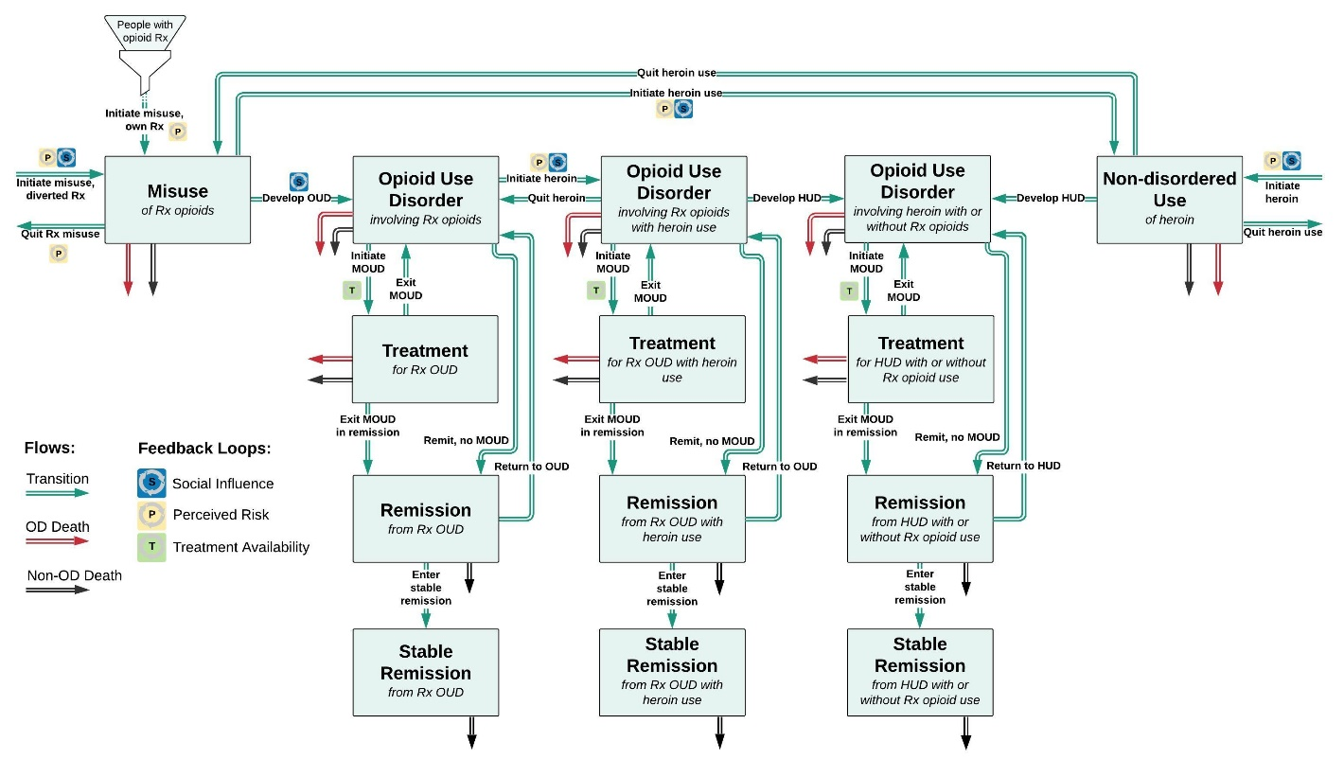

**Figure S1.** Overview of model use states (stocks) and transitions (flows).

Treatment states are further separated by MOUD type.

People enter the opioid system by either initiating prescription opioid misuse – with their own prescription (*initiating Rx misuse own Rx*, rMI), or with others’ (*initiating Rx misuse diverted*, rMD) – or by initiating heroin use without prior Rx opioid misuse (*initiating heroin no Rx*, rND).[1] Definitions of opioid misuse vary; we follow the 2002-2014 NSDUH definition, to include *any* use of someone else’s opioid prescription, *or* use of Rx opioids solely ‘for the feeling [they] caused’ (Center for Behavioral Health Statistics and Quality 2015).

People who initiate Rx opioid misuse enter the stock of people with *Rx misuse* (M), while people who initiate heroin use without prior Rx misuse enter the stock of people with *non-disordered heroin use* (N). People misusing opioids can also initiate heroin (*initiating heroin with Rx misuse*, rMN) and enter *N.* Once people transition from *M* to *N*, they are no longer distinguished from people who transitioned directly into *N* without first using Rx opioids. People in *M* and *N* can quit use in a given year, but also later resume use, with net flows (*net quitting Rx misuse*, rMQ; *net quitting NDHU*, rNQ) reflecting the combined total of quits and resumptions of use (but not new initiations) at any given time.

From Rx misuse, *M*, people can develop opioid use disorder (OUD) (*developing Rx OUD*,rMU), thereby entering a disordered state involving Rx opioids only (*Rx OUD no PY heroin*, UR). From the non-disordered heroin use state, they can develop an OUD involving heroin (*developing HUD no Rx OUD*, rNU). For clarity, we call this state *heroin use disorder* or HUD (UH). We also distinguish a third use disorder state, *Rx OUD with PY heroin* (UO), which encompasses people with Rx OUD who have also used heroin in the past year, but whose heroin use does not rise to the level of a use disorder. While relatively uncommon, this is an important transitional state, which we therefore represent explicitly. People enter this state from *UR* by *initiating heroin with* *Rx OUD* (rUO). Once in this state, people can also develop HUD (*developing HUD with Rx OUD*, rOH).[2]

Once in the use disorder states (U), people enter remission (*… in remission*, R(.)) through one of two pathways: via remission without use of medications for opioid use disorder (*remitting… no MOUD*, rUR(.)), which could include psychosocial or behavioural treatment or no treatment at all; or through treatment with MOUD (*… in MOUD Tx*, T(.)). Remission occurs after no longer meeting criteria for a DSM-5 disorder for at least one year. Once in remission, the probability of relapse (*relapsing…*, rRU(.)) or remaining in remission is the same regardless of the pathway by which remission was achieved, with or without MOUD.

After some time in the remission states, people transition to a more durable state of stable remission (… *in stable remission*, RS(.)), from which we assume they are no longer at risk of relapse. This transition (*stabilizing remission…*, rRS(.)) takes place after an average of four additional years (*time to stabilize remission*, $τ_{RS}$) in the base remission state (see S3.c.v)).

Treatment engagement can involve any of the three FDA-approved MOUDs: buprenorphine, methadone, and Vivitrol (subscripts B, M, V respectively). *Treatment engagement* flows (rUT(.)) are limited by both demand and capacity for each of these medications separately, as explained further in S2.d.ii). Once in treatment, people can leave treatment before remitting, thereby returning to use disorder (*Tx exit with UD*, rTU(.)), or leave in remission (*Tx exit in remission*, rTR(.)). Throughout the use disorder-treatment-remission chain, stocks are separated by drugs of use (subscripts R, O, H) and by medication used (subscripts B, M, V) as appropriate.

Each stock in the model also has two additional outflows (one for remission states, R(.)) – death from non-overdose causes (*nonOD death*, n(.)), as well as opioid-caused *overdose death* (o(.)) for all states except remission. Overdose death rates are significantly impacted by naloxone availability and fentanyl penetration into the heroin supply, as detailed in S2.d.iii).

The vast majority of transition rates or flows in the model are formulated as fractional annual hazard rates ($ρ_{(.)}$) multiplied by source populations, sometimes further multiplied by additional coefficients, e.g.:

$$\begin{aligned}r_{MN}=\left(ρ_{MN}M\right)S_{MN}{P_{MN}A}_{MN} \#\left( STYLEREF 1 \backslash s 2. SEQ Equation \backslash * ARABIC \backslash s 1 1\right)\end{aligned}$$

Where *S*(.), *P*(.), and *A*(.) are coefficients for various endogenously generated effects, elaborated on in S2.c). Different transition rates are subject to different effects and coefficients, while treatment entry/exit and overdose death flows are subject to additional influences as well. In most cases, the base rates ($ρ$) are estimated model parameters; in a few cases they are derived from extant literature.

For two of the three entry flows into the system (rMD, rND), source populations are not explicitly represented in the model. Instead we estimate an absolute base rate in place of a fractional hazard rate, which implicitly accounts for the source population size. For the third entry flow, misuse starting with one’s own prescription (rMI), we calculate the number of medical users of Rx opioids (*patients with current opioid Rx*, mC) as the source population based on exogenous input data. The patient population is large and relatively static compared to the rest of the model, with very short average residence times, so it is not explicitly modelled as a stock. Details of this calculation are included in S3.b).

**Table S1.** Main states, transitions, and feedback coefficients

|  |  |  |
| --- | --- | --- |
| **State variables** | | |
| M | Rx misuse no heroin | Prescription opioid misuse |
| N | Nondisordered heroin use | Non-disordered heroin use |
| UR | Rx OUD no PY heroin not in MOUD Tx | Prescription opioid use disorder, no past-year heroin use |
| UO | Rx OUD with PY heroin not in MOUD Tx | Prescription opioid use disorder, past-year heroin use |
| UH | HUD not in MOUD Tx | Heroin use disorder |
| TR | Rx OUD no heroin by MOUD | Prescription opioid use disorder, no past-year heroin use, in medication for opioid use disorder treatment |
| TO | Rx OUD with heroin by MOUD | Prescription opioid use disorder with past-year heroin use, in medication for opioid use disorder treatment |
| TH | HUD by MOUD | HUD in medication for opioid use disorder treatment |
| RR | Rx OUD no heroin in remission | Remission from prescription opioid use disorder, no heroin use in the year prior to quitting |
| RO | Rx OUD with heroin in remission | Remission from Rx OUD with heroin use in the year prior to quitting |
| RH | HUD in remission | Remission from heroin use disorder |
| RSR | Rx OUD no heroin in stable remission | > 5 years in remission from prescription opioid use disorder, no heroin use in the year prior to quitting |
| RSO | Rx OUD with heroin in stable remission | > 5 years in remission from Rx OUD with heroin use in the year prior to quitting |
| RSH | HUD in stable remission | > 5 years in remission from heroin use disorder |
| **Flows** | | |
| rMI | Initiating Rx misuse own Rx | Initiating prescription opioid misuse with one’s own prescription opioid |
| rMD | Initiating Rx misuse diverted | Initiating prescription opioid misuse with someone else’s prescription opioid |
| rND | Initiating heroin no Rx | Initiating non-disordered heroin use without having misused prescription opioids |
| rMN | Initiating heroin with Rx misuse | Initiating non-disordered heroin use after having misused prescription opioids |
| rMQ | Net quitting Rx misuse | Quitting prescription opioid misuse |
| rNQ | Net quitting NDHU | Quitting non-disordered heroin use |
| rMU | Developing Rx OUD | Developing opioid use disorder from prescription opioid use |
| rNU | Developing HUD no Rx OUD | Developing opioid use disorder from heroin use without having had opioid use disorder from prescription opioid use |
| rUO | Initiating heroin with Rx OUD | Initiating heroin use after having had opioid use disorder from prescription opioid use |
| rOH | Developing HUD with Rx OUD | Developing opioid use disorder from heroin after having had opioid use disorder from prescription opioid use |
| rUR(.) | Remitting… no MOUD | Remitting from (…) without medication-based treatment for opioid use disorder |
| rRU(.) | Relapsing…, | Returning to opioid use disorder from remission from (…) |
| rUT(.) | Treatment engagement | Engaging in medication-based treatment for opioid use disorder from (…) |
| rTU(.) | Tx exit with UD | Exiting medication-based treatment for opioid use disorder from (…) with opioid use disorder from (…) |
| rTR(.) | Tx exit in remission | Exiting medication-based treatment for opioid use disorder for (…) in remission from (…) |
| n(.) | *NonOD death* | Dying from causes besides opioid-involved overdose from (…) |
| o(.) | *Overdose death* | Dying from an opioid-involved overdose from (…) |
| **Feedback effects** | | |
| *S(.)* | *Social influence coefficient* | Effect of social influence processes on (…) |
| *P(.)* | *Perceived risk coefficient* | Effect of responses to perceived risk on (…) |
| *A(.)* | *Rx / Heroin / Rx vs. H availability coefficient* | Effect of drug availability or comparative availability on (…) |

## Major feedback effects

The model contains three main sets of endogenous influences (i.e. feedback loops or effects) on transition rates (r(.)) between use states, shown in **Figure S2**:

1) Social influence reinforcing feedbacks, whereby existing users increase initiation and people with UD accelerate disorder development among existing users;

2) Risk perception balancing feedbacks, whereby opioid overdoses, especially overdose mortality, discourage initiation;

3) Availability balancing feedbacks, whereby the availability of Rx opioids (sometimes compared to heroin) fluctuates with the balance of supply and demand, influencing initiation, development of use disorder, transitions between Rx opioid and heroin use, and potentially quitting.

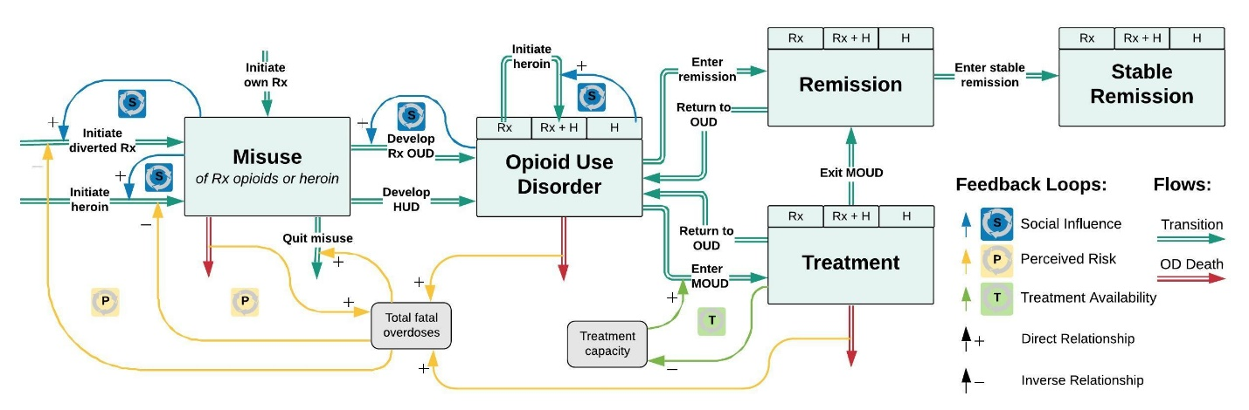

**Figure S2.** Overview of key feedback effects in model.

These feedback effects are all formulated with the same basic structure:

$$\begin{aligned}C_{\left(.\right)}={\left(D_{C\left(.\right)}\right)}^{ε_{\left(.\right)}} \#\left( STYLEREF 1 \backslash s 2. SEQ Equation \backslash * ARABIC \backslash s 1 2\right)\end{aligned}$$

Where $C_{(.)}∈\left\{S_{\left(.\right)}, P_{\left(.\right)}{,A}_{\left(.\right)}\right\}$ is the *social influence coefficient*, *perceived risk coefficient*, or *Rx availability / H availability / Rx vs. H availability coefficient* for a given transition rate respectively; $D_{C(.)}$ is the relevant driver of the effect (*relative social influence*, *relative perceived risk*, *relative availability*); and $ε_{(.)}∈\left\{ψ_{\left(.\right)},π_{\left(.\right)},α_{(.)}\right\}$ is the *social influence strength*, *perceived risk strength*, *availability strength* for that particular transition rate. These effect strengths are model parameters, estimated through the model estimation process (see S4)).

Specifics on the drivers of each effect are in the following sections; in all cases, the driver is a time-varying quantity normalised by its initial value. Normalising allows coefficients on transition rates to vary with changes in their drivers without needing to tease apart baseline transition rates from the endogenous effects present at the start of the simulation time period.

In addition to these three main sets of feedbacks, treatment capacity limitations create a fourth, balancing feedback process, whereby as new patients enter treatment, the limited number of available treatment spots is filled, reducing or preventing further treatment engagement until existing patients leave (see S2.d.ii.(2)).

### Social influence

Drug use behaviour has an element of social contagion (Fast et al. 2009; Guarino et al. 2018; Harocopos, Allen, and Paone 2016; Lovell 2002; Mars et al. 2014). As more people use a substance, its use becomes increasingly normalised, and relevant knowledge about its use (e.g. methods of administration, sources of supply, etc.) becomes more widespread and accessible (Guarino et al. 2018; Mars et al. 2014). Access to the substance in social networks grows as people seek the substance or become suppliers to others (especially in the case of prescription opioids). Collectively, these processes increase initiation of drug use, creating a self-reinforcing growth process. (These processes can also work in reverse as use declines.) Similarly, social space-driven ratcheting effects can potentially drive increasingly heavy drug use (Roy, Nonn, and Haley 2008; Debeck et al. 2011), which we operationalise as social influence on the UD development process (but see S2.c.iv)).

We operationalize social influence separately for Rx misuse (rMI, rMD) and heroin initiation (rND, rMN, rUO) flows, as well as for initiation vs. development of use disorder (rMU, rNU, rOH). The *relative social influence* ($D_{S(.)}$) for a given transition depends on the fraction of the total population (see S3.a.viii)) engaging in the relevant drug use behaviours. Essentially, 1) only users of a given substance class (Rx vs. heroin) exert social influence on initiation or development of use disorder for that substance, and 2) heavier users exert influence on lighter users, but not vice-versa, such that people with use disorder affect initiation rates, but those without use disorder do not affect use disorder development rates (see **Figure S3** for details).

Note that while network effects on the accessibility of drugs in social networks are captured in this social influence process, the aggregate effect of a changing user base on the demand-supply balance is represented separately in the availability effects detailed below.

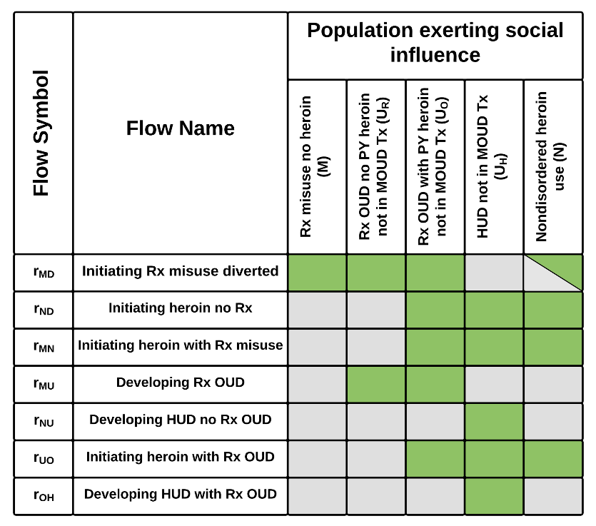

**Figure S3.** Use state populations driving each social influence effect.

Initiating Rx misuse from diverted opioids is influenced by the fraction of people in the non-disordered heroin use state who also misuse Rx opioids.

### Perceived risk

Perceived risk coefficients $P_{\left(.\right)}$ reflect the deterrent effect that adverse outcomes like death can have on drug use behaviour. As overdoses and especially overdose mortality become more common, the perceived risk associated with a drug increases, dissuading potential initiates (reducing rMI, rMD, rND, rMN, rUO) and possibly encouraging current misusers (but not people with a disorder) to quit use (rMQ, rNQ), creating a balancing feedback process (Musto 1999; Rydell, Caulkins, and Everingham 1996; Arria et al. 2008).

The perceived risk associated with use of a drug ($D_{PR}, D_{PH}$) adjusts with some lag to an underlying *indicated perceived risk* ($D_{PR}^{*}, D_{PH}^{*}$). The lag is asymmetric, i.e. the *perceived risk increase time* ($τ_{PI}$) is significantly shorter than the *perceived risk decrease time* ($τ_{PD}$), reflecting that deaths, overdoses, etc. tend to get more attention than the lack of them, and a dangerous reputation for a drug fades slowly (Rydell, Caulkins, and Everingham 1996; Musto 1999). The indicated perceived risk is operationalized as a weighted sum of the fatal and nonfatal overdoses associated with that drug, with a lower relative weight (*perceived risk weight NFOD*, $w_{η}$) given to non-fatal overdoses in users’ or potential users’ perceptions of risk:

$$\begin{aligned}\frac{dD_{P}}{dt}=\frac{D_{P}^{*}-D_{P}}{τ_{P}} \#\left( STYLEREF 1 \backslash s 2. SEQ Equation \backslash * ARABIC \backslash s 1 3\right)\end{aligned}$$

$$\begin{aligned}D_{P}=\sum_{(.)}{o_{(.)}\left(1+w_{η}\frac{η_{(.)}}{ω_{(.)}}\right), (.)∈\left\{R, H\right\}} \#\left( STYLEREF 1 \backslash s 2. SEQ Equation \backslash * ARABIC \backslash s 1 4\right)\end{aligned}$$

Where ${η_{(.)}}/{ω_{(.)}}$ is the ratio of nonfatal to fatal overdoses (see S2.d.iii.(4)). Nonfatal overdoses are far more common and receive far less attention (especially for people not already using drugs) than fatal overdoses, so we assume a value of 0.1 for $w_{η}$, i.e., nonfatal overdoses carry 10% the risk perception impact of fatal overdoses.

Note that we operationalise perceived risk based on overdoses, i.e. adverse health outcomes, and do not incorporate perceived risk of arrest, incarceration, or other legal consequences. Rational choice models of illegal behaviour posit that legal consequences could raise the expected costs of drug use and thereby exert a deterrent effect (Becker 1968; Nagin and Paternoster 1991). However, there is little evidence that people who use or initiate drugs behave as rational actors in this way (Gill and Michaels 1991; Friedman et al. 2011; MacCoun 1993; Nagin and Paternoster 1991). Absent such evidence, we have excluded legal risks from the risk perception feedback effect.

### Availability

Availability coefficients $A_{\left(.\right)}$ represent the effects of market forces and drug supply on initiation, use disorder development, and quit rates. The availability of Rx opioids (*Rx availability for misuse*, $D_{ARM}$) affects initiation of Rx misuse and development of Rx OUD (rMD, rMU, rMQ).

Rx availability is in part a function of demand for Rx opioids, which in turn depends on the number of users. It thus exerts a balancing effect whereby more people using reduces the relative availability, in turn reducing initiation. Numerous other factors also influence availability, as detailed in S2.d.i).

Similarly, the availability of heroin (*heroin availability index*, $D_{AH}$) can exert an effect on heroin initiation and use disorder development flows (rND, rNU, rNQ), with greater availability facilitating initiation and UD development and discouraging quitting. Note, however, that we model heroin availability exogenously (see S2.d.i.(3)), so this is not, strictly speaking, a feedback process.

In addition to the separate availabilities of Rx opioids and heroin, we also consider their comparative availability, which affects transitions between Rx and heroin use. For purposes of this comparison, we use separate Rx availability constructs for prescription opioid misuse vs. use disorder ( $D_{ARM}$ vs. *Rx availability for UD*, $D_{ARU}$), as detailed in S2.d.i.(2) below. The ratio of the respective Rx availability construct to heroin availability yields the *Rx vs heroin availability index misuse* ($D_{ACM}$), which drives heroin initiation from Rx opioid misuse (rMN), or the *Rx vs heroin availability index UD* ($D_{ACU}$), which drives initiation or escalation of heroin use with Rx OUD (rUO, rOH).

#### ADF effects on heroin initiation

In addition to availability effects, we allow for one additional supply-related effect on transitions – an effect of abuse-deterrent formulations (ADFs) on heroin initiation with Rx OUD (rUO). Like heroin availability effects, this is not strictly speaking a feedback process, but operates in a similar way, driven by the *ADF fraction of Rx street supply* ($F^{AS}$) (see S2.d.i.(2)).

ADF prescription opioids are specially formulated to impede physical or chemical modification (e.g. crushing or dissolving), which makes them less amenable to non-oral routes of administration (e.g. snorting or injecting) (Moorman-Li et al. 2012). In principle, the intended effect of ADFs is to deter escalation from oral to non-oral misuse of prescription opioids. We do not explicitly distinguish between routes of administration in this model, and therefore cannot represent this effect directly. However, non-oral misuse of opioids is a marker of OUD severity and a significant predictor of heroin initiation (McCabe et al. 2007; Carlson et al. 2016). We therefore approximate the potential effect of ADFs on reducing non-oral misuse as an effect on the subsequent transition to heroin use instead.

### Inclusion & exclusion of specific feedback effects

The feedback processes explained above are all plausible influences on opioid use transitions, with some evidence for their effects. However, the magnitude of each effect and its impact on e.g. initiation rates is difficult to discern with precision from available evidence. For instance, surveys of attitudes toward drug use among young people indicate an increase in the perceived risk associated with Rx opioids and heroin over the last decade[3], but do not associate those changing attitudes with changing likelihoods of initiating drug use. We therefore need to ascertain the impact of each process from the aggregate data, through model estimation.

In order to allow the potential impact of each feedback to emerge from the data, we include all the aforementioned plausible feedbacks in the model structure during the estimation process. Some of the resultant estimated effect strengths show no significant effect for a given feedback on a given rate ($ε_{(.)} \sim 0$); those specific feedbacks are then removed in the final model. In some cases, the lack of effect is likely due to under-determination. For instance, the effect of perceived risk on initiating and quitting heroin use (rND and rNQ) is similar, and given the absence of any reliable data on quit rates, cannot be distinguished. Additional data would allow re-estimation and potentially re-inclusion of these effect strengths. **Figure S4** summarises which feedback effects were allowed to potentially operate on which transitions in the estimation process, and in the final model; see also S6.b).

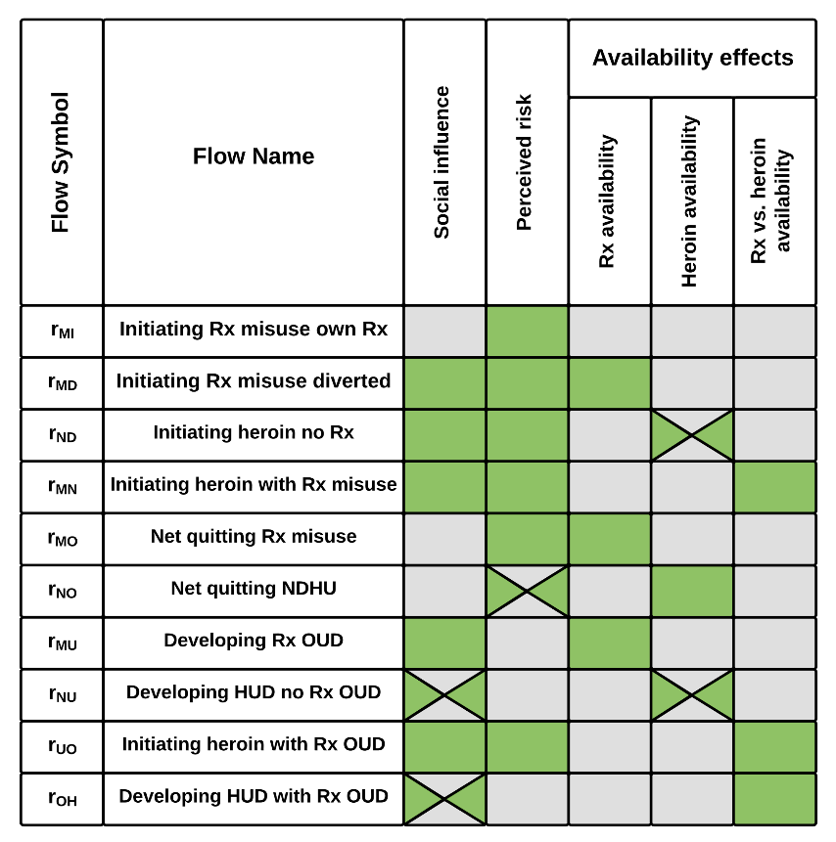

**Figure S4.** Feedback effects actively or potentially influencing each transition.

Initiating heroin with Rx OUD (rUO) also includes a potential effect from ADFs (see S2.c.iii.(1))

## Additional model sectors

### Opioid supply & availability

#### Prescribing and supply

Opioid prescribing practices influence both the number of medical users of opioids (mC) who may initiate opioid misuse (rMI), and the availability of Rx opioids.

The number of medical users of Rx opioids (*patients with current opioid Rx*, mC) is very large relative to other populations in the model, and their average ‘residence time’ fairly short. As such, the population of medical users is close to stable at any given time. We therefore represent them not as an explicit state variable, but with an analytic approximation:

$$\begin{aligned}m_{C}=m_{P}m_{N}τ_{M} \#\left( STYLEREF 1 \backslash s 2. SEQ Equation \backslash * ARABIC \backslash s 1 5\right)\end{aligned}$$

Where $m_{P}$ is the total number of *patients receiving opioid prescription* each year, $m_{N}$ is the number of *prescriptions per person*, and $τ_{M}$ is the *average prescription duration*, as detailed in S3.b.i). The number of medical users at any given time is thus in effect the product of the rate of people receiving prescriptions and their average duration of medical use, per Little’s Law (Sterman 2000). Note that unlike most actual stocks in the model, $m_{C}$ does not represent medical use *within the past year*, but rather currently ongoing use. As such, the transition rates reflecting hazard of misuse initiation from prior medical use ($ρ_{MI}$) or overdose death for medical users ($o_{mc}$) should be interpreted as hazard rates per person-year of medical use of prescription opioids.

The *Rx supply* (qS) represents the total supply that could be made available for potential misuse and can be thought of as ‘excess’ pills not used as prescribed within the time period of the prescription, which therefore present potential opportunities for misuse. Supply is fundamentally a function of total amount of prescription opioid medications dispensed each year, but is potentially influenced by more granular prescribing practices. We distinguish several aspects of prescribing that contribute to total amount prescribed, analogous to the Kaya identity (Kaya and Yokobori 1997) – in its basic form, total supply in morphine milligrams equivalent (MME) is the product of patients receiving prescriptions each year ($m_{P}$), prescriptions per patient ($m_{N}$), and MME per prescription ($m_{M}$):

$$\begin{aligned}q_{S}= m_{P}×m_{N}×m_{M} \#\left( STYLEREF 1 \backslash s 2. SEQ Equation \backslash * ARABIC \backslash s 1 6\right)\end{aligned}$$

These different aspects of prescribing patterns do not necessarily have equal weight in determining the effective supply of Rx opioids, as usage and consumption patterns differ. Simply put, giving twice as many people half as many opioids each vs. giving half as many people twice as many prescriptions each vs. giving the same number of people half the prescriptions of twice the amount, and so on, will not necessarily have the same effect on supply. To allow for this possibility, we operationalise supply with a number of *sensitivity of Rx supply* exponents ($s_{s(.)}$), representing the relative contribution of each factor to overall supply. Specifically:

$$\begin{aligned}q_{S}= {m_{P}}^{s_{sp}}×{m_{N}}^{s_{sn}}×{m_{M}}^{s_{sm}} \#\left( STYLEREF 1 \backslash s 2. SEQ Equation \backslash * ARABIC \backslash s 1 7\right)\end{aligned}$$

Where each factor $m_{(.)}$ is normalised to its initial value, and the sensitivity exponents $s_{s(.)}$ are normalised to have a mean of 1. In the absence of more specific evidence, we assume a baseline value of 1 for each exponent, giving equal importance to number of patients, number of prescriptions, and size of prescriptions, though the relative contributions of each factor could be adjusted to test different possibilities. In addition, other aspects of prescribing such as duration of prescriptions or number of pills (units) could potentially be incorporated into an expanded formulation for supply.

#### Availability and street supply

The availability of Rx opioids for potential misuse (*Rx availability for misuse*, $D_{ARM}$) is driven by the ratio of *Rx supply* to *Rx demand for misuse* (qD):

Where the supply side is the sum of Rx supply (qS) and *counterfeit supply* (qSC), downweighted by some *counterfeit supply weight* ($w_{C}$). The presence of counterfeit Rx opioids in the street supply is a growing concern (Vo et al. 2016; Arens et al. 2016; Green and Gilbert 2016; Gladden et al. 2019; J. K. O’Donnell et al. 2017; Drug Enforcement Administration 2016a, 2021), but there are no estimates presently available of their actual prevalence. As such, we allow for the possibility of their contributing to supply, potentially downweighted to reflect lower desirability, but set their quantity to 0. Rx demand (qp) depends on the sizes of the populations in each drug use state and the expected average demand for individuals in that state (see S3.b.ii)).

The *Rx availability for UD* ($D_{ARU}$) likewise depends on Rx supply, potential counterfeit supply, and demand, as well as an additional *Rx street supply disruption* factor (Z):

$$\begin{aligned}D_{ARU}=\frac{q_{S}+ w_{C}q_{SC}}{q_{D}}\left(1-Z\right)=D_{ARM}\left(1-Z\right) \#\left( STYLEREF 1 \backslash s 2. SEQ Equation \backslash * ARABIC \backslash s 1 10\right)\end{aligned}$$

*Rx street supply disruption* (Z) is a state variable reflecting short-term perturbations, beyond the longer-term dynamics of supply and demand, which affect the street market for Rx opioids: $\begin{aligned}\frac{dZ}{dt}=q_{Z}-\frac{Z}{τ_{Z}} \#\left( STYLEREF 1 \backslash s 2. SEQ Equation \backslash * ARABIC \backslash s 1 11\right)\end{aligned}$

The degree of disruption increases as *Rx street supply shocks* (qZ) occur. We include a single such shock – the 2010 withdrawal of the crushable form of OxyContin from production. OxyContin was by far the single most widespread formulation in the prescription opioid street supply at the time (see S3.b.i.(5)), and although it was replaced with an abuse-deterrent formulation, the withdrawal of the non-ADF form nonetheless represented a substantial disruption of available supply, as the crush-resistant ADF form is not a perfect substitute. Disruptions fade as suppliers find new sources and consumers adjust their consumption preferences to available alternatives; this is a gradual process, taking *time to readjust Rx street supply* ($τ_{Z}$).

We separate Rx availability for people with misuse vs. use disorder ( $D_{ARM}$ vs. $D_{ARU}$) in order to allow these street supply disruptions to affect the latter but not the former. People with OUD consume far more opioids than those only misusing; they are much more likely to obtain at least some of their drugs from the ‘street’ or black market, including purchasing drugs through monetary or equivalent transactions (J. Y. Park and Wu 2020; Han et al. 2017); and they are more likely to have specific preferences for higher-dosage units or pills they can modify for non-oral routes of administration (e.g. crushing or dissolving) (Cicero, Ellis, and Kasper 2017). As such, they are more vulnerable or sensitive to potential disruptions in prescription opioid availability, particularly as compared to the availability of alternatives like heroin.

We calculate the *ADF fraction of Rx street supply* ($F^{AS}$) as a function of the *ADF fraction of prescribed Rx opioids* ($F^{AR}$):

$$\begin{aligned}F^{AS}={\left(F^{AR}\right)}^{s_{af}} \#\left( STYLEREF 1 \backslash s 2. SEQ Equation \backslash * ARABIC \backslash s 1 12\right)\end{aligned}$$

Where $s_{af}$ is the *ADF substitutability factor*, representing the ability of the street supply to preferentially take up or avoid ADFs, shifting the composition of the street supply to include disproportionately high or low amounts of ADFs compared to what is prescribed ($F^{AR}$). While we allow for this possibility of differential uptake, in the absence of evidence indicating a strong skew one way or the other, we set $s_{af}$ =1 by default, resulting in ADFs being as prevalent in the street supply as in the prescribed supply. We treat prescribed ADF supply ($F^{AR}$) as exogenous (see S3.b.i.(4)).

#### Heroin availability

As described in S2.c.iii), heroin availability can influence heroin initiation or UD development. In reality, heroin availability depends not only on street price but also features such as convenience, reliability, purity, and safety of obtaining supply (Ciccarone 2017). However, to our knowledge, there are no reliable data on availability or a suitable proxy thereof, besides price. We therefore operationalise heroin availability as simply the inverse of normalised heroin price, as calculated in S3.b.iii).

There is some evidence that heroin supply chains benefit from learning or improving returns to scale (Caulkins and Reuter 2006; Bouchard 2007), as producers, traffickers, distributors and dealers improve the efficiency of their practices or overwhelm law enforcement efforts. These learning effects may be partly responsible for the decline in heroin prices particularly from the mid-2000s onward (Drug Enforcement Administration 2016b, 2018). However, the dynamics of the heroin supply chain and market are outside the scope of this model. As such, we do not represent these dynamics explicitly, instead treating heroin price as exogenous.

### Treatment

#### Treatment seeking, demand, and engagement

The process by which people receive addiction treatment can be thought of as a continuum of care (**Figure S5**), with some portion of patients lost to care at each step of the continuum upstream of actual *treatment engagement* (rUT(.)). We represent this continuum with multiple variables, replicated as appropriate for each use disorder and/or MOUD type.

We assume that only people with use disorder will engage in MOUD treatment, as those without use disorder can simply voluntarily cease their drug use. Not all people with use disorder perceive a need for treatment or are interested in MOUDs. The hazard rate for people with use disorder making an effort to seek MOUD treatment is the *Tx seeking rate…* ($ρ_{T(.)}$). Treatment-seeking can be thought of as attempting to inquire with a provider or program about receiving MOUD, regardless of whether MOUD is ultimately received.

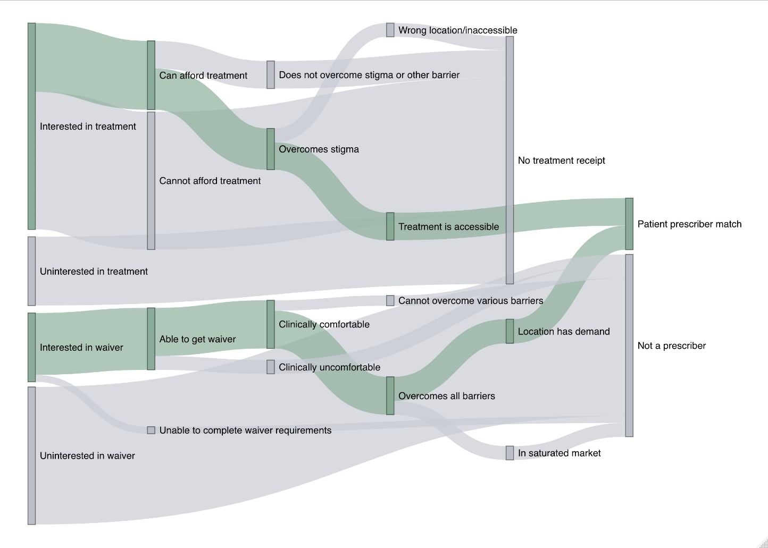

**Figure S5.** Treatment engagement as a dual continuum of care.

Demand (treatment seekers) and supply (treatment providers) need to match in space and time for successful treatment entry, but both providers and seekers face numerous barriers along the way.

Of those thus seeking treatment, some fraction will fail to receive it due to barriers such as affordability, acceptability, or stigma (*Tx seeking barrier loss fraction*, $F^{L}$). Estimates of this loss fraction are detailed in S3.c.ii.(2). The remainder are those who will engage in treatment as long as they have access to it (*Tx demand…*, $r_{UT(.)}^{*}$):

$$\begin{aligned}r_{UT\left(.\right)}^{*}=ρ_{T\left(.\right)}\left(1-F^{L}\right)U_{\left(.\right)} \#\left( STYLEREF 1 \backslash s 2. SEQ Equation \backslash * ARABIC \backslash s 1 13\right)\end{aligned}$$

Treatment demand is then compared with treatment capacity to determine what fraction of demand can actually be met. We represent treatment capacity explicitly in the model, detailed below. If capacity is insufficient, that means some people will be unable to access treatment despite facing no other barriers to engagement:

$$\begin{aligned}r_{UT\left(.\right)}=MIN\left(r_{UT\left(.\right)}^{*},K_{I\left(.\right)}\right) \#\left( STYLEREF 1 \backslash s 2. SEQ Equation \backslash * ARABIC \backslash s 1 14\right)\end{aligned}$$

Where $K_{I(.)}$ is the *Tx intake capacity* at any given time, detailed below.

#### Treatment capacity

Treatment capacity reflects the total number of patients nationwide who could be actively receiving a given treatment at any given time (*Tx capacity effective*, $K_{(.)}$). We calculate $K_{(.)}$ separately for each MOUD (subscripts B, M, V), but not each disorder type.

The maximum number of people who can be *in* treatment at a given time is distinct from the maximum number who can *enter* treatment, i.e. the maximum rate of treatment engagement (*Tx intake capacity*, $K_{I(.)}$); the latter depends on how much of existing capacity is already utilised, the rate of patients leaving treatment (rTR(.) and rTU(.)), and the processing time required for someone seeking treatment to start receiving it (*Tx intake delay*, $τ_{I(.)}$), which for simplicity we estimate at 1 month (0.083 years) for all MOUDs:

$$\begin{aligned}K_{I\left(.\right)}=MAX\left(0, \frac{K_{\left(.\right)}-\sum_{u}{T_{u\left(.\right)}}+\sum_{u}{\left(r_{TRu\left(.\right)}+r_{TUu\left(.\right)}\right)}}{τ_{I\left(.\right)}}\right), u∈\left\{R, O, H\right\} \#\left( STYLEREF 1 \backslash s 2. SEQ Equation \backslash * ARABIC \backslash s 1 15\right)\end{aligned}$$

National-level data on treatment capacity are unfortunately and surprisingly very sparse (see S3.c.iii)). The limitations of data availability significantly constrain the level of detail with which we can represent treatment capacity, particularly for methadone and Vivitrol treatment. For these two MOUD types, we calculate effective treatment capacity $K_{(.)}$ as a fraction (*Tx effective capacity fraction*, $F_{(.)}^{T}$) of estimated nominal or theoretical treatment capacity ($K_{(.)}^{*}$):

$$\begin{aligned}K_{\left(.\right)}=K_{\left(.\right)}^{*}F_{\left(.\right)}^{T}, \left(.\right)∈\left\{M,V\right\}\#\left( STYLEREF 1 \backslash s 2. SEQ Equation \backslash * ARABIC \backslash s 1 16\right)\end{aligned}$$

The effective capacity fraction captures a number of possible reasons why treatment capacity may not be fully utilised even in the face of demand, such as imperfect matching between demand and capacity due to geographic and temporal heterogeneity, or possibly treatment providers’ and facilities’ preferences for maintaining some capacity buffer.

We represent effective buprenorphine treatment capacity ($K_{B}$) in more detail, using data on the number of providers waivered to prescribe buprenorphine (see S3.c.iii)). While the DATA 2000 buprenorphine waiver requirement and its different levels (US Congress 2016) create a certain theoretical maximum number of patients who could be receiving buprenorphine nationwide, in practice, providers face numerous other barriers to prescribing buprenorphine besides the waiver requirement, and rarely prescribe up to their full waivered capacity (Duncan et al. 2020; Thomas et al. 2017). We do not disaggregate these barriers, but they include factors like low reimbursement, lack of training, stigma, or lack of coordinating providers for e.g., mental health services (Mackey et al. 2020).

Empirical evidence indicates the average number of buprenorphine patients per provider increased initially, but has been decreasing for several years now (see S3.c.iii)). This pattern results from the combination of two trends. First, there is an overall trend of diminishing marginal returns to effective capacity from additional waivered providers. This diminishing trend interacts with an early increase in patients per provider over the first several years after buprenorphine was approved for use in OUD treatment.

The overall diminishing trend likely arises for two main reasons. First, there is self-selection among providers in who gets waivered first (Fatseas and Auriacombe 2007). Those providers who got waivered early on (in the order of waiver receipt) were more likely to be those for whom addiction treatment was a major focus of their practice, or those with many patients who showed a need for treatment, and therefore more likely to dedicate more time and effort to prescribing. Conversely, those waivered later on are less likely to be focused on addiction treatment and less likely to make much time and effort available for buprenorphine prescribing. Second, there is some geographic mismatch between supply of waivered providers and demand for buprenorphine treatment (Langabeer et al. 2019; C. W. Jones et al. 2018), which tends to worsen with more waivered providers. A growing fraction of later-waivered providers are in areas where capacity is plentiful and demand is already saturated, even while other locales still have unmet demand.

The early increases in patients or effective capacity per provider result primarily from exogenous changes in the waiver requirement itself. The DATA 2000 waiver allowed providers to increase their prescribing limits after a year (US Congress 2016, 2000) and a 2005 amendment raised limits for group practice settings (US Congress 2005), allowing more capacity to come online gradually. In addition, there was likely some degree of learning as providers established and developed the practice-management infrastructure to handle this new treatment option, leading to gradual capacity growth.

To reflect the underlying trend of diminishing returns, we first calculate an indicated effective buprenorphine capacity $K_{B}^{*}$ as the integral of an exponential decay function representing each additional provider’s diminishing contribution to capacity ($\hat{K}$):

$$\begin{aligned}K_{B}^{*}=\int{\hat{K}}dB \#\left( STYLEREF 1 \backslash s 2. SEQ Equation \backslash * ARABIC \backslash s 1 17\right)\end{aligned}$$

$$\begin{aligned}\hat{K}={\hat{K}}_{0}e^{-λ_{B}B} \#\left( STYLEREF 1 \backslash s 2. SEQ Equation \backslash * ARABIC \backslash s 1 18\right)\end{aligned}$$

$$\begin{aligned}K_{B}^{*}=\frac{{\hat{K}}_{0}e^{-λ_{B}B}+{\hat{K}}_{0}}{{-λ}_{B}} \#\left( STYLEREF 1 \backslash s 2. SEQ Equation \backslash * ARABIC \backslash s 1 19\right)\end{aligned}$$

Where $B$ is the number of waivered *Bup providers*, ${\hat{K}}_{0}$ is the initial or base effective capacity per provider (*Bup effective capacity per provider base*), and $λ_{B}$ is a decay constant (*Bup effective capacity decay constant*) indicating the rate at which capacity added per additional provider diminishes. The effect of these parameters on the marginal effective capacity per new provider $\hat{K}$ is shown in **Figure S6**.

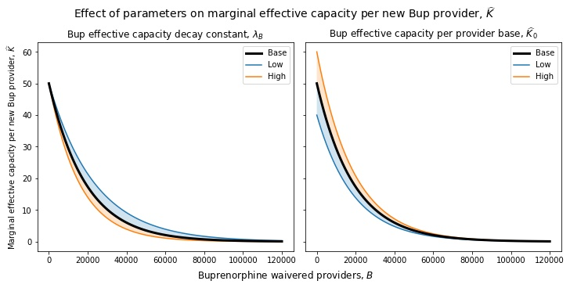

**Figure S6.** Functional relationship between buprenorphine-waivered providers and marginal effective capacity added per new waivered provider.

Panels show the effect of varying parameters $λ_{B}$ and ${\hat{K}}_{0}$ by ±20%. Note that while marginal capacity declines rapidly with additional providers, average capacity per provider never declines, as additional marginal providers only ever add capacity, never reduce it (see S3.c.iii)).

Rather than represent in detail the policy changes and learning processes driving the early growth in patients per provider, we approximate these processes with a multiplier ($F_{KB}$) that adjusts from 0-100% of indicated effective capacity with a exponentially distributed delay:

$$\begin{aligned}K_{B}=K_{B}^{*} F_{KB}\#\left( STYLEREF 1 \backslash s 2. SEQ Equation \backslash * ARABIC \backslash s 1 20\right)\end{aligned}$$

$$\begin{aligned}F_{KB}=\int_{t≥t_{B}}{\frac{1}{τ_{KB}}e^{-\frac{t-t_{B}}{τ_{KB}}}dt}=\left\{\begin{aligned}1-e^{-\frac{t-t_{B}}{τ_{KB}}}, t≥t_{B} \\ 0, t<t_{B}\end{aligned}\right.\#\left( STYLEREF 1 \backslash s 2. SEQ Equation \backslash * ARABIC \backslash s 1 21\right)\end{aligned}$$

Where $τ_{KB}$ is the *Bup effective capacity rampup time* and $t_{B}$ is the *Bup rampup start year* in which capacity starts to come online.

#### Treatment effects and outcomes

Patients in treatment will exit that state after a certain *Tx average duration* ($τ_{T(.)}$) for each treatment type. Weighted averages for each MOUD were derived from an extensive review of literature; see S3.c.iv.(1).

Following treatment, patients exit to either a remission state (rTR(.)), or back to use disorder (rTU(.)). The proportion exiting to remission rather than back to use disorder (*Tx success fraction*, $p_{(.)}^{R}$) is itself a function of duration in treatment:

$$\begin{aligned}p_{\left(.\right)}^{R}=\frac{r_{TR\left(.\right)}}{r_{TR\left(.\right)}+r_{TU\left(.\right)}}=f\left(τ_{T\left(.\right)}\right) \#\left( STYLEREF 1 \backslash s 2. SEQ Equation \backslash * ARABIC \backslash s 1 22\right)\end{aligned}$$

$$\begin{aligned}f\left(τ_{T}\right)=\left\{\begin{aligned}\left(\frac{{κ_{R}}^{2}}{1+{κ_{R}}^{2}}\right)e^{\left(\frac{λ_{R}}{κ_{R}}\right)\left(τ_{T}-m_{R}\right)}p^{RM}, τ_{T}≤m_{R} \\ \left(1-\left(\frac{1}{1+{κ_{R}}^{2}}\right)e^{\left({-λ}_{R}κ_{R}\left(τ_{T}-m_{R}\right)\right)}\right)p^{RM}, τ_{T}>m_{R}\end{aligned} \right. \#\left( STYLEREF 1 \backslash s 2. SEQ Equation \backslash * ARABIC \backslash s 1 23\right)\end{aligned}$$

The duration-success function, based on an asymmetric Laplace function, creates an asymmetric S-shaped curve (see **Figure S7**), whose shape and scale are based on a combination of expert judgment and existing studies (see S3.c.iv.(1)). The *Tx success fraction* function takes four parameters – the *inflection* point ($m_{R}$), asymmetry parameter *kappa* ($κ_{R}$), scale parameter *lambda* ($λ_{R}$), and the *max* possible success fraction ($p^{RM}$).

Patients in the treatment stocks T(.) include a mix of people in one-year remission and people with ongoing use disorder. Transitions in and out of remission while in treatment are not uncommon, but to our knowledge there has been no attempt made to quantify these transition rates. For each treatment type, therefore, we specify a *remission fraction in Tx* ($F_{(.)}^{R}$), which is the average proportion of patients in that type of treatment whose use disorder is in remission. The fraction of treatment patients who are *not* in remission count towards the total number of people with use disorder, even though they are not in the U(.) stocks. For simplicity, we assume the remission fraction in each treatment type is equal to the current success fraction for that type:

$$\begin{aligned}F_{\left(.\right)}^{R}=p_{\left(.\right)}^{R} \#\left( STYLEREF 1 \backslash s 2. SEQ Equation \backslash * ARABIC \backslash s 1 24\right)\end{aligned}$$

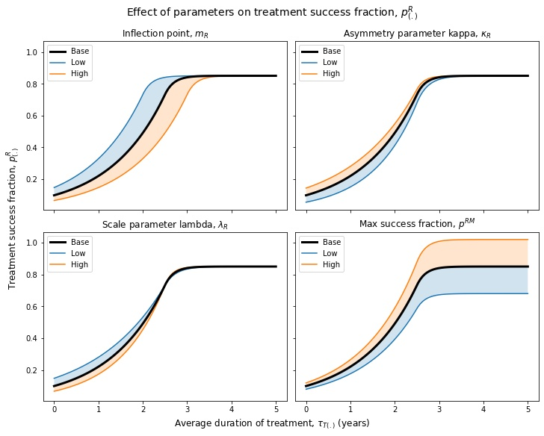

**Figure S7.** Functional relationship between duration of treatment and treatment success fraction.

Panels show the effect of varying parameters $m_{R}$, $κ_{R}$, $λ_{R}$ and $p^{RM}$ by ±20%.

Overdose and non-overdose death rates for treatment stocks ( $ω_{T\left(.\right)}$ and nT(.)) are weighted by this fraction, with the portion of treatment patients in remission experiencing non-overdose deaths at the same rate as people in remission stocks (R(.)) rather than use disorder stocks (U(.)), and experiencing no overdose deaths. For those in treatment but not yet in remission, being in treatment nonetheless has beneficial effects on overdose and non-overdose death rates (*effect of MOUD Tx on OD death rate / non-OD death rate*, $w_{(.)}^{TO}$/ $w_{(.)}^{TN}$). Magnitudes of these effects are based on extant literature (see S3.c.iv.(2)). The net overdose death rate for a given stock of people in treatment is thus:

$$\begin{aligned}ω_{T\left(.\right)}=ω_{U\left(.\right)}\left(1-F_{\left(.\right)}^{R}\right)w_{\left(.\right)}^{TO}\#\left( STYLEREF 1 \backslash s 2. SEQ Equation \backslash * ARABIC \backslash s 1 25\right)\end{aligned}$$

While the non-overdose death rate is:

$$\begin{aligned}n_{T\left(.\right)}=n_{U\left(.\right)}\left(1-F_{\left(.\right)}^{R}\right)w_{\left(.\right)}^{TN}+n_{R\left(.\right)}F_{\left(.\right)}^{R} \#\left( STYLEREF 1 \backslash s 2. SEQ Equation \backslash * ARABIC \backslash s 1 26\right)\end{aligned}$$

Treatment also reduces opioid consumption for patients in treatment not yet in remission (*effect of MOUD Tx on Rx consumption*, $w_{(.)}^{Tq}$), thereby reducing their influence on demand for Rx opioids:

$$\begin{aligned}q_{DT\left(.\right)}=q_{DU\left(.\right)}\left(1-F_{\left(.\right)}^{R}\right)w_{\left(.\right)}^{Tq} \#\left( STYLEREF 1 \backslash s 2. SEQ Equation \backslash * ARABIC \backslash s 1 27\right)\end{aligned}$$

### Overdoses, naloxone, and synthetics

#### Basic overdose death structure

The hazard rates of overdose and overdose death ($o_{(.)}$) differ based on drug use state. Overdose death data identify overdoses by the drug[s] involved (see S3.d.i)), but to keep the model estimation tractable, we instead allocate overdose deaths to user populations based on the populations’ primary drug of use (Rx opioids vs. heroin), with further allocation of synthetic-opioid-involved deaths as detailed in S3.d.ii) below.

Not all overdoses result in death; sometimes death is averted through intervention, and sometimes an overdose is inherently less than lethal. For simplicity, we assume that the inherent lethality of an overdose and the probability that intervention occurs (or at least is attempted) are independent; many attempted interventions occur for overdoses that may not have resulted in death in the first place. In its basic form, therefore, we represent the overdose death rate ($ω_{\left(.\right)}$) as:

$$\begin{aligned}ω_{\left(.\right)}=β_{\left(.\right)}\left(1-p_{S\left(.\right)}\right)p_{D\left(.\right)}\#\left( STYLEREF 1 \backslash s 2. SEQ Equation \backslash * ARABIC \backslash s 1 28\right)\end{aligned}$$

The overall overdose rate ($β_{(.)}$) is multiplied by the complement of some base probability that overdoses are nonlethal, differentiating between Rx opioid and heroin overdoses (*base survival probability Rx OD / H OD*, $p_{SR}$/ $p_{SH}$), and the probability that some lifesaving intervention does not successfully occur (*probability OD death not averted Rx / heroin*, $p_{DR}$/ $p_{DH}$). We assume $p_{S(.)}$ is on average constant for a given substance, reflecting its inherent lethality given its usual modes of use; $p_{D(.)}$ is detailed further below.

Each use state (M, N, UR, UO, UH) has its own base overdose rate parameter $β_{(.)}^{*}$, reflecting the combined effects of not only the substance involved and its usual modes of use, but also of frequency and patterns of use for that use state. For Rx OUD without heroin use (UR), we also estimate a baseline (i.e., pre-illicitly manufactured fentanyl) synthetic-involved overdose rate (*overdose rate synth baseline*, $β_{R}^{S}$). We use the synthetic-involved overdose rate to help distinguish the effects of illicitly manufactured fentanyl from that of misused prescription fentanyl on overdose deaths, as detailed in S2.d.iii.(3) and S3.d.ii). Base overdose rates ( $β_{(.)}^{*}$/ $β_{R}^{S}$) and survival probabilities ( $p_{SR}^{*}$/ $p_{SH}^{*}$) are estimated model parameters.

#### Intervention probability structure & naloxone probabilities

For a death to not be averted, none of the potential interventions that could prevent it can occur. An intervention can only occur if an overdose is first witnessed by someone who could intervene. For simplicity, we treat potential interventions as independent conditional on an overdose being witnessed, such that $p_{D(.)}$ is the joint probability that none of them occur:

$$\begin{aligned}p_{D}=1-p_{W}p_{I} \#\left( STYLEREF 1 \backslash s 2. SEQ Equation \backslash * ARABIC \backslash s 1 29\right)\end{aligned}$$

$$\begin{aligned}p_{I}=1-\prod_{j}{\left(1-p_{Ij}\right)} \#\left( STYLEREF 1 \backslash s 2. SEQ Equation \backslash * ARABIC \backslash s 1 30\right)\end{aligned}$$

Here $p_{W}$ is the *probability OD witnessed* and $p_{Ij}$ is the probability that intervention *j* successfully occurs, given that an overdose is witnessed. The value of $p_{W}$ is derived from existing studies; see S3.d.v).

We represent two types of intervention, each with distinct probabilities of occurrence – bystander naloxone administration or calling emergency services. The *probability of calling emergency services* ($p_{IE}$) is a constant value estimated from literature (see S3.d.v)), which we assume results in a life-saving response by emergency medical services (EMS). EMS responders have the ability to avert death for the overdose victim regardless of naloxone availability, by for instance using rescue breathing or mechanical ventilation during an ambulance ride to the hospital (A. Walley 2020, pers. comm., 1 Jul), though they increasingly use naloxone as well (see S3.d.iv.(1)).

The probability of bystander naloxone administration (*probability Nx bystander*…, $p_{IB(.)}$) depends on the amount of naloxone distributed. Specifically, we represent $p_{IB(.)}$ using as a cumulative exponential distribution function of the density of naloxone kits distributed in the population:

$$\begin{aligned}p_{IB\left(.\right)}=1-e^{λ_{N}ν_{\left(.\right)}} \#\left( STYLEREF 1 \backslash s 2. SEQ Equation \backslash * ARABIC \backslash s 1 31\right)\end{aligned}$$

Where $λ_{N}$ is the *Nx kit distribution efficiency*, reflecting how effectively kits distributed end up in the times and places where they are needed, and $ν_{(.)}$ is the number of *Nx kits per 100k population* for heroin or Rx users. $λ_{N}$ is an estimated parameter; the effect of varying efficiency on $p_{IB(.)}$ can be seen in **Figure S8**.

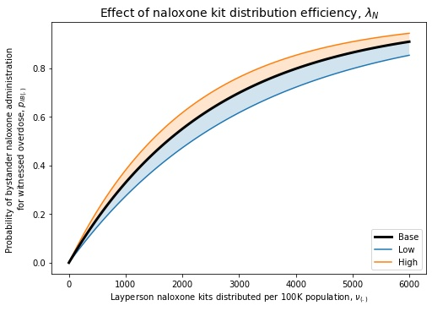

**Figure S8.** Functional relationship between naloxone kits distributed and probability of naloxone administration

in the event of witnessed overdose, as dependent on naloxone kit distribution efficiency parameter $λ_{N}$.

Note that $ν_{(.)}$ is normalised per 100,000 *total* people, rather than just people who use Rx opioids or heroin. The distinction between $ν_{R}$ and $ν_{H}$ depends on the channels by which naloxone is distributed and the populations such distribution focuses on (see S3.d.iv.(3)). The total amount of naloxone distributed is an exogenous time-series input, which is apportioned between Rx and heroin users based on an estimated parameter, the *fraction Nx kits to H users* ($F^{NH}$) (see S3.d.iv.(2)).

#### Fentanyl effects on OD rates, survival rates, intervention probabilities

The prevalence of illicitly manufactured fentanyl in the illicit drug supply has increased rapidly since around 2013 (Drug Enforcement Administration Diversion Control Division 2017a, 2017b). Fentanyl is far more potent than other Rx opioids or even heroin (Suzuki and El-Haddad 2017), and has substantially affected overdose risks. We operationalise the effects of fentanyl on each stage of the overdose process based on its prevalence in the drug supply. Specifically, we drive the underlying growth in fentanyl prevalence with exogenous data (*fentanyl penetration curve*, $ϕ$; see S3.d.iii)), representing the penetration of illicitly manufactured fentanyl in the heroin supply.

Note that while there is some evidence of fentanyl in counterfeit prescription opioids, especially on the west coast (Vo et al. 2016; Green and Gilbert 2016; J. K. O’Donnell et al. 2017; Drug Enforcement Administration 2021), to our knowledge no quantitative data tracking counterfeit prevalence exists. We therefore cannot quantitatively account for illicit fentanyl in the Rx supply at this time, nor the effects of counterfeit prescription pills containing fentanyl on the street availability of Rx opioids.

Fentanyl penetration $ϕ$ can be thought of as the average probability of exposure to fentanyl for users of heroin in any given instance of drug use. We can therefore approximate the average effects of fentanyl on overdose rates and survival probabilities as averages weighted by $ϕ_{H}$ of their baseline heroin values and their corresponding values for fentanyl overdoses:

$$\begin{aligned}β_{\left(.\right)}= β_{\left(.\right)}^{*}\left(1-ϕ\right)+ w_{βF}β_{\left(.\right)}^{*}ϕ\#\left( STYLEREF 1 \backslash s 2. SEQ Equation \backslash * ARABIC \backslash s 1 32\right)\end{aligned}$$

$$\begin{aligned}p_{SH}= p_{SH}^{*}\left(1-ϕ\right)+ p_{SF}ϕ\#\left( STYLEREF 1 \backslash s 2. SEQ Equation \backslash * ARABIC \backslash s 1 33\right)\end{aligned}$$

Where $w_{βF}$ is the *fentanyl effect on OD rate H max*, i.e. how many times more likely overdose events are for fentanyl use relative to heroin use, and $p_{SF}$ is the *base survival probability* of a fentanyl-involved overdose. These parameters, as well as the fentanyl penetration scaling factor ($s_{ϕH}$), are estimated in the main model calibration process.

Comparing overdose death rates against the counterfactual base death rates calculated using the base overdose rates and survival probabilities that exclude the effect of fentanyl allows us to attribute a certain portion of heroin-user deaths to the effects of illicit fentanyl (*overdose death rate synth…*, $ω_{\left(.\right)F}$):

$$\begin{aligned}ω_{\left(.\right)F}=β_{\left(.\right)}\left(1-p_{SH}\right)p_{DHJ}-β_{\left(.\right)}^{*}\left(1-p_{SH}^{*}\right)p_{DH}\#\left( STYLEREF 1 \backslash s 2. SEQ Equation \backslash * ARABIC \backslash s 1 34\right)\end{aligned}$$

We use this calculated death rate to estimate the contribution of illicit fentanyl penetration to overall overdose deaths.

#### Nonfatal overdoses

We explicitly track nonfatal overdoses for each of the five main use states (M, N, UR, UO, UH). The nonfatal overdose rate for each use state ($η_{\left(.\right)}$) is simply the difference between the overdose rate and overdose death rate for that state:

$$\begin{aligned}η_{\left(.\right)}=β_{\left(.\right)}-ω_{\left(.\right)} \#\left( STYLEREF 1 \backslash s 2. SEQ Equation \backslash * ARABIC \backslash s 1 35\right)\end{aligned}$$

# Data Sources

## Main drug use states & transitions

Most data on drug use states and transitions in the model are drawn from the National Survey on Drug Use and Health (NSDUH). NSDUH allows us to distinguish individuals by the substances they have used in the past year (Rx opioids vs. heroin), as well as the degree of use associated with each substance (non-use vs. misuse / non-disordered use vs. use disorder). Both severity and substance of use are important distinctions on multiple dimensions – behaviourally, socially, clinically, and in terms of overdose and non-overdose risks. In particular, there is a clear psychological and social distinction between using prescription opioids and heroin (Mars et al. 2014; Cicero et al. 2014; Harocopos, Allen, and Paone 2016; Guarino et al. 2018), as well as clear differences in both overdose risk and aggregate patterns of overdose mortality (Ciccarone 2019), which makes it crucial to distinguish between substances of use (but see also S2.b), footnote 1).

With two substances with three use states each, this creates a 3 x 3 matrix with 9 cells, of which 8 (excluding non-use of both) collectively map on to the 5 main drug use states in the model (M, N, UR, UO, UH; see **Figure S9** and **Table S8**), in combination with the fraction of people in treatment not in remission (see 0). Broadly, we aggregated matrix cells based on what substance is associated with the highest severity of use disorder and/or risk of overdose.

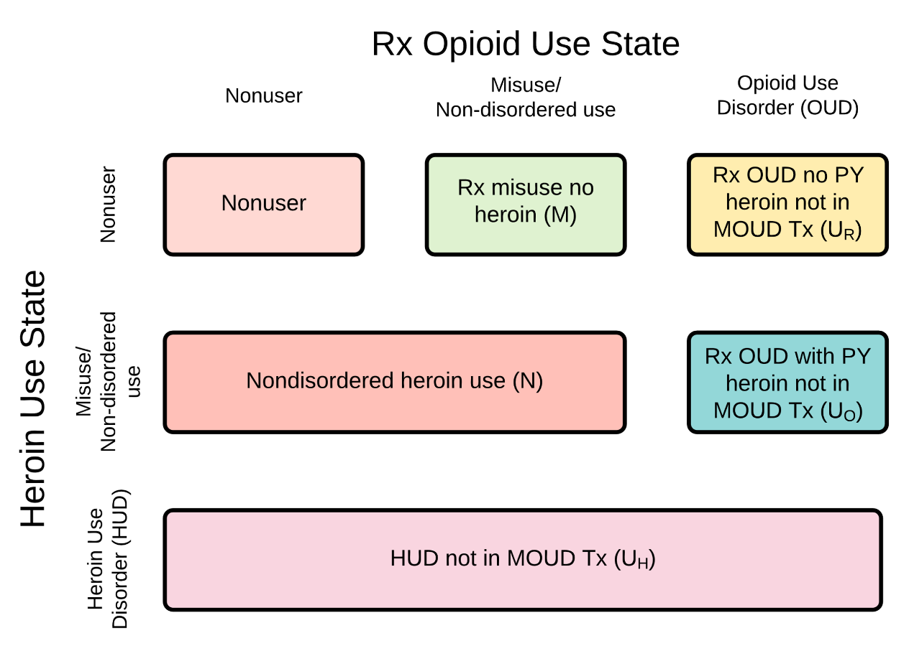

**Figure S9.** Prescription opioid / heroin use state matrix with corresponding NSDUH data variables or model states

### Prescription opioid misuse

We define Rx opioid misuse as including *any* use of someone else’s opioid prescription *or* use of Rx opioids solely “for the feeling [they] caused”. This definition matches the pre-2015 question wording in NSDUH (Center for Behavioral Health Statistics and Quality 2015).

Our definition of Rx opioid misuse excludes people sometimes called “medical misusers”, i.e., people who 1) used Rx opioids that were prescribed to them; 2) used them in ways other than as directed by their medical care providers; but 3) did so to treat pain (which is the intended therapeutic use of Rx opioids) and not for any other reason. This can include, for instance, using Rx opioids prescribed to oneself, in therapeutic doses, to treat pain, of the same kind for which they were originally prescribed, but without first consulting a medical professional regarding the repeat use.

#### Adjustments for NSDUH question change

From 2015 onward, NSDUH defines misuse more broadly, in a way that includes “medical misusers” or more specifically anyone who has used Rx opioids in *any* way not as directed by their medical care providers (Center for Behavioral Health Statistics and Quality 2015).

We account for this definitional change, which SAMHSA considers a trend break (Center for Behavioral Health Statistics and Quality 2015), using a fixed effect for the percentage increase in reporting of misuse due to the definitional change (*NSDUH misuse redefinition fixed effect*, $F^{M}$). This fixed effect parameter is estimated as part of the model calibration process (see S4)). From 2015 onward, we adjust the time series on Rx misuse and misuse initiation (see S3.a.v)) accordingly:

$$\begin{aligned}M_{adj}^{y}=\frac{M^{y}}{1+F^{M}} \#\left( STYLEREF 1 \backslash s 3. SEQ Equation \backslash * ARABIC \backslash s 1 1\right)\end{aligned}$$

$$\begin{aligned}{r_{MI}}_{adj}^{y}=\frac{r_{MI}^{y}}{1+F^{M}} \#\left( STYLEREF 1 \backslash s 3. SEQ Equation \backslash * ARABIC \backslash s 1 2\right)\end{aligned}$$

This adjustment reduces the number of people misusing after 2015 by approximately a third.

### Prescription opioid use disorder

We define use disorder states according the DSM-5 criteria; however, NSDUH does not use the DSM-5 definition. Instead, we approximate the DSM-5 definition from NSDUH using the count of DSM-IV criteria for substance abuse or substance dependence that they meet. We ignore reported legal problems, which is no longer a DSM-5 criterion for disorder, and we are unable to include craving, which was added to the DSM-5 criteria but is not queried in NSDUH (see **Table S2**) (Center for Behavioral Health Statistics and Quality 2016). Note that our use of NSDUH’s DSM-IV criteria to approximate DSM-5 criteria differs from how NSDUH commonly reports ‘use disorder’ – NSDUH typically reports the union of DSM-IV substance abuse and substance dependence as ‘use disorder’, even though that more accurately reflects DSM-IV diagnoses rather than DSM-5 use disorder. This difference results in our calculated estimates for use disorder, particularly Rx OUD, being higher than what NSDUH reports as “use disorder.”

We separate people with Rx OUD who have not used heroin in the past year vs. those who have (UR vs. UO, see **Figure S9**). We adjust all NSDUH heroin-use estimates, including the count of people with Rx OUD with past-year heroin use ($U_{O}^{y}$), to account for systematic under-reporting (see S3.a.vii)).

The NSDUH counts of people with past-year use disorder also include that fraction of people in treatment states in the model (T(.)) who are not yet in remission, who by definition have qualified for use disorder within the past year (see **Table S8**).

**Table S2.** DSM-5 criteria for substance use disorder, compared to DSM-IV substance abuse & substance dependence criteria

|  |  |
| --- | --- |
| **DSM-IV** | **Diagnostic criterion** |
| * | Craving or a strong desire to use opioids |
| A | Recurrent opioid use resulting in failure to fulfill major role obligations at work, school, or home |
| A | Continued opioid use despite having persistent or recurring social or interpersonal problems caused or exacerbated by the effects of opioids |
| A | Recurrent opioid use in situations in which it is physically hazardous |
| D | Opioids are often taken in larger amounts or over a longer period of time than intended |
| D | There is a persistent desire or unsuccessful efforts to cut down or control opioid use |
| D | A great deal of time is spent in activities necessary to obtain the opioid, use the opioid, or recover from its effects |
| D | Important social, occupational or recreational activities are given up or reduced because of opioid use |
| D | Continued use despite knowledge of having a persistent or recurrent physical or psychological problem that is likely to have been caused or exacerbated by opioids. |
| D | *Tolerance, as defined by either of the following: (a) a need for markedly increased amounts of opioids to achieve intoxication or desired effect (b) markedly diminished effect with continued use of the same amount of an opioid |
| D | *Withdrawal, as manifested by either of the following: (a) the characteristic opioid withdrawal syndrome (b) the same (or a closely related) substance are taken to relieve or avoid withdrawal symptoms |
| DSM-IV column indicates DSM-IV diagnosis corresponding to DSM-5 criteria:  A = substance abuse; 1 or more needed; 4th criterion (legal problems) removed from DSM-5  D = substance dependence; 3 or more needed in 12-month period  * Craving is a DSM-5 criterion not included in DSM-IV diagnoses and not queried in NSDUH  Source: (Center for Behavioral Health Statistics and Quality 2016) | |

### Non-disordered heroin use

Approximately one-quarter of the people who report heroin use in the past year in NSDUH do not meet use disorder criteria for their heroin use. Anyone who reports past-year heroin use in NSDUH who does not qualify for HUD is counted either as having non-disordered heroin use ($N^{y}$) if they do not qualify for Rx OUD, or Rx OUD with past-year heroin use ($U_{O}^{y}$) if they do (see **Figure S1**). We adjust all NSDUH heroin-use estimates, including the count of people with NDHU ($N^{y}$), to account for systematic under-reporting (see S3.a.vii)).

### Heroin use disorder

As with Rx OUD, we approximate the DSM-5 use disorder definition using NSDUH criteria (see above). Note that substance use disorder associated with Rx opioid use vs. heroin use are sometimes both collectively referred to as ‘opioid use disorder’, since heroin is an opioid substance. However, NSDUH queries each UD criterion for each substance separately, allowing us to identify whether UD is associated with use of Rx opioids, heroin, or both. For clarity, we use ‘Rx OUD’ to refer to UD associated with use of Rx opioids, and ‘HUD’ to refer to UD associated with use of heroin or both.

We adjust all NSDUH heroin-use estimates, including the count of people with HUD ($U_{H}^{y}$), to account for systematic under-reporting (see S3.a.vii)).

The NSDUH counts of people with past-year use disorder also include that fraction of people in treatment states in the model (T(.)) who are not yet in remission, who by definition have qualified for use disorder within the past year (see **Table S8**).

#### Caveat regarding HUD data

NSDUH’s 2018 data on HUD prevalence and heroin use initiation show a downward trend from previous years, and 2019 data continue this downward trend, showing a sharp decline. The drop is large and rapid enough that several subject-matter experts expressed concern about the accuracy of the data. Changes in overdose mortality and MOUD treatment engagement are insufficient to explain the drop, but without specific data on remission (and relapse), we cannot conclusively demonstrate the physical impossibility or inconsistency of the reported numbers.

In consultation with our subject-matter experts, we have considered several plausible explanations for the decline – increased under-reporting due to growing fear or stigma, possibly associated with fentanyl; increasing self-identification as a fentanyl rather than heroin user (e.g. in regions where fentanyl has almost completely displaced heroin); and decreasing relapse due to ‘older’ cohorts of former heroin users attaining an increasingly durable state of remission. We found no evidence for the first two of these explanations, and our subject-matter expert team considered them less likely than there being issues with the NSDUH data.

Increasing durable or sustained remission was the only other explanation supported by our subject-matter experts as well as existing literature. We modified the model’s remission structure (see S2.b) and S3.c.v)) to more accurately reflect this effect, which improved model performance but was insufficient to produce the observed decline.

We have queried SAMHSA directly about the 2019 HUD and heroin initiation data, and they report that the 2019 data are in no way anomalous as no methodological changes occurred that may account for the difference.

With no further explanation or justifiable alternative, we have estimated the model on the assumption that the NSDUH 2019 HUD and heroin initiation data are no less accurate than in other years. This has several implications for the model’s estimates, behaviour and projections.

Most importantly, the rapid drop in initiation indicates the risk response feedback (see S2.c.ii)) is very strong, exerting a dominant effect on the system in the last few years as the sharp rise in overdose mortality due to illicit synthetics deters new heroin initiates. Similarly, the fall in HUD prevalence indicates relatively high rates of remission vs. relapse, absent new initiations or use disorder development. With sustained high overdose mortality, this strong behavioural response results in a substantial projected decline in opioid use and mortality over the next decade (see S5.c)).

If the 2019 heroin use data turn out to be, for whatever reason, a substantial under-estimate, then our model will have over-estimated the strength of this risk response feedback, as well as rates of HUD remission vs. relapse. A weaker risk response and lower remission / higher relapse rates will result in persistently higher levels of opioid use and overdose mortality than we are currently projecting, with a much slower decline.

### Initiating prescription opioid misuse

We derive data on annual initiation rates of Rx opioid use from NSDUH’s Restricted Data Analysis System (RDAS), which allows identification of past-year initiates. The data do not directly distinguish between initiation of use with vs. without a prescription (rMI vs. rMD). To make that distinction, we use the fraction of past-year initiates who report that the source of Rx opioids for their *most recent* instance of misuse was one or more of their own prescriptions (vs. other sources), averaged over time, as a proxy for the fraction initiating misuse from a prescription. Due to the trend break in misuse reporting in 2015, we use separate fractions before 2015 and from 2015 onward.

### Initiating heroin use

We derive data on annual initiation rates of heroin use from NSDUH’s Restricted Data Analysis System (RDAS) as well, using it to identify whether individuals are initiating heroin with no past-year Rx opioid use (rND), with past-year Rx opioid misuse (rMN), or with past-year Rx OUD (rUO). These data were then adjusted to address under-reporting, as outlined below.

### Heroin use adjustments

NSDUH estimates of the number of people who use heroin are notoriously low (Reuter, Caulkins, and Midgette 2021; Barocas et al. 2018; Compton et al. 2010; Midgette et al. 2019; Grucza et al. 2007; Compton et al. 2013). This under-reporting is due in part to exclusion of incarcerated populations where heroin use is disproportionately common, and in part to the strong stigma associated with heroin use. To correct for this under-estimation, we adjust all NSDUH data on prevalence and initiation of heroin use ($N^{y}$, $U_{O}^{y}$, $U_{H}^{y}$, $r_{ND}^{y}$, $r_{MN}^{y}$, $r_{UO}^{y}$) as follows.

No adjustment to empirical data should ever be undertaken lightly. We make this change noting that 1) the systematic problems with the data are well-known, and 2) the alternative of not adjusting the data would be worse, forcing skewed estimates of various parameters and creating errors that would propagate throughout the model (due to its enforced internal consistency and conservation of matter). Our adjustments are based on extensive literature review as well as discussions with subject matter experts (J. Caulkins 2020, pers. comm., 28 May; J. Mcaninch 2020 pers. comm., 24 Jul; R. Pacula 2020, pers. comm., 31 Jul) .

We base the adjustment on estimates of chronic heroin users (CHU) from the RAND Corporation report “What America's Users Spend on Illegal Drugs, 2006-2016” (Kilmer et al. 2014; Midgette et al. 2019). The report estimates number of CHUs for 2006-2016. We compare the RAND CHU population against the total NSDUH reported population of heroin users year by year ($N_{t}^{y}+U_{Ot}^{y}+U_{Ht}^{y}$), yielding an average ratio of 3.15. We then multiply each NSDUH heroin use population and initiation flow by this ratio. Note that the actual ratios of RAND to corresponding NSDUH estimates in the data decline over time, but for simplicity, we use a single average figure for each population group, meaning the temporal trends in the data are driven by NSDUH. This may result in some underestimation of heroin users in our adjusted data in earlier years, and some overestimation in later years.

### Total population

As great a problem as the opioid crisis may be, the total US population is orders of magnitude larger. We therefore represent total population – or more accurately, the NSDUH survey population of non-institutionalised individuals aged 12 and older – as exogenous.

Total population figures for 1999-2019 are taken directly from NSDUH data. Projected total population for 2019-2031 is calculated using the ratio of the 2019 NSDUH population to 2019 population projected by the US Census. This ratio (approx. 83%) is applied to US Census projected population for 2019-2031 to yield a projection of the NSDUH population:

$$\begin{aligned}Projected NSDUH pop.=\frac{2019 NSDUH pop.}{2019 US Census pop.}×Projected US Census pop. \#\left( STYLEREF 1 \backslash s 3. SEQ Equation \backslash * ARABIC \backslash s 1 3\right)\end{aligned}$$

## Opioid prescribing, supply, and price data

### Prescription opioid supply

We draw most data regarding prescribing patterns, as detailed in S2.d.i.(1), from several proprietary IQVIA datasets – the National Sales Perspective®(NSP), National Prescription Audit® (NPA), and Total Patient Tracker® (TPT). NPA and TPT are national-level projected services designed to estimate the total number of prescriptions dispensed and unique (non-duplicated) patients receiving prescriptions respectively, across all drugs and therapeutic classes. NPA captures prescriptions dispensed in the outpatient setting at US retail and mail-order pharmacies, as well as pharmacies that dispense to long-term care facilities, while TPT projects patient counts based on prescriptions dispensed from US retail pharmacies. TPT uses prescription activity as part of their projections and integrates information from pharmacies to eliminate duplicate patients. As of 2019, IQVIA data captures 92% of all dispensed prescriptions in the U.S. from a sample of about 49,900 retail pharmacies, for a total of over 3.5 billion transactions annually. The prescription coverage and sample size have varied across the time period in our analyses. NPA and TPT are projected to the known universe of retail pharmacies.

NSP estimates the volume of prescription drug products moving from distributors and manufacturers into various retail and non-retail outlets, in terms of sales dollars and product quantities. Retail outlets include various pharmacy settings, including mail-order; non-retail outlets include clinics, hospitals, long-term care facilities, and other such settings. NSP captures 86% of sales in the retail channel and 97% of the sales in the non-retail channel, or about 90% of the US pharmaceutical market in total. It includes sales from 388 indirect suppliers and direct sales reported from around 100 manufacturers, totaling about 1.5 billion transactions per year.

#### Total prescriptions and MMEs

For the total number of opioid analgesic prescriptions dispensed annually (*total prescription opioid Rx*), we use IQVIA NPA® data on the total number of prescriptions for all opioid analgesic products dispensed from US outpatient pharmacies (retail and mail-order).

We calculate the total annual MMEs (*total Rx MME prescribed*) by multiplying the opioid units (e.g. tablets, patches, liquid volume) reported in IQVIA NPA by the milligram strength per unit and by the appropriate MME conversion factors as showin in **Table S3**.

**Table S3.** MME conversion factors for different opioid substances

|  |  |  |  |  |  |
| --- | --- | --- | --- | --- | --- |
| **Opioid** | **Dosage Formulation** | **MME conversion factor** | **Opioid** | **Dosage Formulation** | **MME conversion factor** |
| Benzhydrocodone | Oral solid/liquid | 1.22 | Meperidine | Injectable | 0.3 |
| Buprenorphine | Injectable | 100 | Meperidine | Oral solid/liquid | 0.1 |
| Buprenorphine | Oral solid/liquid | 0.03 | Methadone | Injectable | 4.29 |
| Buprenorphine | Patch | 12.6 | Methadone | Oral solid/liquid | 3 |
| Butorphanol | Injectable | 15 | Morphine | Injectable | 3 |
| Butorphanol | Nasal spray | 7 | Morphine | Oral solid/liquid | 1 |
| Codeine | Oral solid/liquid | 0.15 | Morphine | Rectal | 1 |
| Dihydrocodeine | Oral solid/liquid | 0.25 | Nalbuphine | Injectable | 3 |
| Fentanyl | Injectable | 150 | Opium | Oral solid/liquid | 1 |
| Fentanyl | Oral solid/liquid | 0.13 | Oxycodone | Oral solid/liquid | 1.5 |
| Fentanyl | Patch | 7.2 | Oxycodone (Xtampza) | Oral solid/liquid | 1.67 |
| Fentanyl (Lazanda) | Nasal spray | 1.28 | Oxymorphone | Injectable | 30 |
| Fentanyl (Subsys) | Nasal spray | 0.18 | Oxymorphone | Oral solid/liquid | 3 |
| Hydrocodone | Oral solid/liquid | 1 | Pentazocine | Injectable | 1 |
| Hydromorphone | Injectable | 20 | Pentazocine | Oral solid/liquid | 0.37 |
| Hydromorphone | Oral solid/liquid | 4 | Tapentadol | Oral solid/liquid | 0.4 |
| Hydromorphone | Rectal | 4 | Tramadol | Oral solid/liquid | 0.1 |
| Levorphanol | Oral solid/liquid | 11 |  |  |  |
| **Sources:**  (Centers for Disease Control and Prevention 2019; McPherson 2018; Kishner and Schraga 2018; GlobalRPh 2019) | | | | | | |

Note that neither total prescriptions nor total MMEs is used directly in the model; instead they are combined to calculate the *avg MME per opioid Rx* ($m_{M}$). They are also used to derive a number of other prescribing-related time series as explained below.

There are recognized limitations with using MME as a standardising conversion factor for quantifying the potency of opioids across different opioid moieties. MME conversion cannot fully account for pharmacologic variability due to moiety, route of administration, and patient characteristics; furthermore, conversion factors are inconsistently applied and interpreted in clinical practice and in research (Dasgupta et al. 2021; U.S. Food and Drug Administration 2021). These limitations likely mean that some moieties are under- or over-represented in total calculations of the Rx supply.

However, in no place does [OSM] directly make use of calculated MMEs or MME per prescription values. Instead, these values are either normalised to their initial values (see S2.c)) or used to calculate fractions (see S3.b.i.(4)), and it is the temporal trend in these normalised or fractional values that drives changes in the model. As such, barring extreme shifts in the composition of overall opioid prescribing by opioid moiety, the exact MME conversion factors used in calculating total MMEs makes little difference to the overall temporal trends in prescribing and hence to the behaviour of the rest of the model. The model also does not rely on MME to estimate overdose or other hazard rates.

#### Prescriptions per person and average duration

For the average number of *prescriptions per person* ($m_{N}$) over time, we use data from IQVIA TPT® and NPA®, described above. The TPT® data provide estimates of total unique patients receiving opioid analgesic prescriptions each year from 2006-2019, while the NPA® data provide estimates of total opioid analgesic prescriptions dispensed each year from 1999-2019 (see above).

We calculate *prescriptions per person* ($m_{N}$) over time using the ratio of total prescriptions in NPA® to total patients in TPT® each year. This ratio is calculated for 2006-2019 and increased only modestly over this period. As such we hold $m_{N}$ constant at its 2006 value, in order to avoid introducing an artificial discontinuity>.

To calculate the *average prescription duration* ($τ_{M}$), we use data from Symphony Health Integrated Dataverse® (IDV), which contains longitudinal patient data sources that capture adjudicated prescription, medical, and hospital claims across the United States for all payment types. IDV contains over 10 billion prescriptions claims linked to over 280 million unique patients of with an average of 5 years of prescription drug history. The overall sample represents over 65,000 pharmacies, 1,500 hospitals, 800 outpatient facilities, and 80,000 physician practices.

The Symphony Health data record national estimates of numbers of patients receiving incident opioid analgesic prescriptions dispensed from outpatient retail pharmacies each year,[4] and group the patients by whether they receive 1, 2, 3, 4, and 5+ prescriptions within a calendar year. The data cover the period from 2009-2019. On the advice of the FDA Office of Surveillance and Epidemiology (OSE), we assume that patients receiving 5+ prescriptions per year are more likely long-term opioid users whereas those receiving 1-4 prescriptions are more likely short-term users (see also (Woods et al. 2021)). For long-term users we assume a prescription duration of 1 month / 30 days, as long-term users typically require continuous daily use; for short-term users we assume a prescription duration of 0.5 months / 15 days. Using these distinctions, we calculate the overall average duration for each prescription based on the proportions of prescriptions received by presumptive short-term vs. long-term users, yielding $τ_{M}$ =0.059 years.

#### Total patients receiving prescriptions

For the total number of *patients receiving opioid prescription* each year ($m_{P}$) we use IQVIA TPT® data on the total unique patients receiving opioid analgesic prescriptions each year from 2006-2019. Prior to this period, we calculate the value for $m_{P}$ as the total dispensed prescriptions from NPA® divided by the extrapolated ratio of *prescriptions per person* ($m_{N}$) (see above).

#### ADF fraction of prescribed supply

**Table S4.** FDA-approved abuse-deterrent formulation opioids currently marketed in the US*

|  |  |  |  |  |  |
| --- | --- | --- | --- | --- | --- |
| **FDA-approved ADF opioids** | | | | | |
| **Product name** | **Active ingredient** | **Year approved** | **Product name** | **Active ingredient** | **Year approved** |
| Arymo™ ER | Morphine | 2017 | OxyContin® | Oxycodone | 2010 |
| Embeda® | Morphine | 2009 | RoxyBond™ | Oxycodone | 2017 |
| Hysingla® ER | Hydrocodone | 2014 | Xtampza® ER | Oxycodone | 2016 |
| MorphaBond ER™ | Morphine | 2015 |  |  |  |
| * Three other abuse-deterrent formulations are approved but not marketed in the US, and are therefore excluded from this analysis: Targiniq™ ER, Troxyca® ER, and Vantrela™ ER | | | | | |

We calculate a time series for the *ADF fraction of prescribed Rx opioids* ($F^{AR}$) (see S2.d.i.(2)) using the same IQVIA NPA data and MME conversion factors used to calculate total annual MMEs above (**Table S3**). We use a list of all FDA-approved ADF opioids currently marketed in the United States (see **Table S4**) to identify the total annual MMEs prescribed for ADF products and divide that by *total Rx MME prescribed* to arrive at the ADF fraction (of MMEs prescribed) for each year.

#### OxyContin withdrawal street supply shock

We include a single historical Rx street supply shock (see S2.d.i.(2)), representing the August 2010 withdrawal of non-ADF OxyContin. To estimate the magnitude of this shock, in terms of the proportion of the street supply impacted, we used StreetRx, a crowdsourced database of street prices paid for illicit substances. StreetRx reports include information on substance, quantity, and price. We set the magnitude of the shock at 0.45 (where 100% of street supply = 1), equal to the fraction of total MMEs reported in StreetRx for 2010 consisting specifically of OxyContin (excluding other oxycodone). OxyContin MMEs are calculated based on conversion factors in **Table S3**.

### Prescription opioid demand

To calculate the *Rx demand for misuse* (qD), we use the number of people in each opioid use state multiplied by the per-person demand for opioid use for that use state, expressed in MMEs per year. We calculate per-person demand based on NSDUH data on average number of days of use per year, rounded to the nearest 10 days, reported over the 2010-2018 period: 50 days for M, 120 days for UR, 170 days for UO, 110 days for N, and 130 days for UH. (The latter two categories are modified by the average fraction over 2010-2018 of people in those states who also use Rx opioids.) Note that these reported days of use are likely underestimates, particularly for the UR and UO groups. We multiply the days of use by assumed MME per day values of 40 MME/day for non-disordered groups (M and N), and 100 MME/day for use disorder (UR, UO, UH). We believe these are conservative estimates, and actual use quantities are likely higher.

### Heroin price

We calculate a normalised index of heroin price using data from two sources – US wholesale prices for heroin from the UN Office on Drugs and Crime (UNODC 2018), and heroin retail prices from the DEA System to Retrieve Information from Drug Evidence (STRIDE), as used in (J. Homer and Wakeland 2020). These two sources cover different years (2007-2018 vs. 2002-2011, 2013 & 2015 respectively). To combine them, we first normalised each price series to its 2007 value. We combined the two 2007-normalised indices, taking the mean in years where both were available and using whichever was available otherwise. Finally, we re-normalised the combined index to 1999, the year of model initialisation.

## Treatment & remission

[OSM] explicitly represents use of the three FDA-approved MOUDs – buprenorphine, methadone, and Vivitrol. Other forms of treatment (e.g., psychosocial, mutual aid group, etc.) are not explicitly represented; their effects are incorporated into non-MOUD remission pathways (rUR(.)). Note that in contrast to drug use states, which represent *past-year* use, the treatment states in the model represent current, ongoing treatment receipt.

### Treatment receipt

We represent buprenorphine treatment receipt using IQVIA Total Patient Tracker® (TPT) data, which reports estimated total people receiving buprenorphine each year. This total includes only people receiving buprenorphine products designated for use as opioid antagonists (i.e. as MOUD), and not for pain. We multiply the TPT estimates by the average duration of buprenorphine treatment ($τ_{TB}$) to yield estimated total patients receiving buprenorphine at any point in time ($T_{B}^{y}$).

Methadone maintenance treatment (MMT) receipt ($T_{M}^{y}$) is estimated using N-SSATS point-in-time counts as of March 31 for each year from 1999-2019, with data interpolated for missing years.

For Vivitrol receipt, we use IQVIA National Sales Perspective®, which reports annual injections of Vivitrol. Because Vivitrol can also be used for alcohol use disorder (AUD), and IQVIA does not report the indication for use, we subtracted the average number of injections from 2006-2010 (prior to Vivitrol’s approval for OUD treatment) from subsequent years, to arrive at estimates for Vivitrol injections for OUD. These estimates were then divided by 12, as injections are usually given monthly, to arrive at point-in-time counts for patients receiving Vivitrol ($T_{V}^{y}$).

### Treatment-seeking and barriers

#### Treatment seeking rates

We estimate a single base treatment-seeking rate in the model, which is the total treatment-seeking rate across MOUD types for people with Rx OUD without heroin use ($ρ_{TR}=ρ_{TRB}+ρ_{TRM}+ρ_{TRV}$), as part of the model calibration process. This base rate provides an anchor for all other treatment-seeking rates in the model.

In the absence of more detailed data to distinguish the states, we assume people with Rx OUD with heroin use seek treatment at the same rate as those without heroin use ($ρ_{TO(.)}=ρ_{TR(.)}$). Most literature on treatment does not distinguish between these two groups; indeed, most literature on treatment focuses on people with HUD rather than Rx OUD.

We express total HUD treatment seeking rate ($ρ_{TH}$) as a multiple of the base rate:

$$\begin{aligned}ρ_{TH}=m_{TRH}ρ_{TR} \#\left( STYLEREF 1 \backslash s 3. SEQ Equation \backslash * ARABIC \backslash s 1 4\right)\end{aligned}$$

Where $m_{TRH}$ is the *Tx seeking rate HUD relative to Rx OUD no H*. We set $m_{TRH}$ = 4.84, based on 2019 NSDUH data on the fraction of people with HUD reporting receipt of MOUD treatment compared to the equivalent fraction for people with Rx OUD (Substance Abuse and Mental Health Services Administration 2019).[5]

Treatment-seeking rates for each MOUD type are expressed as fractional multipliers of the total base rate, differing for Rx OUD vs. HUD:

$$\begin{aligned}ρ_{Tij}=m_{Tij}ρ_{Ti}, i∈\left\{R, H\right\}, j∈\left\{B, M, V\right\} \#\left( STYLEREF 1 \backslash s 3. SEQ Equation \backslash * ARABIC \backslash s 1 5\right)\end{aligned}$$

The values of each of these fractions are based on expert estimates on relative patient preferences for each treatment type (see **Table S5**). For instance, while buprenorphine treatment is generally the most popular (Gryczynski et al. 2013; Yarborough et al. 2016), people with HUD are much more likely to seek MMT than people with Rx OUD.

**Table S5.** Rates of treatment-seeking by use disorder and MOUD type, relative to total Tx-seeking rate for OUD (rUTR)

|  |  |  |  |  |
| --- | --- | --- | --- | --- |
|  | **Total MOUD Tx-seeking rate** | **Buprenorphine** | **Methadone** | **Vivitrol** |
| **Opioid use disorder** | 0 | 0.625 | 0.05625 | 0.31875 |
| **Heroin use disorder** | 4.84 | 2.6637 | 1.743 | 0.4359 |

Note that we do not account for people switching between medications within a given treatment episode, though it is possible for someone who receives one MOUD during one treatment episode to subsequently receive a different one later. We also assume patients seek a specific MOUD during a given treatment-seeking attempt, as the three available medications are generally viewed as quite different.

#### Barriers to treatment receipt

We calculate the *Tx seeking barrier loss fraction* ($F^{L}$), i.e. the fraction of people seeking treatment who fail due to barriers such as affordability, acceptability, or stigma, based on data from NSDUH. Specifically, for people who make an effort to get treatment but do not receive it, NSDUH offers 15 potential reasons for non-receipt. We divide these reasons into three categories (see **Table S6**) – 1) affordability, e.g., lack of health insurance or insurance that doesn’t cover treatment; 2) accessibility, e.g. lack of transportation to get to a treatment provider or providers not having space available for new patients; and 3) stigma and other non-affordability issues, e.g. fear of potential negative opinions or belief that treatment will not help.

**Table S6.** Barriers to treatment engagement queried in NSDUH (with variable codes)

and corresponding overarching categories used in model

|  |  |  |
| --- | --- | --- |
| Need treatment but no health coverage or cannot pay | NDTRNNOCOV | Affordability |
| Need treatment but insurance doesn’t cover substance use treatment | NDTRNNOTPY |
| Need treatment but transportation posed a difficulty | NDTRNTSPHR | Accessibility |
| Need treatment but the type desired is not available | NDTRNWANTD |
| Need treatment but the treatment centers had no open spaces | NDTRNPFULL |
| Need treatment but don’t know where to get it | NDTRNDKWHR |
| Need treatment but afraid neighbors would have a negative opinion | NDTRNNDRNG | Stigma & other |
| Need treatment but afraid job will have a negative opinion | NDTRNJOBNG |
| Need treatment but afraid others would find out | NDTRNFNDOU |
| Need treatment but not ready to stop using | NDTRNNSTOP |
| Don’t think you need treatment | NDTRNNONED |
| Need treatment but think you can handle the problem without it | NDTRNHANDL |
| Need treatment but don’t think that it will help | NDTRNNOHLP |
| Need treatment but don’t have time | NDTRNNTIME |
| Some other reason | NDTRNMIMPT |

Since the model explicitly represents treatment capacity constraints, which captures the loss of potential treatment patients due to accessibility reasons, we do not include those people who report non-receipt exclusively for accessibility reasons in $F^{L}$. Instead, we include only those who report at least one of affordability and stigma or other non-affordability issues as reasons for treatment non-receipt:

$$\begin{aligned}F^{L}=\frac{Treatment seekers not receiving due to affordability or stigma barriers}{Total treatment seekers, receiving or not} \#\left( STYLEREF 1 \backslash s 3. SEQ Equation \backslash * ARABIC \backslash s 1 6\right)\end{aligned}$$

We capture the effect of accessibility barriers through the treatment capacity constraint. The *Tx demand fulfilment ratio* reflects how much of treatment demand, after accounting for non-accessibility barriers, can be met given the available capacity:

$$\begin{aligned}DFR=\frac{r_{UT\left(.\right)}}{r_{UT\left(.\right)}^{*}}=\frac{MIN\left(r_{UT\left(.\right)}^{*},K_{I\left(.\right)}\right)}{r_{UT\left(.\right)}^{*}} \#\left( STYLEREF 1 \backslash s 3. SEQ Equation \backslash * ARABIC \backslash s 1 7\right)\end{aligned}$$

We calculate a prior (see S4.a.ii)) for this value for buprenorphine in 2018 ($\frac{r_{UTB}}{r_{UTB}^{*}}$) based on a recent audit study (Beetham et al. 2019), which tracked treatment-seeking attempts and the success rate at obtaining an appointment for buprenorphine treatment. Specifically, we use the number of appointments offered as a proxy for $r_{UTB}$, and the sum of appointments offered and attempts failed due to access or capacity barriers as a proxy for $r_{UTB}^{*}$, yielding a calculated demand fulfilment ratio of 58.7% in 2018 (see S4.b)).

### Treatment capacity

We calculate total buprenorphine-waivered providers ($B$), used to calculate effective buprenorphine capacity ($K_{B}$) as described in S2.d.ii.(2), using multiple literature sources (see S3.e)). These studies have reported the estimated number of buprenorphine (i.e., DATA 2000) waivered providers each year since 2003, when buprenorphine was first approved for OUD treatment.

Comparing the number of patients receiving buprenorphine against the number of waivered providers shows that since around 2011, the average number of patients per waivered providers has been dropping as more providers get waivered (**Figure S10**). Combined with evidence that capacity continues to be a binding constraint on receipt of buprenorphine treatment (see above), we infer from this that the marginal contribution of each new waivered provider to effective capacity is diminishing, as explained in S2.d.ii.(2). We also use the patients-per-provider data to estimate the *Bup effective capacity rampup time* ($τ_{KB}$), which affects the fraction of indicated effective capacity per waivered provider that is actually online. We estimate the *Bup effective capacity decay constant* ($λ_{B}$) at 5.30E-5, base capacity per provider (${\hat{K}}_{0}$) at 50, and $τ_{KB}$ at 9 years, to match the empirically observed pattern (**Figure S10**; see also **Figure S6**). We define the *Bup rampup start year* at which point capacity starts to adjust toward indicated capacity as $t_{B}$ = 2001.5 (note that this is actually prior to when buprenorphine was actually approved and the first providers waivered to approximate the fact that initial waivered providers had nonzero capacity at the time they were first waivered and reflected in the data).

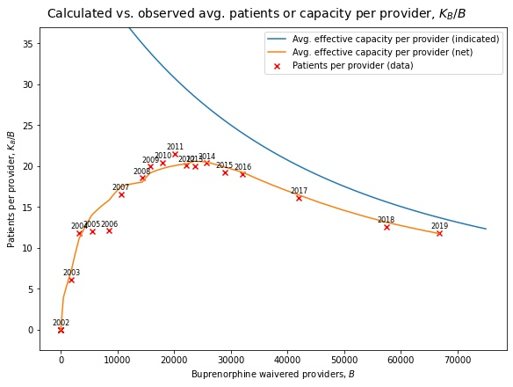

**Figure S10.** Observed patients per provider against number of waivered providers in historical data

, compared with indicated and net average effective capacity per provider in model. The indicated average effective capacity (blue) reflects the diminishing marginal capacity per waivered provider, while the net average effective capacity (orange) also incorporates the effect of the capacity rampup delay.

To our knowledge, there are no time series data available for methadone (MMT) and Vivitrol capacity (including from national treatment surveys such as N-SSATS). As such, we estimate theoretical capacity ($K_{(.)}^{*}$) based on the number of patients receiving each of these types of treatment (see S3.c.i)) divided by the capacity utilization percentages ($F_{(.)}^{TU}$) reported for each in N-SSATS:

$$\begin{aligned}K_{\left(.\right)}^{*}=\frac{T_{M}^{y}}{F_{\left(.\right)}^{TU}}, \left(.\right)∈\left\{M,V\right\}\#\left( STYLEREF 1 \backslash s 3. SEQ Equation \backslash * ARABIC \backslash s 1 8\right)\end{aligned}$$

Absent additional data, we assume the effective capacity fraction is equal to the capacity utilization percentage ($F_{(.)}^{T}=F_{(.)}^{TU}$ = 0.866 for methadone and 0.88 for Vivitrol). Note that this creates a circularity – effective treatment capacity ($K_{(.)}$) will be *exactly* equal to the number of patients receiving treatment $T_{(.)}^{y}$, resulting in an artificially perfect fit between simulated patient numbers and data as long as capacity is the binding constraint on treatment receipt in the model. This circularity can only be resolved with additional data on treatment capacity.

### Treatment duration, outcomes, and effects

#### Average treatment duration and outcomes

Average durations for buprenorphine, methadone, and Vivitrol treatment ($τ_{T(.)}$) are calculated from mean or median reported durations of treatment, weighted by sample size, in multiple studies over two decades (see S3.e)), at 0.61, 1, and 0.22 years respectively. Where studies reported only medians but not means, we approximated the mean using the approach from (Wan et al. 2014) based on either the interquartile range or minimum and maximum.

While a positive relationship between duration of retention in treatment and ‘successful’ treatment outcomes (i.e. sustained remission either in or after leaving treatment) is well-established (Connery and Weiss 2020), we identified only one study that actually reports 1) what fraction of treatment patients leave treatment ‘successfully’ vs. return to use disorder, 2) at various durations of treatment, and 3) how long on average each subgroup of patients remains in treatment (Eastwood, Strang, and Marsden 2017).[6]

As such, we also drew on expert estimates to quantify the relationship between duration and outcomes of treatment. Our expert panel stipulated a sigmoidal relationship, estimating a very low success rate for durations < 4 months, approximately 25-40% success at 1 year, depending on medication, and a maximum success rate of approximately 75-80% by about 5 years. Consistent with these estimates and those of (Eastwood, Strang, and Marsden 2017), we parametrise the function for *Tx success fraction* ($p_{(.)}^{R}$) to match these estimates, with $m_{R}$ = 1, $λ_{R}$ = 3.5, $κ_{R}$ = 0.85, and $p^{RM}$ = 0.8 (see 0). Note that this results in higher success rates for treatment durations < 4 months than the near-zero rates that our experts estimated; however, there is evidence that *some* success with treatment is possible even after short durations (Potter et al. 2015).

#### Effects of treatment on mortality

We express the *effect of MOUD Tx on OD death rate / non-OD death rate* ( $w_{(.)}^{TO}$/ $w_{(.)}^{TN}$) as multipliers of the respective mortality rates for people with HUD or OUD not receiving MOUD treatment.

For non-OD mortality, we calculate an average aggregate non-OD mortality rate for untreated HUD and OUD groups of 1.43 people per 100 person-years. Based on reported hazard ratios, we calculate the effect of MOUD treatment ($w_{(.)}^{TN}$) at 0.54 for buprenorphine, 0.37 for MMT, and 0.93 for Vivitrol (see S3.e)).

For the effect on OD mortality ($w_{(.)}^{TO}$), several studies report no significant difference between hazard ratios for buprenorphine and methadone. As our calculated averages for each were very close (0.301 and 0.289 respectively), we instead use a combined average effect for buprenorphine and MMT of 0.295, with an effect of 0.439 for Vivitrol (see S3.e)). Note that for simplicity, we apply these multipliers to the overdose death rate, without modifying the base overdose rate. Insofar as the reductions reflect greater likelihood of resuscitation in the event of overdose, this is accurate; insofar as they may reflect reductions in baseline overdose rates, it likely means that non-fatal overdoses are being somewhat overestimated for people in MOUD treatment. This overestimation is, however, very small in absolute terms.

### Remission

Remission from disorder is a critical part of recovery, which ideally encompasses a return to functioning, health, and quality of life (Fleury et al. 2016), though clinical remission is more narrowly defined as people who have had no symptoms of a substance use disorder for at least one year (American Psychiatric Association 2013). The estimated millions of people who are in opioid use disorder remission (J. F. Kelly et al. 2017) reflect the history of the crisis. They are both a potential role model and source of hope for others, and also remain at risk of relapse themselves.

We found no reliable time series data on size of populations in remission, and so remission is excluded from our panel of time-series data used in model estimation. Nevertheless, their inclusion in the model is important, and indeed model performance is improved when this group is retained rather than allowed to disappear from the system.

Initial values for remission stocks (RR, RO, RH, RRS, ROS, RHS) are estimated using findings from various papers analysing NESARC Waves I and II (see S3.e)). Once people enter remission, they are no longer distinguished by their treatment history. This distinction could be made in future iterations of the model, if data become available on rates of relapse after remission by treatment history and type.

Note that though remission does not require abstinence, NSDUH does not identify people who report non-disordered use who are in remission from use disorder. Due to this lack of data, and to reduce model complexity, we do not represent non-abstinent remission (which would entail non-disordered use) as a separate state, nor do we capture flows of people from UD states into non-disordered use states. As a result, NSDUH respondents who report non-disordered use while in remission will be counted in the corresponding non-disordered use population counts ( $M^{y}$ or $N^{y}$).

Remission via MOUD is a function of duration in treatment (see 0). We estimate the hazard rates of remission without MOUD (*remission rate… no MOUD Tx*, $ρ_{UR(.)}$) for people with HUD and for people with Rx OUD as part of the main model estimation process.

After four years on average in the remission stocks, people transition to stable remission (RSR, RSO, RSH), after which they are no longer at risk of relapse or overdose death. Evidence indicates that the risk of return to use disorder typically drops considerably after an average total of five years in remission (Hser et al. 2015; DuPont, Compton, and McLellan 2015). We therefore set the *time to stabilize remission* ($τ_{RS}$) at 4 years (4 + 1 year already in remission by definition for the remission stocks = 5 years total).

## Overdoses, naloxone, and synthetics

### Overdose mortality data

We use annual multiple cause of death mortality data from CDC’s National Vital Statistics System (NVSS) to estimate overdose death flows (o(.)). The records in the NVSS microdata provide information on all deaths occurring within the United States, and each underlying cause of death is coded according to the International Classification of Diseases (ICD) classification system, Tenth Revision (ICD-10) (NVSS and Centers for Disease Control and Prevention (CDC) 2021).

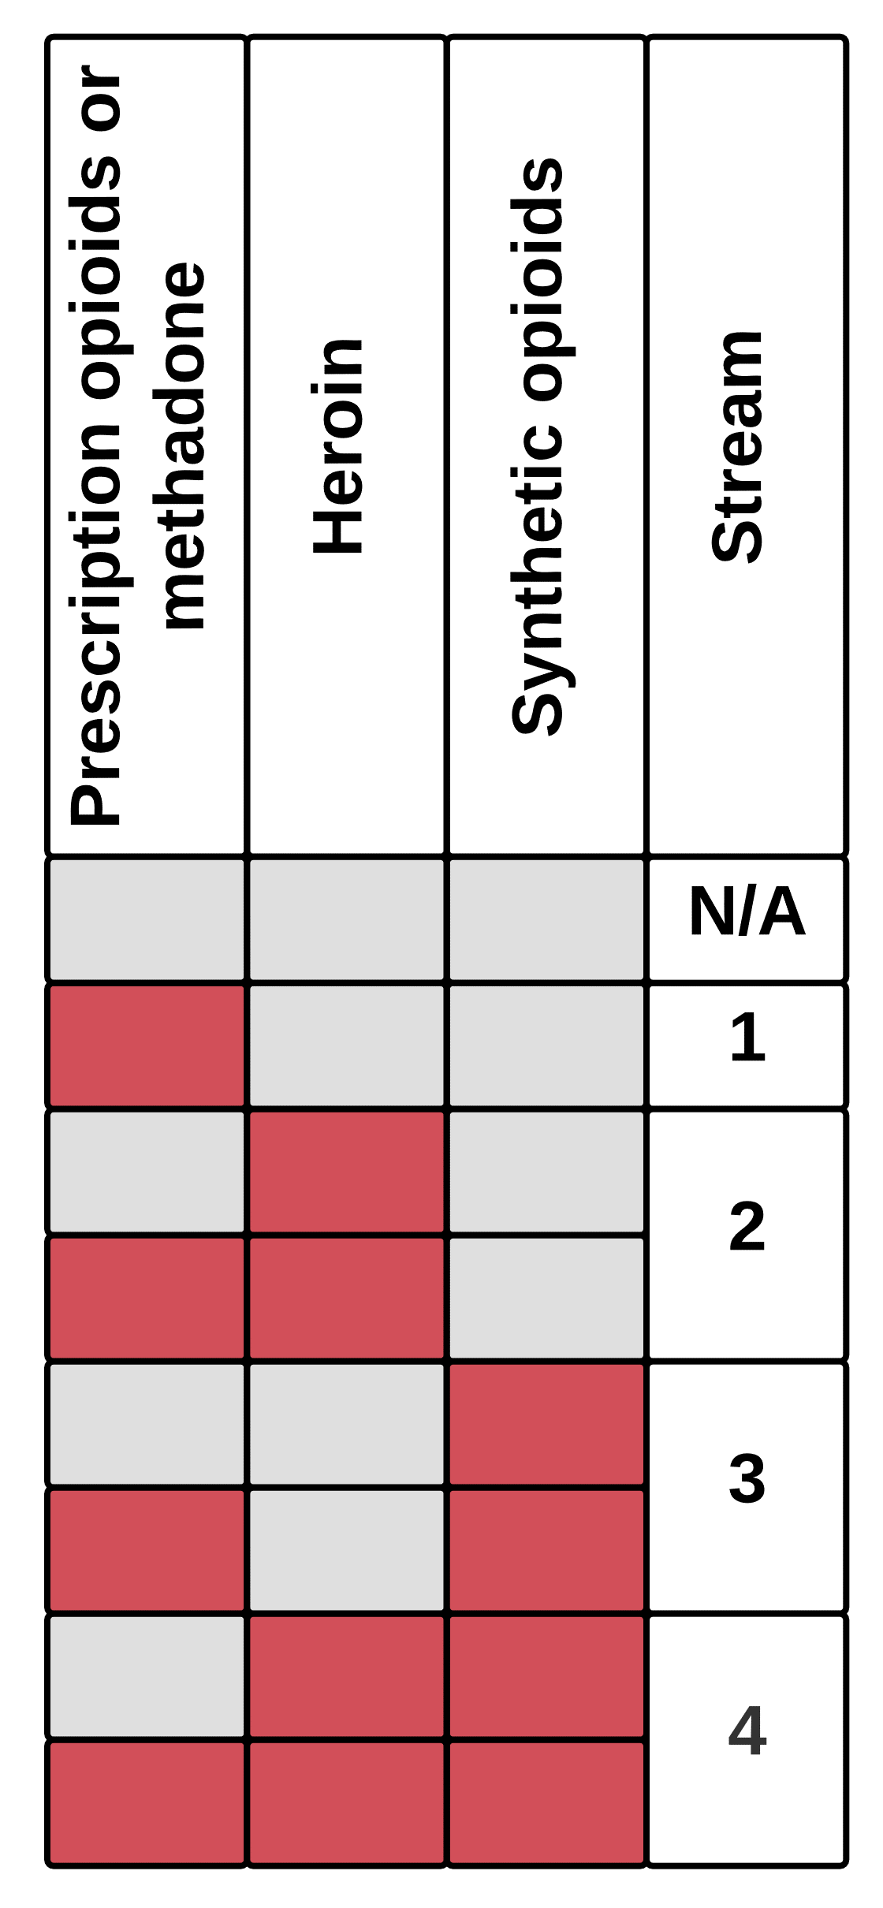

**Figure S11:** Allocation of overdose mortality by MECE categories to model data streams.

Red indicates that a drug class is reported as involved in a death, and grey indicates it is not.

We identified all drug-related fatal overdoses in NVSS mortality data using the following ICD-10 underlying cause of death codes: X40–X44, X60–X64, X85, or Y10–Y14. Among these records, we identified opioid-involved fatal overdoses by type[s] of opioid, using the following ICD-10 codes: prescription opioids or methadone (T40.2 or T40.3), heroin (T40.1), synthetic opioids other than methadone (T40.4), and unspecified opioids (T40.6) (Wilson et al. 2020). We group these records into a set of mutually exclusive and collectively exhaustive combinatorial categories, which we then aggregate into four streams of annual deaths (see **Figure S11**) involving:

1. Prescription opioids or methadone, but *not* heroin or synthetics
2. Heroin but *not* synthetics, possibly involving prescription opioids or methadone
3. Synthetics but *not* heroin, possibly involving prescription opioids or methadone
4. Synthetics *and* heroin, possibly involving prescription opioids or methadone

Deaths involving only unspecified opioids are allocated in proportion to the size of these four categories each year. These four death data streams are read into the model to estimate overdose death flows.

The NVSS data identify overdose deaths by the substance[s] involved, e.g., Rx opioids only, Rx opioids + heroin, heroin + synthetic opioids, synthetic opioids only, and so on. This creates a fundamental limitation – deaths are identified by the substance[s] involved in the last use episode[s] before death, not by the use *behaviour* that the decedent primarily engaged in, but [OSM] classifies people by usebehaviour (e.g., Rx OUD vs. HUD). We allocate deaths involving a given substance to the user group[s] which primarily use that substance, recognising that this is a substantial simplifying assumption. People with Rx misuse or Rx OUD with or without heroin use (M, UR, UO) are assumed to contribute to Rx overdose deaths, while people with non-disordered heroin use or HUD (N, UH) contribute to heroin deaths.

### Synthetic death allocation structure

Synthetic-involved deaths present an additional challenge. We do not explicitly identify synthetic users. Most synthetic use, especially since ~2013, involves illicitly manufactured synthetics that have entered the drug supply, whether as an adulterant in or replacement for heroin, or possibly in the form of counterfeit prescription pills. Unfortunately, the CDC data (or any overdose death data to our knowledge) do not distinguish between prescription and illicitly manufactured synthetics.

Prior to ~2013, the vast majority of synthetic-involved deaths involved *only* synthetics, without other Rx opioids or heroin. All available evidence indicates that widespread fentanyl contamination of both pill and powder drug supplies only occurred after 2013 (Ciccarone 2017; Drug Enforcement Administration Diversion Control Division 2017a, 2017b). We therefore assume that a small fraction of synthetic-involved deaths pre-2013 (specifically, those with co-reported heroin + synthetics) may have been due to low-level penetration of fentanyl in the illicit/powder drug supply (including a small but notable spike in 2005-2006 (Drug Enforcement Administration Office of Diversion Control 2008; Algren et al. 2013)), but that the vast majority of synthetic-involved deaths at the time (i.e. those with no co-reported heroin) were due to intentional misuse of prescription fentanyl. This separation allows us to estimate the baseline rate of overdose due to prescription fentanyl ($β_{R}^{S}$), which we assume affects people with Rx OUD (Mrvos et al. 2012; Jumbelic 2010).

Using $β_{R}^{S}$ based on pre-2013 data, we can then separate synthetic-involved overdose deaths after 2013 into two streams:

1. a ‘base’ stream driven by intentional prescription synthetic use (without co-reported heroin), and
2. an ‘excess’ stream that combines
   1. synthetic deaths without co-reported heroin, less the projected base stream, presumably driven by largely unintentional use of illicitly manufactured fentanyl, with
   2. all synthetic deaths with co-reported heroin, driven by contamination of the heroin supply.

The latter two streams collectively account for the excess deaths attributable to fentanyl penetration through its effects on the process of overdose death (see S2.d.iii.(3)), which allows estimation of the effect sizes involved.

Note that we combine heroin deaths and excess synthetic deaths into a single stream for purposes of model estimation (see S4.b) for details).

### Fentanyl penetration

We calculate a time series of fentanyl prevalence (*fentanyl penetration curve*, $ϕ$) using data from the National Forensic Laboratory Information System (NFLIS). NFLIS aggregates the number of reports of various drugs from forensic analyses of substances seized by law enforcement. We calculate $ϕ$ as the fraction of reports involving fentanyl or its analogues out of the total reports of heroin or fentanyl & analogues each year:

$$\begin{aligned}ϕ=\frac{Reports of fentanyl \& analogues}{\left(Reports of heroin+ Reports of fentanyl \& analogues\right)} \#\left( STYLEREF 1 \backslash s 3. SEQ Equation \backslash * ARABIC \backslash s 1 9\right)\end{aligned}$$

Note that some portion of the reports of fentanyl & analogues may actually involve prescription fentanyl rather than illicitly manufactured fentanyl, as well as fentanyl pressed into counterfeit prescription pills as opposed to in powder form (see S2.d.iii.(3)). NFLIS data do not disambiguate reports by form or source, only substance. Because we cannot exclude these reports, $ϕ$ is almost certainly an overestimate of powder-form, illicitly manufactured fentanyl as a fraction of heroin + fentanyl *reports*. However, several studies point to fentanyl exposure among heroin users being at least as great as indicated in NFLIS, if not much higher – at least 50% by 2017 (Carroll et al. 2017; Macmadu et al. 2017; Sherman et al. 2019; Meacham et al. 2020; Scholl et al. 2019; J. N. Park et al. 2018). We therefore do not think the overestimation of $ϕ$ due to prescription fentanyl or counterfeit prescription pills is of substantial concern.

### Naloxone distribution

#### Total kits distributed

We approximate total naloxone distributed using two data sources, corresponding to the two main channels by which naloxone kits enter the community – distribution through harm reduction and other community programs, and pharmacy purchases.

We calculate the former using the only published national data on naloxone kit distribution through community programs (Wheeler et al. 2015, 2012; Wheeler and Doe-Simkins 2020). These reports provide annual estimates of kits distributed for three years (2009, 2013, 2019). We extrapolate to other years from these data points using the annual percentage growth in programs and estimates reported in these three years. Note that after mid-2014, the only publicly available data are on *injectable* naloxone kits (i.e., not Narcan®) distributed by the OSNN naloxone buyer's club (Wheeler and Doe-Simkins 2020), a different sample of harm reduction programs than is reported on in 2012 and 2015.

For naloxone purchased in pharmacies, we use IQVIA NPA® data (see S3.b.i)) on prescriptions for naloxone filled in outpatient pharmacies (retail and mail-order).

These naloxone distribution totals do not include naloxone distributed to EMS, which are not reflected in sales data and for which, to our knowledge, time series data are not available at the national level. Naloxone is useful but not usually necessary for successful EMS intervention (Belz et al. 2006) (see S2.d.iii.(2)), so for simplicity, we do not include EMS naloxone use in the current version of the model.

#### Naloxone kit allocation

Kits are not distributed equally between people who use prescription opioids vs. heroin (D. Raymond 2020, pers. comm., 20 Aug), though we do not have a direct estimate of what fraction of kits go to heroin users ($F^{NH}$) vs. prescription opioid users, or more precisely, to people most likely to witness heroin user overdoses vs. prescription opioid user overdoses (e.g., including friends & family).

In order to estimate $F^{NH}$, we calculate the fraction of naloxone utilisation events involving heroin vs. prescription opioid overdoses, based on the total overdoses of each type multiplied by $p_{W}p_{IB(.)}$. We anchor the estimate of $F^{NH}$ using a prior value (see S4.a.ii)) for the fraction of utilisation events involving heroin overdoses. We calculate at this fraction at 86% based on the fraction of naloxone reversals reported to harm reduction programs involving heroin or something other than prescription opioids (Wheeler et al. 2015).

#### Naloxone distribution efficiency

We derive the functional form for *probability Nx bystander*…, $p_{IB(.)}$ (see S2.d.iii.(2)) based on data from (Irvine et al. 2020), which is the only estimate to our knowledge of how naloxone distribution affects probability of utilisation in the event of overdose. (Irvine et al. 2020) reports the probability of naloxone utilisation in witnessed overdoses across 12 US states as a function of naloxone kits distributed per 100,000 population. It also reports partial data on how probability of naloxone utilisation varies by distribution channel (standing order vs. prescription vs community distribution, though these data are insufficient to derive separate functions. An exponential function fits well with both the aggregated and disaggregated data reported.

Note that given the data available on total naloxone kits distributed (see above), this function results in naloxone kit utilisation fractions consistent with existing estimates from literature, which finds that 6-13% of all kits distributed are used (see S3.e)).

### Intervention Probabilities

We calculate *probability OD witnessed* ($p_{W}$) as the weighted average of the proportion of nonfatal overdoses that have been reported as witnessed (76.4%) across six studies (see S3.e)). Note that most of the data for this estimate come from older studies, as newer studies tend to report only the fraction of fatal overdoses that are witnessed. Conditioning on overdose fatality skews the reported probability compared to the unconditional probability ($p_{W}$), as whether an overdose is witnessed changes the net probability of death. Because the vast majority of overdoses are nonfatal, conditioning on overdoses being non-fatal results in less skew than conditioning on fatal overdoses, which are less likely to have been witnessed (41.1% weighted average; see S3.e)). In the absence of studies reporting aggregate witnessing probabilities for both fatal and nonfatal overdoses, we therefore use those with samples limited to the latter.

We calculate *probability of calling emergency services* ($p_{IE}$) in the event of a witnessed overdose using the weighted average from 31 studies that reported the fraction of all events witnessed during which the witness or someone else present called emergency services, yielding $p_{IE}$ = 42.4% (see S3.e)). Most studies included people who use drugs, though some also included e.g. friends and family members. Note that several studies were of people who had been trained in the use of naloxone, but at witnessed overdoses they reported only using naloxone and not also calling emergency services. Some evidence suggests possession of naloxone reduces the likelihood of calling emergency services (Koester et al. 2017), but we do not account for this potential interaction effect.

## Literature sources for parameter estimates

Various parameters in the model are synthesised from multiple studies following extensive literature searches. As a general rule, we sought to use multiple and diverse sources to compensate for the potential non-representativeness of study populations. Calculations and explanations for each parameter are described in the relevant sections above. Literature sources used are summarised in **Table S7**.

**Table S7.** Literature sources for parameter estimates

|  |  |  |  |
| --- | --- | --- | --- |
| **Parameter name** | **Parameter symbol** | **Parameter value** | **Sources** |
| Average duration for buprenorphine | $$τ_{TB}$$ | 222.3 days, 0.61 years | (Proctor et al. 2014; Mintzer et al. 2007; Khemiri et al. 2014; Tierney et al. 2019; Lee et al. 2018; Clark et al. 2015; Lo-Ciganic et al. 2016; Bell 2009; Saloner et al. 2018; Hser et al. 2016; Bhatraju et al. 2017; Samples et al. 2018; Clay et al. 2014; Manhapra et al. 2018; Bell and Mutch 2006; Hickman et al. 2018; Saloner, Daubresse, and Alexander 2017; Gryczynski et al. 2019; Robertson et al. 2018; Morgan et al. 2018; Shcherbakova et al. 2018; Hadland et al. 2018) |
| Average duration for methadone | $$τ_{TM}$$ | 365 days, 1 year | (Amiri et al. 2018; Bell and Mutch 2006; Hickman et al. 2018; S. M. Kelly et al. 2011; Reisinger et al. 2009; Nosyk et al. 2009; Robertson et al. 2018; Strain et al. 1999; Clark et al. 2015; Proctor et al. 2014; Hadland et al. 2018; Bell 2009; Hser et al. 2016) |
| Average duration for injectable naltrexone (Vivitrol) | $$τ_{TV}$$ | 82.4 days, 0.23 years | (Saxon et al. 2018; Krupitsky et al. 2013; Chang et al. 2018; Murphy et al. 2019; Lee et al. 2018; Morgan et al. 2018) |
| Average aggregate non-OD mortality rate for untreated OUD and HUD groups |  | 1.43 per 100 person-years | (Degenhardt et al. 2011; Sordo et al. 2017; Kelty and Hulse 2017; Kelty, Joyce, and Hulse 2019; Bahji et al. 2019; Ma et al. 2019) |
| Buprenorphine-waivered providers | $$B$$ |  | (Stein et al. 2015; C. M. Jones et al. 2015; HHS 2016; Congressional Research Service 2018; SAMHSA 2020) |
| Effect of MOUD treatment on non-OD mortality | $$w_{B}^{TN}$$ | 0.54 | (Degenhardt et al. 2019; Morgan et al. 2019; Bahji et al. 2019; Larochelle et al. 2018; Ma et al. 2019; Sordo et al. 2017; Kelty and Hulse 2017; Kelty, Joyce, and Hulse 2019) |
| Effect of MOUD treatment on non-OD mortality | $$w_{M}^{TN}$$ | 0.37 | (Bahji et al. 2019; Larochelle et al. 2018; Degenhardt et al. 2019; Ma et al. 2019; Sordo et al. 2017; Kelty and Hulse 2017; Kelty, Joyce, and Hulse 2019; Morgan et al. 2019) |
| Effect of MOUD treatment on non-OD mortality | $$w_{V}^{TN}$$ | 0.93 | (Bahji et al. 2019; Larochelle et al. 2018; Degenhardt et al. 2019; Ma et al. 2019; Sordo et al. 2017; Kelty and Hulse 2017; Kelty, Joyce, and Hulse 2019; Morgan et al. 2019) |
| Effect of MOUD treatment on OD mortality | $w_{B}^{TO}$, $w_{M}^{TO}$ | 0.295 | (Bahji et al. 2019; Larochelle et al. 2018; Degenhardt et al. 2019; Ma et al. 2019; Sordo et al. 2017; Kelty and Hulse 2017; Kelty, Joyce, and Hulse 2019; Morgan et al. 2019) |
| Effect of MOUD treatment on OD mortality | $$w_{V}^{TO}$$ | 0.439 | (Bahji et al. 2019; Larochelle et al. 2018; Degenhardt et al. 2019; Ma et al. 2019; Sordo et al. 2017; Kelty and Hulse 2017; Kelty, Joyce, and Hulse 2019; Morgan et al. 2019) |
| Initial value for remission stocks | RR, RO, RH, RRS, ROS, RHS |  | (Wu et al. 2011; Compton et al. 2007; Grella et al. 2009; Hoffman, Vilsaint, and Kelly 2019; Martins et al. 2017) |
| Naloxone kit utilization fraction |  | 6-13% | (Galea et al. 2006; Katzman et al. 2020; Doe-Simkins et al. 2009; Enteen et al. 2010; Tobin et al. 2009; Strang et al. 2008; P. Leece et al. 2016; Yokell, Bowman, and Alpert 2011; Banjo et al. 2014; P. N. Leece et al. 2013; Gaston et al. 2009; Wheeler et al. 2015) |
| Probability OD witnessed | $$p_{W}$$ | 76.4% | (Darke and Zador 1996; Mcgregor et al. 1998; Strang J et al. 1999; Sergeev et al. 2003; Tobin, Davey, and Latkin 2005; Bohnert, Tracy, and Galea 2012) |
| Probability fatal OD witnessed |  | 41.1% | (Ogeil et al. 2018; Levy et al. 2016; Mattson et al. 2018; J. O’Donnell et al. 2020; Somerville et al. 2017) |
| Probability of calling emergency services | $$p_{IE}$$ | 42.4% | (Davidson et al. 2002; Seal et al. 2003; Sergeev et al. 2003; Seal et al. 2005; Bohnert, Tracy, and Galea 2012; Tracy et al. 2005; Bohnert, Tracy, and Galea 2009; Tobin, Davey, and Latkin 2005; Pollini et al. 2006; Sherman et al. 2008; Tobin et al. 2009; Walley et al. 2013; Bennett et al. 2011; Doe-Simkins et al. 2009; Best et al. 2009; Wagner et al. 2010; Doe-Simkins et al. 2014; Lim et al. 2019; Lankenau et al. 2013; Rowe et al. 2015; Dwyer et al. 2015; P. Leece et al. 2016; Wagner et al. 2015; Schiavon et al. 2018; Ataiants et al. 2020; Schwartz et al. 2020; Galea et al. 2006; Enteen et al. 2010; Levy et al. 2016; Banjo et al. 2014; Gaston et al. 2009) |

## Expert consultation process

We developed [OSM]’s structure through an extensive process of iterative consultation with subject-matter experts. In accordance with established best practices in model development (Martinez-Moyano and Richardson 2013), initial model development involved close engagement with client groups, consultations with subject-matter experts, and extensive review of existing literature, especially the few other models of the crisis extant at the time (Pitt, Humphreys, and Brandeau 2018; Wakeland, Nielsen, and Geissert 2015). As part of this process, we interviewed 22 subject-matter experts within and outside the federal government, including clinicians, epidemiologists, and addiction and harm reduction experts. Initial development focused on identifying main feedbacks and areas of operational importance, while establishing a simulating (but not yet quantified) model structure. This stage of development lasted approximately nine months.

We then iteratively refined the model through 30 meetings with an expert working group that included five clinicians and addiction experts and three modelling consultants, as well as nine additional meetings with other individual subject-matter experts. These discussions addressed issues such as the causal structure of important phenomena, expert estimates of various parameters, and questions of data interpretation, as well as testing and evaluation of model estimates and behaviour. Along with primary quantification, this process of model refinement took approximately 15 months.

# Model Estimation

## Overview

[OSM] is a nonlinear and complex model, which makes finding an estimation framework with clean, closed-form analytical solutions highly challenging and unlikely. Instead, we estimate the model by maximum likelihood (Struben, Sterman, and Keith 2015), using a Gaussian likelihood function to fit simulated time series to historical data, as well as a penalty term on a small number of point observations of certain key ratios.

The model can be thought of as a deterministic system of ordinary differential equations, with some set of unknown parameters (as well as known ones specified based on literature, expert estimates, etc., and exogenous time-series inputs). To avoid over-fitting, we do not use any time-varying parameter inputs (Basu and Andrews 2013), instead relying on endogenous feedbacks captured in the model structure to generate observed dynamics.

The maximum likelihood estimation framework identifies the most likely value for each unknown parameter, given the historical data. We combine this with a Markov Chain Monte Carlo (MCMC) simulation approach (Vrugt et al. 2009; Osgood and Liu 2015) to identify the credible regions of parameter space and quantify uncertainties in parameter estimates and projections. We describe a synthetic data validation procedure aimed at building confidence in the estimation framework in S4.e).

### Likelihood function for historical data

The model generates simulated expected values for several time series variables, such as populations in several use states and various transition flows between states (see **Table S8** for full listing of time series used in estimation). Let $μ_{it}$ represent simulated values for variable $i$ at time $t$, while $y_{it}$ represents the corresponding observed historical data points. With $θ$ as the vector of unknown model parameters, we can summarise the model as a function *f* that yields predicted values for $μ_{it}$ given $θ$ as well as a set of exogenous time-series inputs $x_{jt}$ (for variables *j* e.g. prescribing rates, naloxone distribution; see **Table S8** and S3) for details):

$$\begin{aligned}μ_{it}=f\left(θ,x_{jt}\right) \#\left( STYLEREF 1 \backslash s 4. SEQ Equation \backslash * ARABIC \backslash s 1 1\right)\end{aligned}$$

We use a Gaussian (log-) likelihood function to specify the likelihood of observing $y$ values given $θ$ and $x$ (which result in predictions $μ$):

$$\begin{aligned}LT\left(y_{it}|θ,x_{it}\right)=\sum_{it}{-\frac{{\left(μ_{it}-y_{it}\right)}^{2}}{2{ω_{i}}^{2}}-\ln\left(ω_{i}\right)} \#\left( STYLEREF 1 \backslash s 4. SEQ Equation \backslash * ARABIC \backslash s 1 2\right)\end{aligned}$$

Summing the log-likelihood function over variables $i$ and times $t$ yields the full log-likelihood for observed data given a specific parameterisation and set of time-series inputs. The Gaussian function includes a set of scale para meters or calibration weights for each $i$ variable ($ω_{i}$), which we approximate with the standard deviations of the corresponding observed time series $y_{it}$. These weight variables account for differences in the underlying magnitude and variability of the different time series used. Note that this estimation approach assumes i.i.d. error terms; it may therefore result in overly narrow credible intervals on the resultant parameter estimates (see S4.e)).

### Penalty terms for key point observations

In addition to the likelihood value for observing historical data series, we also calculate a penalty term for certain key ratios and other point observations $k$ (see **Table S9**). These penalty terms represent priors derived from literature estimates, expert judgment, or limited datasets, which we incorporate to provide some constraint on the estimation process:

$$\begin{aligned}LP\left(y_{kt}|θ,x_{jt}\right)=-\sum_{kt}{\frac{{\left(μ_{kt}-y_{kt}\right)}^{2}}{2{ω_{k}}^{2}}} \#\left( STYLEREF 1 \backslash s 4. SEQ Equation \backslash * ARABIC \backslash s 1 3\right)\end{aligned}$$

Here $y_{kt}$ represents the prior expected values for $k$ defined over specified time periods, which are compared against the model-generated values $μ_{kt}$. The scaling parameter $ω_{k}$ represents the pre-specified allowable deviation of $k$ values from their prior expected values.

While the selection of key observations $k$ and their prior expected values $y_{kt}$ and allowable variance $ω_{k}$ are guided by existing data, there is inevitably an element of subjectivity in their selection. Such subjectivity, however, is not disqualifying. There is a degree of subjective judgment involved in any modelling endeavour, from problem definition to model specification to the estimation process, and indeed in all scientific endeavour in the first place. Incorporating priors in this manner allows us to inject valuable information into the estimation process without constraining it more than the quality of said information warrants. Absent the use of priors, we would either have to discard the informational value of these data points, or build them into hard constraints on parameters or fixed assumptions, neither of which seems like a desirable alternative. Instead, therefore, we aim to present the use of these assumed priors in a transparent manner while also validating the estimation procedure where possible (see S4.e)). Comparison of the model’s simulated key observations $k$ and their prior expected values $y_{kt}$ are presented in S5.b), **Table S12**.

## Data used in estimation

**Table S8** summarises the panel of time series data used in model estimation, whether as observed targets for model fitting $y_{it}$ or as exogenous input variables $x_{jt}$. Sources and adjustments for these data are detailed in S3).

**Table S8.** Panel of time-series data used in model estimation

|  |  |  |  |
| --- | --- | --- | --- |
| **Time series** | | **Source** | **Model variable[s]** |
| Observed data / calibration targets $y_{it}$ | Rx misuse no PY heroin | NSDUH | $$M$$ |
| Nondisordered heroin use | NSDUH | $$N$$ |
| Rx OUD no PY heroin | NSDUH | $$\sum_{(.)}{U_{R}+(1-F_{\left(.\right)}^{R})T_{R(.)}}, (.)∈\left\{B, M, V\right\}$$ |
| Rx OUD with PY heroin | NSDUH | $$\sum_{(.)}{U_{O}+(1-F_{\left(.\right)}^{R})T_{O(.)}}, (.)∈\left\{B, M, V\right\}$$ |
| HUD | NSDUH | $$\sum_{(.)}{U_{H}+(1-F_{\left(.\right)}^{R})T_{H(.)}}, (.)∈\left\{B, M, V\right\}$$ |
| Total buprenorphine patients | Various | $$\sum_{(.)}{T_{\left(.\right)B}}, (.)∈\left\{R, O, H\right\}$$ |
| Initiating Rx misuse own Rx | NSDUH | $$r_{MI}$$ |
| Initiating Rx misuse diverted | NSDUH | $$r_{MD}$$ |
| Total heroin initiation | NSDUH | $$r_{ND}+r_{MN}+r_{UO}$$ |
| Initiating heroin no Rx | NSDUH RDAS | $$r_{ND}$$ |
| Initiating heroin with Rx misuse | NSDUH RDAS | $$r_{MN}$$ |
| Initiating heroin with Rx OUD | NSDUH RDAS | $$r_{UO}$$ |
| Total overdose deaths base Rx | NVSS | $$o_{mc}+o_{M}+o_{UR}+o_{UO}+o_{TR}+o_{TO}$$ |
| Total overdose deaths synth base | NVSS | $$o_{URS}$$ |
| Total overdose deaths heroin & excess synthetics | NVSS | $$o_{UN}+o_{UH}+o_{UNF}+o_{UHF}+o_{TH}$$ |
| Total overdose deaths | NVSS | $$\sum_{(.)}{o_{\left(.\right)}}$$ |
| Exogenous inputs $x_{it}$ | Patients receiving opioid prescription | IQVIA, Symphony Health | $$m_{P}$$ |
| Prescriptions per person | Symphony Health | $$m_{N}$$ |
| Average opioid MME per prescription | IQVIA | $$m_{M}$$ |
| ADF fraction of prescribed opioids | IQVIA | $$F^{AR}$$ |
| Buprenorphine-waivered treatment providers | Various | $$B$$ |
| Methadone maintenance treatment capacity* | N-SSATS | $$K_{M}$$ |
| Vivitrol® treatment capacity* | IQVIA | $$K_{V}$$ |
| Naloxone kits distributed | IQVIA, various | $$ν_{T}$$ |
| Heroin price index (1999 = 1) | UNODC, STRIDE | $$1/{D_{AH}}$$ |
| Fentanyl penetration | NFLIS | $$ϕ$$ |

**Table S9.** Point data used as priors $y_{kt}$ in model estimation

|  |  |  |  |  |
| --- | --- | --- | --- | --- |
| **Prior** | **Model variable[s]** | **Year** | **Value** | **Source** |
| Nonfatal OD ratio Rx | $$\sum_{(.)}{\frac{η_{R\left(.\right)}}{ω_{R\left(.\right)}}}$$ | < 2013 | 35 | (Darke, Mattick, and Degenhardt 2003; Neale 2003) |
| Nonfatal OD ratio heroin | $$\sum_{(.)}{\frac{η_{H\left(.\right)}}{ω_{H\left(.\right)}}}$$ | < 2013 | 30 | (Darke, Mattick, and Degenhardt 2003; Neale 2003) |
| Bup demand fulfilment ratio | $$\frac{r_{UTB}}{r_{UTB}^{*}}$$ | 2018 | 0.587 | (Beetham et al. 2019) |
| Probability Nx bystander heroin | $$p_{IBH}$$ | 2019 | 0.2 | Expert judgment |
| Nx utilization events H user fraction | $$\frac{\sum_{(.)}{{(n+o)}_{H\left(.\right)}p_{W}p_{IBH}}}{p_{W}\sum_{(.)}{\left({(n+o)}_{H\left(.\right)}p_{IBH}+{(n+o)}_{R\left(.\right)}p_{IBR}\right)}}$$ | 2013 | 0.86 | (Wheeler et al. 2015) |
| Rx OUD in remission total | $$\sum_{(.)}{R_{R\left(.\right)}+R_{O\left(.\right)}}, (.)∈\left\{B, M, V\right\}$$ | 2013 | 1521920 | (Saha et al. 2016; Hoffman, Vilsaint, and Kelly 2019) |
| HUD in remission total | $$\sum_{(.)}{R_{H\left(.\right)}}, (.)∈\left\{B, M, V\right\}$$ | 2013 | 596174 | (Hoffman, Vilsaint, and Kelly 2019; Martins et al. 2017) |
| HUD in stable remission total |  | 2013 | 345,649 | (Hoffman, Vilsaint, and Kelly 2019; Martins et al. 2017) |
| Rx OUD in stable remission total |  | 2013 | 882,376 | (Saha et al. 2016; Hoffman, Vilsaint, and Kelly 2019) |

## Iterative estimation procedure

With 53 estimated parameters and an additional 20 initial stock corrections, the model is sizeable, but not so large as to make searching the full parameter space computationally impractical. Nonetheless, to speed up the estimation process, we use a multi-step iterative procedure (**Figure S12**), estimating partial models first (J. B. Homer 2012) in order to converge on the most likely region of parameter space before estimating the full parameter vector simultaneously. The goal of this process is first to identify the location in parameter space of the global peak in the likelihood surface, i.e. the most likely parameter set given the data and model structure, and second to define the credible region or hypervolume in parameter space around that maximum-likelihood peak. All steps prior to 7) use the Powell direction search method implemented in Vensim™ simulation software.

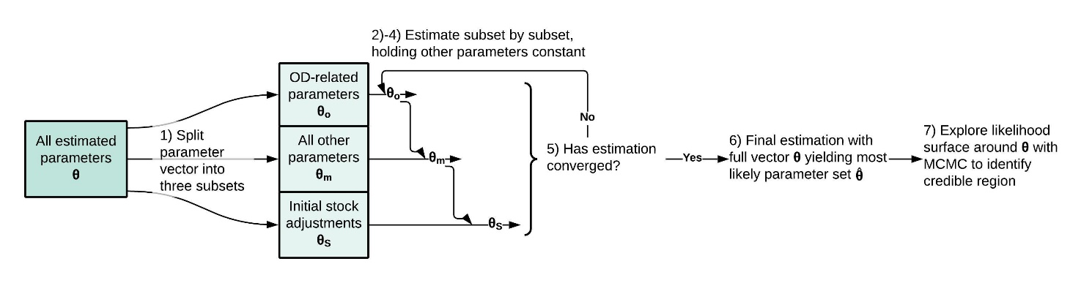

**Figure S12.** Overview of iterative estimation procedure.

1. We split the parameter vector $θ$ and the set of data variables used in calibration $y_{it}$ into a few subsets. Specifically, we define $θ_{o}$ as the subset of parameters that directly affect overdose death risks (as explained in S2.d.iii)), with $y_{ot}$ being the data variables directly tracking overdose deaths; we also define $θ_{S}$ as the subset of *initial stock correction* parameters ($m_{0(.)}$), explained further below. Remaining parameters (excluding $θ_{o}$ and $θ_{S}$) we define as $θ_{m}$.
2. We first estimate only the subset of parameters $θ_{o}$ that directly affect overdoses, to maximise the likelihood of observing $y_{ot}$, holding all other parameters constant at their previous best-estimate values. The first time we perform this step during each estimation process, overdose deaths are calculated using exogenous data values $y_{(.)t}$ for all drug user stocks; subsequently, we use endogenously generated stock values. This is in effect a partial model calibration aimed at matching just the overdose death data using only overdose-related parameters. With 11 overdose-related parameters included in this step out of 53 estimated parameters total, it helps to narrow down the plausible range of parameter space.
3. Next we estimate only $θ_{m}$, using the full set of target data $y_{it}$, holding $θ_{o}$ constant at the values estimated in step (2).
4. Next we estimate only the initial stock correction parameters $θ_{S}$, using the full set of target data $y_{it}$, holding $θ_{o}$ and $θ_{m}$ constant at previously estimated values. The initial stock corrections modify the baseline initial stock values ($S_{(.)0}^{*}$), which are derived from values of data at the initialisation of the run in 1999:

$$\begin{aligned}S_{\left(.\right)0}=m_{0\left(.\right)}S_{\left(.\right)0}^{*} \#\left( STYLEREF 1 \backslash s 4. SEQ Equation \backslash * ARABIC \backslash s 1 4\right)\end{aligned}$$

$$\begin{aligned}S_{\left(.\right)0}^{*}=y_{\left(.\right)0} \#\left( STYLEREF 1 \backslash s 4. SEQ Equation \backslash * ARABIC \backslash s 1 5\right)\end{aligned}$$

The correction parameters are necessary to allow initial stock values to differ from the first observed data points. These first data points ($y_{(.)0}$) are not inherently any more accurate than any other values for these stocks observed in the data ($y_{(.)t}$), and are equally subject to random variation like process noise and measurement error. The estimation process accounts for such randomness over time; however, using the first data points directly as the initial stock values would effectively over-weight those first points, asserting that the random variation contained in their values is of zero magnitude. The initial stock corrections ($m_{0(.)}$) provide a means to avoid this problem, giving the first data points the same importance as any others.

1. We iterate through steps (2)-(4), each time holding constant the parameter subsets ($θ_{o}$, $θ_{S}$, $θ_{m}$) not being estimated in the current step at their last-estimated values, until the iterations cease to offer significant improvement (approx. 0.05% of total log-likelihood) when compared at step (3). At that point, we assume the estimation has converged to close to the optimal parameter set, speeding the subsequent steps. Step (4) is repeated one more time before moving on.
2. We conduct a full optimization using the complete parameter vector $θ$ and comparing the full set of time-series data $y_{it}$, starting from the parameter values estimated in the last iteration in step (5). This full optimization locates the exact peak in the full likelihood landscape, which corresponds to the best-fit maximum likelihood parameter set $\hat{θ}$ for the full model.
3. Finally, we carry out an MCMC simulation to explore the likelihood surface in parameter space around $\hat{θ}$. We use an MCMC algorithm designed for exploring high-dimensional parameter spaces using differential evolution with self-adaptive randomised subspace sampling (Vrugt et al. 2009). We use an extensive burn-in period of 1500000 MCMC samples, by which point the MCMC chains yield stable outcomes (Gelman-Rubin PSRF < 1.1 for 93.0% and < 1.2 for 98.1% of chains) (Gelman and Rubin 1992); we then continue the MCMC to sample a further 1000000 outcomes, and then randomly take a subsample of 5000 of those 1000000 sampled points to use for sensitivity analyses and projections (see S6)). We also use this subsample to derive 90% credible intervals for parameter estimates.

This process is automated using a Python script that controls the simulation software (Vensim). We conduct the analysis using a parallel computing feature of Vensim on a multi-core Windows machine. Full analysis code is available online at [LINK].

## Quantifying uncertainties

### Credible intervals for parameter estimates

Estimated parameters can have interacting effects on the total likelihood and overall fit of the model to observed data. Maximum likelihood parameter estimates are therefore not independent, but should be thought of as a parameter set $\hat{θ}$. Similarly, the MCMC simulation explores the high-likelihood credible *region* of parameter space, producing a sample or subsample of credible parameter *sets*. This credible region provides a more meaningful quantification of uncertainty in parameter estimates than univariate ranges, which are in effect the projections of the credible region onto each parameter’s axis. We therefore utilise the MCMC subsample of credible parameter sets for projections and sensitivity analyses, detailed below.

However, reporting a high-dimensional credible region is impractical and difficult to present meaningfully. For transparency, we report here the univariate 90% credible intervals for each parameter (**Table S10** in S5.a)), with the caveat that there may be substantial covariation between different estimated parameters (due to e.g. compensatory effects) that the univariate intervals will miss. The full MCMC subsample that defines this region is available online at [LINK].

### Estimating measurement error

The estimation procedure identifies the region of parameter space that results in the highest likelihood of observing the data $y_{it}$ given the model $f$. The model, however, is deterministic, and does not account for random process noise nor measurement error. Model-generated predictions based on the maximum-likelihood parameter set, ${\hat{μ}}_{it}$, therefore represent expected values for observed variables $y_{it}$, rather than predictions or projections of the exact unobserved realisations of variables $i$, which will include process noise, or of observed variables $y_{it}$, which will include measurement error as well. Similarly, projections based on the credible region of parameter space around $\hat{θ}$ capture uncertainty in the expected values of observed variables, rather than the full range of uncertainty in possible trajectories for those variables, which includes the aforementioned sources of randomness.

In order to make projections that better express the range of possible trajectories, therefore, we need to account for such randomness. We do this by injecting random noise into model projections for variables $i$, with a unique realisation of this noise stream for each parameter set in the credible region used in projections or sensitivity analyses.

To parametrise the distribution of this noise term, we fit a multivariate Normal distribution to the residuals from the main model estimation process. Use of a multivariate rather than independent univariate Normal distributions is important as many of the observed variables draw on the same few data sources (e.g. NSDUH, NVSS), so there is likely to be substantial covariance in their measurement errors. On the other hand, while autocorrelation is a common issue with time-series data, the long interval between data points (1 year) relative to the speed of underlying processes means there is little autocorrelation in the residuals, with most sources of inertia in the data accounted for by model mechanisms. We therefore use noise terms without autocorrelation.

For a handful of estimated variables, there is a clear systematic bias in the temporal pattern of the residuals (see S5.b)). Reasons for these biases are largely understood and excluded from current model scope, as discussed further in S5.b). In order to accurately approximate the random, unbiased component of measurement error (and generate realistic synthetic data; see below), before fitting the noise distribution, we first detrend the residuals using a fitted 2nd-order polynomial function. We then fit the multivariate Normal distribution to the detrended residuals.

## Synthetic data validation

To build confidence in our estimation framework, we conducted a synthetic data experiment to better assess its accuracy. We generate synthetic data representing artificial ‘parallel universes’ by simulating the model with known parameter values combined with simulated measurement noise. We then attempt to recover those parameter values from the simulated data using our exact estimation framework. We can then assess how well the estimated parameters and credible intervals correspond to the known, true values.

### Data generation and estimation

To generate the synthetic data, we first randomly draw 20 parameter sets $θ^{s}$ from the MCMC subsample generated in the main model estimation process as described in S4.b). Since these parameters sets are drawn from the credible region of parameter space, they provide plausible alternatives similar but not identical to the model’s estimated most-likely parameter set $\hat{θ}$. We then simulate the model using these parameter sets, injecting ‘measurement’ noise into simulated model outputs to create realistic ‘observed’ values for data, $y_{it}^{s}$. The noise stream for each synthetic data set is randomly drawn from the same multivariate Normal distribution estimated for the residuals from the main model estimation process, as described in S4.d.ii).

The synthetic data sets thus generated are available online at [LINK].

We then estimate the model using each synthetic data set $y_{it}^{s}$ in turn, in place of observed data. We use the same set of exogenous time-series inputs $x_{jt}$ for each estimation. Estimation follows the same procedure as for the main model, described in S4.b). As with the main estimation, we start with uninformed priors on all parameters (uniform distributions with large ranges).

### Synthetic data estimation results

The synthetic data estimation process covers a total of 1460 parameters (20 synthetic data sets x (53 parameters + 20 initial s each)). In most cases, the estimation process recovers results close to the ‘true’ parameter values from the synthetic data, with the median distance between estimated and true values expressed as a percentage of the width of the estimated 95% credible interval at 30%.

Overall, estimated credible intervals contain true values at close to, but slightly under, the theoretically expected rates – the 50%, 80%, 90%, 95% and 98% CIs contain true parameter values 35%, 61%, 71%, 76%, and 80% of the time respectively (**Figure S13**). The under-fitting indicates that estimated CIs are on the whole slightly narrower than they should be, i.e. that the estimation of CIs is slightly over-confident.

The most likely driver of this overconfidence is the existence of covariance between different time series used in estimation, in both errors and expected values. The error covariance is captured in the measurement noise estimation (see S4.d.ii)) and hence the synthetic data. The estimation process, however, treats each time series used as an independent component of the likelihood function. As such, the estimation process ‘overstates’ the informational content of the time series data used in estimation (which is lowered due to covariance), resulting in overconfident i.e. overly narrow credible intervals. In addition, it is possible that there is some over-dispersion of error terms, such that an alternative likelihood function (e.g. exponential, negative binomial) may be more suitable for estimation and would yield more theoretically accurate (i.e. wider) CIs.

In light of these factors, while not perfect, the estimation process performs very well – in benchmark tests on a far simpler SEIR model, similar Gaussian maximum likelihood estimates performed far worse (<20% true values in 50% CI, and <40% in 90% CI) (Li, Rahmandad, and Sterman 2021). This result therefore gives some confidence that our estimated credible intervals, while on the narrow side, are reasonable approximations of the most likely ranges of true parameter values.

Complete results of the synthetic data estimation exercise are presented in S5.c.i).

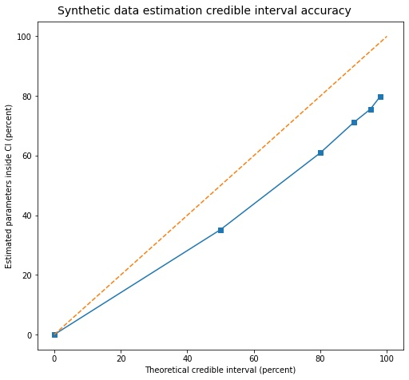

**Figure S13.** Theoretical vs. actual percentage of parameters contained within different credible intervals.

The dashed 1:1 diagonal would indicate perfect matching between theoretical and estimated CIs.

# Full Results

## Full parameter estimates

**Table S10** shows most likely values $\hat{θ}$ as well as medians and 90% credible intervals for all 53 estimated parameters and 20 initial stock value adjustments $θ$. In some cases, the most likely value falls outside the 90% credible interval. While uncommon, this is not inherently erroneous – it could for instance indicate a ‘cliff-shaped’ likelihood surface, shallow-sloped on one side of its highest point and dropping off steeply on the other.

**Table S10.** Complete list of estimated parameter values & credible intervals

|  |  |  |  |  |
| --- | --- | --- | --- | --- |
|  | Value | 0.05 | 0.5 | 0.95 |
| ADF effect strength initiating heroin with Rx OUD | 1.00E-06 | 1.00E-06 | 0.1384 | 0.59 |
| Base survival probability H OD relative to Rx | 0.9803 | 0.9713 | 0.9811 | 0.9907 |
| Base survival probability Rx OD | 0.9729 | 0.9649 | 0.9726 | 0.9771 |
| Developing HUD rate no Rx OUD | 0.1902 | 0.1008 | 0.1732 | 0.2532 |
| Developing HUD rate with Rx OUD | 0.7231 | 0.6128 | 0.7153 | 0.8182 |
| Developing Rx OUD rate | 0.03272 | 0.02688 | 0.03308 | 0.04444 |
| Fentanyl effect on base survival max relative to H | 0.639 | 0.5833 | 0.6449 | 0.7046 |
| Fentanyl effect on OD rate H max | 2 | 2 | 2.026 | 2.131 |
| Fraction Nx kits to H users | 0.9406 | 0.8875 | 0.9291 | 0.95 |
| Heroin price strength developing HUD | 1.00E-06 | 1.00E-06 | 0.04482 | 0.2084 |
| Heroin price strength initiating NDHU no Rx | 1.00E-06 | 1.00E-06 | 0.02633 | 0.1313 |
| Heroin price strength net quit NDHU | 1.688 | 1.322 | 1.692 | 1.985 |
| Initial stock correction[RXM] | 1.2 | 1.115 | 1.177 | 1.2 |
| Initial stock correction[NDH] | 1.2 | 1.145 | 1.19 | 1.2 |
| Initial stock correction[OUB] | 1.033 | 0.8 | 0.9807 | 1.195 |
| Initial stock correction[OUM] | 0.8 | 0.8 | 0.9897 | 1.2 |
| Initial stock correction[OUV] | 1.091 | 0.8019 | 1 | 1.198 |
| Initial stock correction[OUT] | 1.158 | 1.026 | 1.165 | 1.2 |
| Initial stock correction[OUR] | 1.2 | 0.8338 | 1.088 | 1.2 |
| Initial stock correction[OUS] | 0.8536 | 0.8 | 0.9853 | 1.196 |
| Initial stock correction[OHB] | 1.073 | 0.8 | 0.9199 | 1.169 |
| Initial stock correction[OHM] | 0.8 | 0.8076 | 1.051 | 1.2 |
| Initial stock correction[OHV] | 1.057 | 0.8 | 0.948 | 1.174 |
| Initial stock correction[OHT] | 1.2 | 0.8613 | 1.106 | 1.2 |
| Initial stock correction[OHR] | 0.8 | 0.8 | 0.9798 | 1.184 |
| Initial stock correction[OHS] | 0.9413 | 0.8 | 0.9945 | 1.197 |
| Initial stock correction[HUB] | 1.196 | 0.8083 | 1.034 | 1.2 |
| Initial stock correction[HUM] | 1.2 | 0.9906 | 1.141 | 1.2 |
| Initial stock correction[HUV] | 0.8828 | 0.8019 | 0.9917 | 1.2 |
| Initial stock correction[HUT] | 0.8 | 0.8 | 0.8099 | 0.8574 |
| Initial stock correction[HUR] | 0.9316 | 0.8 | 0.9901 | 1.2 |
| Initial stock correction[HUS] | 1.072 | 0.8235 | 1.058 | 1.2 |
| Initiating heroin no Rx base | 121200 | 115100 | 120400 | 126100 |
| Initiating Rx misuse diverted base | 1843000 | 1820000 | 1937000 | 2088000 |
| Initiation rate heroin with Rx misuse | 0.01619 | 0.01467 | 0.01631 | 0.01801 |
| Initiation rate heroin with Rx OUD relative to Rx misuse | 3.626 | 3.294 | 3.677 | 4.137 |
| Initiation rate Rx misuse own Rx | 0.0361 | 0.03107 | 0.03672 | 0.04224 |
| Net quit rate heroin with Rx misuse | 0.01 | 0.01 | 0.01828 | 0.0871 |
| Net quit rate heroin with Rx OUD | 0.01 | 0.01 | 0.0166 | 0.04379 |
| Net quit rate NDHU | 0.4028 | 0.3162 | 0.4038 | 0.4893 |
| Net quit rate Rx misuse | 0.1524 | 0.1174 | 0.1496 | 0.1783 |
| NSDUH misuse redefinition fixed effect | 0.4601 | 0.4121 | 0.4637 | 0.5 |
| Nx kit distribution efficiency | 0.0003969 | 0.0003359 | 0.0004054 | 0.0004759 |
| Overdose rate base HUD | 0.1518 | 0.1298 | 0.1513 | 0.1793 |
| Overdose rate NDHU relative to HUD | 0.25 | 0.25 | 0.26 | 0.3076 |
| Overdose rate base Rx misuse | 0.001 | 0.001 | 0.00246 | 0.006232 |
| Overdose rate base Rx OUD | 0.255 | 0.187 | 0.2452 | 0.2994 |
| Overdose rate synth baseline | 0.005476 | 0.005 | 0.005614 | 0.006656 |
| Perceived risk strength initiating heroin with Rx use | 0.9156 | 0.7457 | 0.9314 | 1.1 |
| Perceived risk strength initiating NDHU no Rx | 0.2165 | 0.1585 | 0.2667 | 0.3996 |
| Perceived risk strength initiating Rx misuse diverted | 0.5186 | 0.5101 | 0.6927 | 0.9705 |
| Perceived risk strength initiating Rx misuse own Rx | 0.7036 | 0.4732 | 0.7505 | 1.052 |
| Perceived risk strength net quit heroin with Rx OUD | 1.00E-06 | 0.01132 | 0.2925 | 0.5 |
| Perceived risk strength net quit NDHU | 1.00E-06 | 1.00E-06 | 0.01688 | 0.07881 |
| Perceived risk strength net quit NDHU with Rx | 1.00E-06 | 1.00E-06 | 0.09458 | 0.4134 |
| Perceived risk strength net quit Rx misuse | 0.862 | 0.6164 | 0.8595 | 1.123 |
| Relapse rate HUD | 0.08136 | 0.01 | 0.1807 | 0.4896 |
| Relapse rate Rx OUD relative to HUD | 1 | 0.25 | 0.684 | 1 |
| Remission rate HUD no MOUD Tx | 0.06687 | 0.06212 | 0.09272 | 0.1336 |
| Remission rate Rx OUD relative to HUD | 1.988 | 1.14 | 1.674 | 2 |
| Rx availability strength developing Rx OUD | 0.8286 | 0.02623 | 0.8312 | 1.594 |
| Rx availability strength initiating Rx misuse | 0.09691 | 0.0782 | 0.5347 | 1.183 |
| Rx availability strength net quit Rx misuse | 2 | 1.548 | 1.88 | 2 |
| Rx vs H price strength developing HUD with Rx OUD | 1.402 | 0.8993 | 1.353 | 1.85 |
| Rx vs H price strength initiating heroin with Rx OUD | 1.00E-06 | 1.00E-06 | 0.06071 | 0.1845 |
| Rx vs H price strength initiating NDHU with Rx | 1.039 | 0.6991 | 1.041 | 1.35 |
| Social influence strength developing HUD | 1.01E-06 | 1.00E-06 | 0.01895 | 0.08399 |
| Social influence strength developing Rx OUD | 0.3757 | 1.00E-06 | 0.3832 | 0.9462 |
| Social influence strength initiating heroin with Rx OUD | 2 | 1.82 | 1.963 | 2 |
| Social influence strength initiating NDHU no Rx | 0.05538 | 0.00219 | 0.1248 | 0.3268 |
| Social influence strength initiating NDHU with Rx | 1.445 | 1.25 | 1.45 | 1.645 |
| Social influence strength initiating Rx misuse | 0.929 | 0.2437 | 0.6643 | 0.9687 |
| Tx seeking rate Rx OUD no H total | 0.5659 | 0.3632 | 0.639 | 0.9872 |

## Fit to historical data

**Figure S14** shows fit between simulated model output $μ_{it}$ and historical data $y_{it}$ for all time-series data used in model estimation (see **Table S8** in S4.b)), spanning 1999-2019.

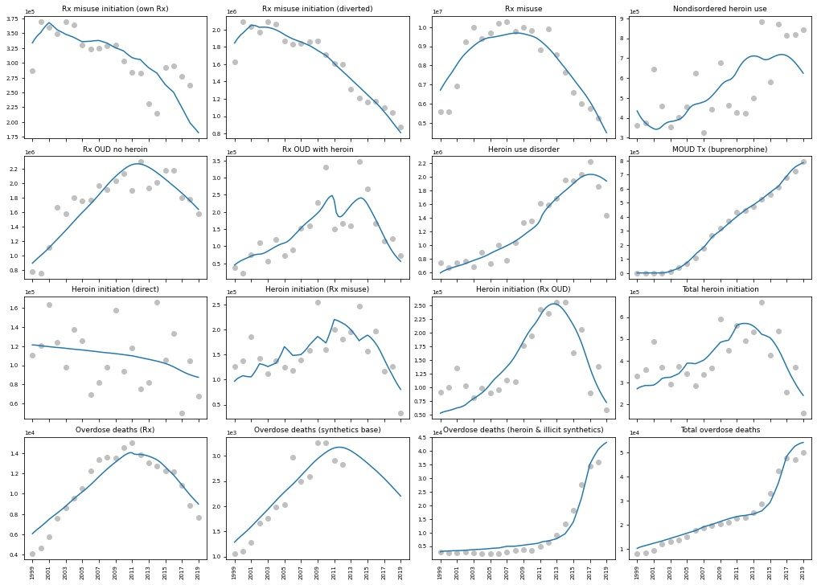

**Figure S14.** Comparison of simulated model output (blue) to historical data (grey) for all time-series data used in estimation.

**Table S11** reports full quality-of-fit metrics for each estimated time series. Most of the time series fit well, with the majority of error stemming from unequal covariance (Uc), indicating an unbiased estimation (Theil 1966; Sterman 2000).

In a few cases there is substantial unequal variance (Us) or bias (Um). Notably, for overdose flows, there is some degree of systematic skew. The most likely reason for this is cohort effects on the likelihood of overdose which we do not incorporate in our model, particularly for people with Rx OUD. For Rx-involved overdose deaths, trends in the prescribing of benzodiazepines and their joint use with prescription opioids may play some role as well. For heroin & illicit synthetic overdoses, anecdotal reports indicate changes in the purity and potency of heroin in the years around 2010, when mortality data show sharper rises in overdose deaths than our estimates. However, reliable data on heroin purity are extremely difficult to obtain, especially at regional level, so we have been unable to test for this effect.[7]

**Table S11.** Goodness of fit statistics for each estimated time series

|  |  |  |  |  |  |  |  |
| --- | --- | --- | --- | --- | --- | --- | --- |
|  | MAEN | MAPE | R2 | MSE | Um | Us | Uc |
| Rx misuse | 0.071 | 0.080 | 0.891 | 5.37E+11 | 0.011 | 0.498 | 0.491 |
| Rx OUD no heroin | 0.086 | 0.095 | 0.796 | 3.75E+10 | 0.005 | 0.003 | 0.992 |
| Rx OUD with heroin | 0.250 | 0.322 | 0.718 | 2.14E+09 | 0.001 | 0.205 | 0.793 |
| Nondisordered heroin use | 0.236 | 0.242 | 0.331 | 2.40E+10 | 0.007 | 0.110 | 0.883 |
| Heroin use disorder | 0.093 | 0.103 | 0.900 | 2.67E+10 | 0.006 | 0.001 | 0.992 |
| MOUD Tx (buprenorphine) | 0.030 | 0.053 | 0.997 | 1.82E+08 | 0.003 | 0.010 | 0.987 |
| Rx misuse initiation (own Rx) | 0.089 | 0.100 | 0.485 | 1.17E+09 | 0.003 | 0.003 | 0.994 |
| Rx misuse initiation (diverted) | 0.045 | 0.049 | 0.947 | 7.83E+09 | 0.000 | 0.000 | 1.000 |
| Total heroin initiation | 0.184 | 0.202 | 0.515 | 7.44E+09 | 0.002 | 0.049 | 0.949 |
| Heroin initiation (direct) | 0.224 | 0.253 | 0.127 | 8.56E+08 | 0.001 | 0.540 | 0.459 |
| Heroin initiation (Rx misuse) | 0.189 | 0.234 | 0.458 | 1.31E+09 | 0.005 | 0.075 | 0.920 |
| Heroin initiation (Rx OUD) | 0.185 | 0.226 | 0.774 | 1.04E+09 | 0.003 | 0.030 | 0.967 |
| Overdose deaths (Rx) | 0.079 | 0.108 | 0.940 | 1.10E+06 | 0.024 | 0.542 | 0.434 |
| Overdose deaths (heroin & illicit synthetics) | 0.207 | 0.375 | 0.955 | 5.44E+06 | 0.045 | 0.016 | 0.939 |
| Overdose deaths (synthetics base) | 0.112 | 0.127 | 0.897 | 7.45E+04 | 0.133 | 0.194 | 0.672 |
| Total overdose deaths | 0.084 | 0.104 | 0.966 | 6.40E+06 | 0.098 | 0.001 | 0.900 |

**Table S12** reports simulated values for key point observations used as prior expected values in the estimation process (see S4.a.ii)). Most of the simulated values are close to their prior expected values in the relevant years, with the exception of Rx OUD in remission, which is somewhat lower than expected.

**Table S12.** Simulated values for key point observations

|  |  |  |  |
| --- | --- | --- | --- |
| Prior | Year | Prior Value | Simulated Value (5-95 CI) |
| Nonfatal OD ratio Rx | < 2013 | 35 | 36 (28-43) |
| Nonfatal OD ratio heroin | < 2013 | 30 | 30 (25-35) |
| Bup demand fulfilment ratio | 2018 | 0.587 | 0.589 (0.335-0.918) |
| Probability Nx bystander heroin | 2019 | 0.2 | 0.23 (0.20-0.26) |
| Nx utilization events H user fraction | 2013 | 0.86 | 0.86 (0.76-0.88) |
| Rx OUD in remission total | 2013 | 1521920 | 987922 (747106-1348680) |
| HUD in remission total | 2013 | 596174 | 598562 (423125-712389) |

## Base case projections

**Figure S15** shows base case projections under ‘exogenous trends continue’ (ETC) assumptions for all time-series data used in model estimation (see **Table S8** in S4.b)). As noted in the main text, these projections should not be considered a precise forecast. These projections also do not presently account for the exogenous impact of the COVID-19 pandemic.

The projections show an overall decline in opioid use, use disorder, and mortality for both prescription and illicit opioids. This decline arises in significant part because of the continued effects of perceived risk and social influence driving falls in heroin use that appear to already be under way. This projected pattern depends heavily on the reliability of the most recent 1-2 years of heroin use data from NSDUH (see S3.a.iv.(1)), which should temper interpretation of these trends.

The ETC projections include a slight rebound in prescription opioid use later this decade. Under ETC assumptions, levels of prescribing will fall somewhat from current levels, but remain significant (**Table S15**). This scenario thus presumes continued exposure of large numbers of people to potentially highly addictive prescription opioids, which combined with an attenuating risk response, may lead to an eventual rebound in prescription opioid misuse.

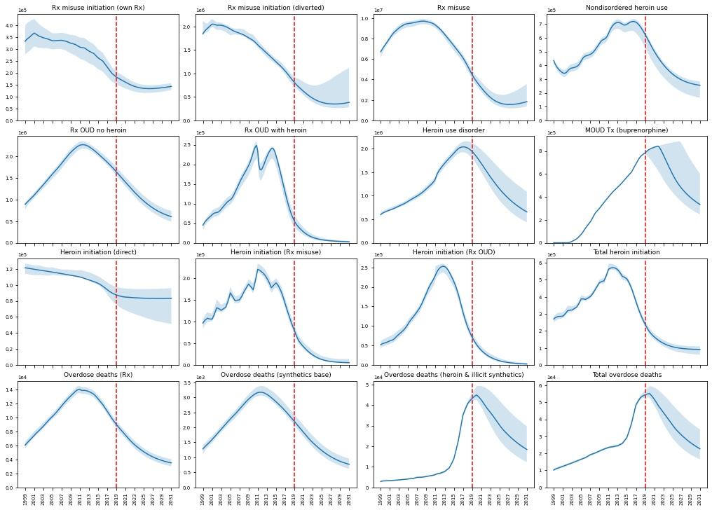

**Figure S15.** Base case ('exogenous trends continue') projections for all time-series data used in estimation.

Shaded areas indicate 95% credible intervals, not accounting for measurement noise.

### Full synthetic data estimation results

**Figure S16** shows complete results of the synthetic data estimation exercise (see S4.e)) for all 20 synthetic data sets and all estimated parameters. Most estimated parameters values are close to their ‘true’ synthetic values across the board, with their 95% CIs containing ‘true’ values in most of the 20 runs. Several of the parameters that perform poorly in this regard are feedback effect strengths with ‘true’ values close to zero (e.g. some availability and social influence strengths), which due to their exponential formulation (see S2.c)) have little effect at such values. Relapse and remission rates, which have little data to anchor them in the estimation and can compensate for each other to some degree, also perform relatively poorly.

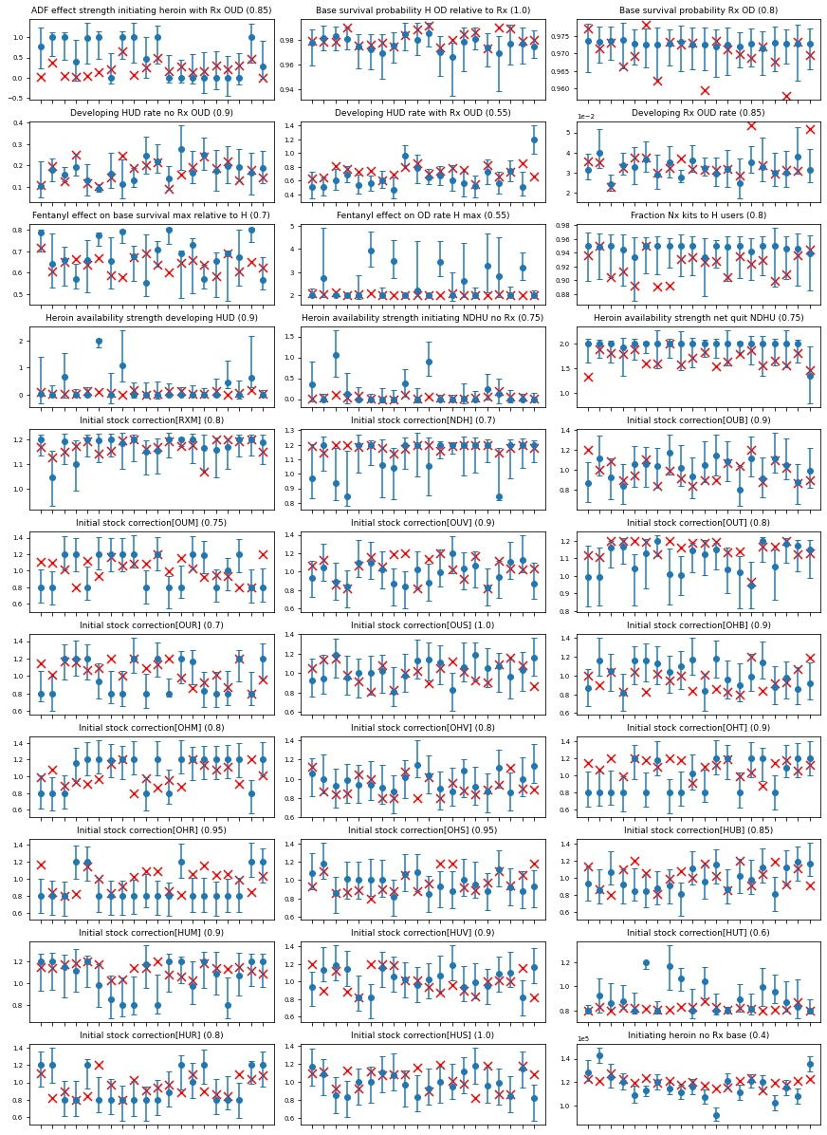

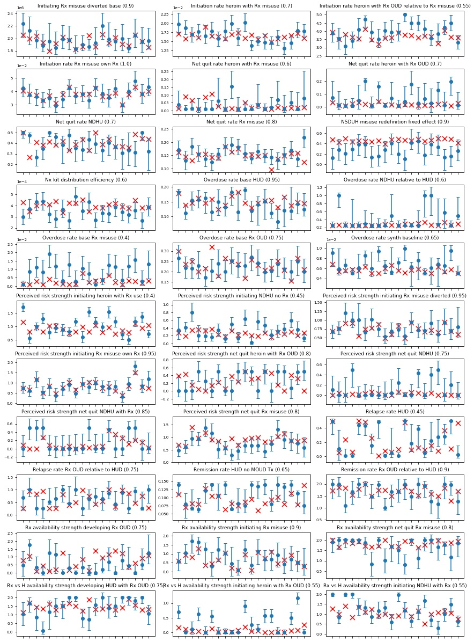

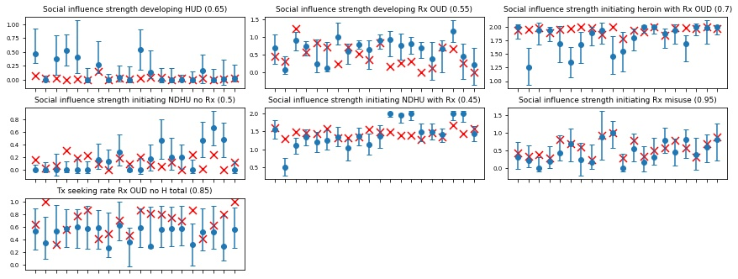

**Figure S16.** Estimated values & 95% credible intervals for all synthetic data parameters compared with ‘true’ values

(estimated value & CI = blue dots & bars; true value = red crosses). Numbers in parentheses after each variable name indicate the fraction of true values for that parameter falling within estimated 95% CIs.

# Sensitivity Analyses

## Sensitivity of outcomes to parametric assumptions

[OSM] includes 43 parametric assumptions drawn from literature and/or expert input (see S3). To assess the sensitivity of the model to these assumptions, we conducted sensitivity analyses on several of these parameters, varying them by ±10% and re-estimating the model in accordance with S4.c).

To keep the analysis computationally tractable, we do not test all 43 parametric assumptions, instead focusing on those with major structural roles or which may drive nonlinear changes.

We exclude several parametric assumptions which have conceptually important policy implications but whose specific values have little impact on the rest of the model. For instance, the *Tx seeking barrier loss fraction* ($F^{L}$) and its components are of great practical importance for increasing access to treatment, but changes in the assumed value of $F^{L}$ will simply result in a proportional change in the estimated value of the *Tx seeking rate* ($ρ_{T(.)}$) with no further impact on the model (see S2.d.ii.(1)):

$\begin{aligned}r_{UT\left(.\right)}^{*}=ρ_{T\left(.\right)}\left(1-F^{L}\right)U_{\left(.\right)} \#\left(2.13\right)\end{aligned}$

As such, we exclude it and other structurally similar parameters from the parametric sensitivity analysis.

We report the impacts of parametric changes on

1. Four main substantive outcomes:
   1. Estimated cumulative overdose deaths and cumulative person-years of use disorder from 1999-2019
   2. Projected cumulative overdose deaths and cumulative person-years of use disorder from 2019-2031, under ‘ETC’ case assumptions (see S6.c))
2. Median and maximum relative changes in estimated parameter values across all estimated parameters, excluding feedback strength parameters estimated at near-zero values (see below)
3. Average and maximum MAEN of all estimated historical time series, to identify impacts on overall goodness-of-fit as well as any outsize impacts on particular time series (see S5.b))

We report the first two sets of these impacts (1) and (2) as elasticities, i.e., fractional changes in outcome measure divided by fractional change (±10%) in the input parametric assumption. This yields a dimensionless value with a useful heuristic interpretation – absolute values < 1 indicate modest sensitivity, whereas absolute values > 1 indicate greater sensitivity meriting closer inspection.

Note that some feedback strengths ($ε_{(.)}$) in the main model (see S2.c)) are estimated at near-zero values, which indicates that feedback has no significant effect (see S2.c.iv)). In these cases, re-estimation can yield seemingly large relative changes in $ε_{(.)}$ which are actually insignificant in practice:

$$\begin{aligned}{\left(D_{C\left(.\right)}\right)}^{1E-06}≈{\left(D_{C\left(.\right)}\right)}^{1E-05}≈{\left(D_{C\left(.\right)}\right)}^{1E-04}≈1 \#\left( STYLEREF 1 \backslash s 6. SEQ Equation \backslash * ARABIC \backslash s 1 1\right)\end{aligned}$$

As such, in order to avoid skewing the reported elasticities of estimated parameters with apparent multiple-order-of-magnitude changes that are actually insignificant, we exclude from the average and maximum parameter elasticity calculation any parameters with baseline estimated value < 1E-04. This threshold restricts the exclusion to only feedback strength parameters $ε_{(.)}$.

### Parametric sensitivity results

**Table S13** reports elasticities of major outcomes and parameter estimates to changes in parametric assumptions, as well as changes in model goodness-of-fit (MAEN).

Overall model goodness-of-fit is virtually identical regardless of small changes in parametric assumptions. Similarly, overdose deaths and use disorder prevalence over the historical period of 1999-2019 are essentially unchanged. Taken together, these two results indicate the model is largely insensitive to precise values of parametric assumptions. Changes in those precise values can be easily accommodated with small changes in the values of estimated parameters, as indicated by the low median elasticity of parameter estimates.

The absolute maximum elasticity across all estimated parameters is distinctly higher. Despite that, the elasticity of key projected outcomes from 2019-2031 remains generally low, with absolute magnitudes well below 1 in most cases. The absolute elasticities for projected outcomes are two orders of magnitude larger than those for historical outcomes, but this is to be expected – firstly, the projected values are not directly constrained by historical data, and secondly, projecting forward amplifies the effect of minor divergences in parameter estimates.

Only in one case is there substantial sensitivity (elasticity ~1) to a parametric assumption – increasing the assumed duration of buprenorphine treatment results in an almost proportional increase in projected deaths.

This result may seem counterintuitive, as increased duration (and hence efficacy) of treatment might be expected to result in *fewer* deaths. To understand this result, it is useful to think of model estimation as a balancing or goal-seeking process, with historical data as the goal. If we assume historically greater treatment efficacy, the estimation process compensates by estimating more severe rates of use disorder development, relapse, etc. to maintain historically observed levels of use disorder. Those more severe or stronger counterbalancing forces, projected out into the future, result in *more* deaths than in the base case.

Notwithstanding that, on the whole, we find that [OSM] is largely insensitive to minor changes in parametric assumptions, which should help allay any concerns about any imprecision in the calculation of those values.

**Table S13.** Sensitivity of key outcomes to ±10% changes in parametric assumptions.

Reported elasticities are averages of absolute value change with increase/decrease in parameter; polarity of change assumes 10% increase from assumed value.

|  |  |  |  |  |  |  |  |  |
| --- | --- | --- | --- | --- | --- | --- | --- | --- |
|  | Cumulative overdose deaths | Cumulative UD person years | Projected cumulative overdose deaths | Projected cumulative UD person years | Med elasticity | Max elasticity | Avg MAEN | Max MAEN |
| ADF substitutability factor | -0.010 | 0.004 | -0.068 | -0.060 | 0.026 | 21.259 | 0.122 | 0.250 |
| Average prescription duration | -0.009 | -0.003 | -0.057 | -0.050 | 0.021 | 23.225 | 0.122 | 0.250 |
| Effect of MOUD Tx on OD death rate[Bup] | -0.010 | -0.002 | -0.154 | -0.132 | 0.124 | 36.296 | 0.122 | 0.250 |
| Effect of MOUD Tx on OD death rate[MMT] | -0.010 | 0.002 | -0.101 | -0.083 | 0.026 | 22.720 | 0.122 | 0.250 |
| Effect of MOUD Tx on OD death rate[Viv] | -0.009 | 0.004 | -0.097 | -0.074 | 0.024 | 22.172 | 0.122 | 0.250 |
| OxyContin withdrawal magnitude | -0.011 | 0.005 | -0.179 | -0.122 | 0.078 | 27.741 | 0.122 | 0.250 |
| Perceived risk decrease time | -0.011 | 0.003 | -0.120 | -0.096 | 0.030 | 25.546 | 0.122 | 0.250 |
| Perceived risk increase time | -0.013 | 0.003 | -0.331 | -0.287 | 0.124 | 37.923 | 0.122 | 0.250 |
| Perceived risk weight NFOD | -0.012 | 0.004 | -0.137 | -0.093 | 0.019 | 14.653 | 0.122 | 0.251 |
| Probability OD witnessed | -0.009 | 0.001 | -0.106 | -0.149 | 0.023 | 19.483 | 0.122 | 0.250 |
| Probability of calling emergency services | -0.010 | 0.005 | -0.155 | -0.126 | 0.026 | 24.907 | 0.122 | 0.250 |
| Rx demand HUD with Rx OUD or misuse | -0.009 | 0.001 | -0.015 | -0.010 | 0.100 | 18.140 | 0.122 | 0.250 |
| Rx demand Rx OUD no H | -0.009 | 0.008 | -0.086 | -0.076 | 0.139 | 29.244 | 0.122 | 0.250 |
| Sensitivity of Rx supply to MME per Rx | -0.010 | 0.004 | -0.089 | -0.107 | 0.033 | 16.474 | 0.122 | 0.250 |
| Sensitivity of Rx supply to patients receiving prescription | -0.010 | 0.004 | -0.196 | -0.156 | 0.025 | 25.576 | 0.122 | 0.250 |
| Sensitivity of Rx supply to Rx per person | -0.011 | 0.001 | -0.126 | -0.147 | 0.146 | 35.147 | 0.122 | 0.250 |
| Time to readjust Rx street supply | -0.010 | -0.002 | -0.114 | -0.092 | 0.033 | 23.022 | 0.122 | 0.250 |
| Tx average duration Bup | 0.008 | 0.010 | 0.894 | 0.301 | 0.077 | 26.917 | 0.126 | 0.250 |
| Tx average duration MMT | -0.009 | 0.011 | 0.102 | 0.120 | 0.126 | 25.465 | 0.122 | 0.250 |
| Tx average duration Viv | -0.011 | -0.006 | -0.186 | -0.161 | 0.104 | 39.720 | 0.122 | 0.250 |
| Tx seeking fraction Bup HUD | -0.010 | 0.003 | -0.108 | -0.074 | 0.108 | 31.287 | 0.122 | 0.250 |
| Tx seeking fraction Bup Rx OUD | -0.009 | 0.004 | 0.058 | 0.066 | 0.111 | 26.020 | 0.122 | 0.250 |
| Tx seeking fraction MMT HUD relative | -0.011 | 0.005 | -0.184 | -0.170 | 0.101 | 35.217 | 0.122 | 0.250 |
| Tx seeking fraction MMT Rx OUD relative | -0.010 | 0.002 | -0.076 | -0.059 | 0.024 | 20.650 | 0.122 | 0.250 |
| Tx seeking rate HUD relative to Rx OUD no H | -0.009 | 0.002 | -0.058 | -0.047 | 0.033 | 20.051 | 0.122 | 0.250 |
| Tx success fraction inflection | -0.010 | 0.008 | -0.196 | -0.182 | 0.032 | 20.296 | 0.122 | 0.250 |

## Feedback loop knockout analyses

[OSM]’s feedback structure is central to its behaviour, projections, and insights about historical trajectories. With multiple feedbacks acting simultaneously, sometimes with similar results, it can be difficult to disambiguate the impacts of different feedback processes through model estimation alone; some form of loop dominance analysis is warranted (Ford 1999). To assess the relative role of different feedbacks in [OSM] and build confidence in our estimates of their strengths, we conducted loop knockout analyses (Sterman 2000; Ford 1999), examining how model behaviour and estimates change in the absence of certain feedbacks.

We test [OSM]’s feedbacks in three groups, corresponding to the three main conceptual sets of feedback processes – social influence, perceived risk, and availability (see S2.c)). We deactivate all loops in one group at a time.

For each of these three sets of loops, we conduct two forms of loop knockout test: 1) running the model with baseline parameter estimates, with the focal loops deactivated; and 2) deactivating the focal loops and re-estimating the model in accordance with S4.c). The first test helps highlight the role played by the focal loops in the baseline model, while the second test highlights the ability of the other feedbacks in the model to compensate for the missing focal feedback, potentially acting as ‘shadow’ feedback structures (Ford 1999).

For each test, we report the changes in the outcomes outlined in S6.a) above: 1) substantive outcomes for 1999-2019 and 2019-2031; 2) changes in estimated parameter values, excluding near-zero values (note that for the first test described, parameter values will not change); and 3) MAEN across historical time series. Unlike in S6.a), as there is no meaningful input change against which to normalise an elasticity value, we report the first two sets of impacts as fractional changes rather than elasticities.

### Loop knockout results

**Table S14** presents summary outcomes of loop knockout analyses, while **Figure S17** shows model fit to data.

In all three ‘deactivated’ tests, model fit worsened considerably and both historical and projected key outcomes changed substantially, indicating that all three loop sets play important roles in generating the model’s behaviour. These changes are greatest when perceived risk feedbacks are deactivated, consistent with recent heroin use data indicating a very strong risk response being vital in shaping the trajectory of the crisis (see S3.a.iv.(1)). Deactivating availability effects reduces both historical and projected deaths and use disorder, affirming the idea that the ready supply of both prescription opioids and heroin has been partly responsible for the scale of the crisis. Interestingly, deactivating social influence feedbacks has relatively little overall impact on cumulative deaths or use disorder, reflecting the fact (or more accurately, the structural assumption) that social influence goes both ways, and has contributed to both increases and decreases in drug use over the last ~20 years.

As expected, model fit in the ‘recalibrated’ tests worsens compared to baseline (baseline average MAEN = 12.2%), but only slightly; it worsens slightly more for the perceived risk feedback knockout than the others. Similarly, most estimated parameters do not change very much. Together, these results indicate some ability of model feedbacks to compensate for each other, as discussed above. Closer examination of how exactly the feedbacks change, however, is instructive.

In particular, social influence and availability effects appear to operate similarly, and are able to compensate for each other to a large extent, albeit more so for social influence compensating for availability effects than vice-versa. Social influence feedbacks play a greater role in driving declines in both Rx and heroin initiation in the last few years and going forward. Overall, the similarity in effects of the two processes is not entirely surprising – in practice, access to drugs is not only a matter of aggregate forces of supply and demand but also ease of access within particular social networks (see S2.c.i)), e.g. whether you have a friend who knows a dealer. While we have operationalised our availability construct to reflect aggregate market forces, there likely remains some overlap between social influence and availability feedback processes.

Consistent with the ‘deactivated’ tests, the perceived risk feedbacks seem to play the greatest role, with the other feedback processes less able to compensate for their absence. Without the risk response, rates of both Rx and heroin initiation are unable to decline as much or as quickly as observed in the data, supporting the potential importance of risk responses in producing the ‘wave’ pattern observed in past substance use crises.

Interestingly, all three ‘recalibrated’ cases show increased projected deaths and use disorder, indicating that at this point, and over the next decade, all three sets of feedbacks are likely working in the direction of lessening the magnitude of the crisis. This observation provides some justification for the optimism of our base case projections (S5.c)), which show that the crisis, in terms of use disorder and mortality, appears to be on the verge of peaking and turning around.

**Table S14.** Sensitivity of key outcomes to loop knockout analyses.

‘Deactivated’ results are from model runs using baseline estimated values with the focal loop[s] subsequently deactivated; ‘Recalibrated’ results deactivate the focal loop[s] and re-estimate the model, using the re-estimated parameters for projections as well.

|  |  |  |  |  |  |  |  |  |
| --- | --- | --- | --- | --- | --- | --- | --- | --- |
|  | Cumulative overdose deaths | Cumulative UD person years | Projected cumulative overdose deaths | Projected cumulative UD person years | Med elasticity | Max elasticity | Avg MAEN | Max MAEN |
| Deactivated Availability | -0.330 | -0.263 | -0.479 | -0.285 | 0 | 0 | 0.283 | 0.615 |
| Recalibrated w/o Availability | 0.000 | -0.006 | 0.177 | 0.241 | 0.062 | 5.4 | 0.136 | 0.318 |
| Deactivated Perceived risk | 1.486 | 0.629 | 4.971 | 1.939 | 0 | 0 | 1.683 | 8.292 |
| Recalibrated w/o Perceived risk | -0.007 | 0.004 | 0.153 | 0.000 | 0.142 | 24.0 | 0.151 | 0.273 |
| Deactivated Social influence | -0.191 | -0.130 | -0.209 | -0.055 | 0 | 0 | 0.223 | 0.511 |
| Recalibrated w/o Social influence | -0.003 | 0.005 | 0.235 | 0.021 | 0.077 | 17.7 | 0.132 | 0.294 |

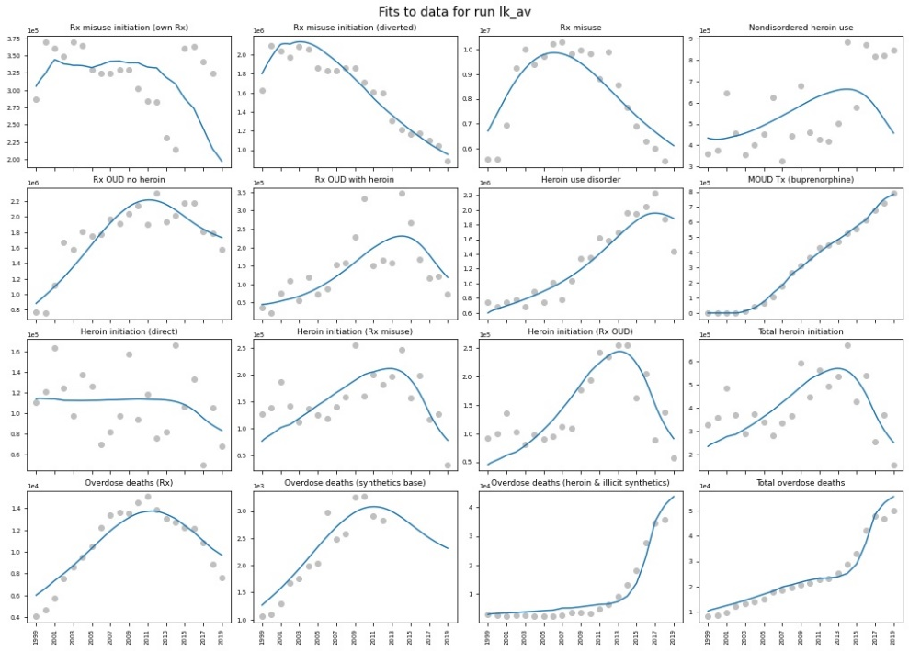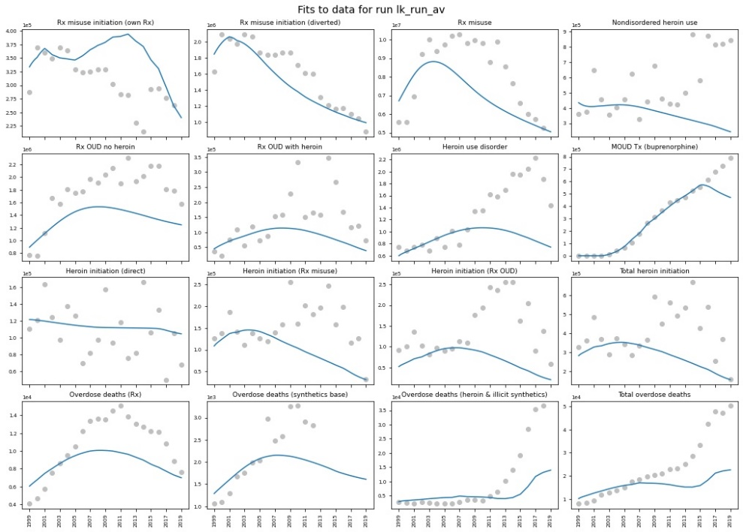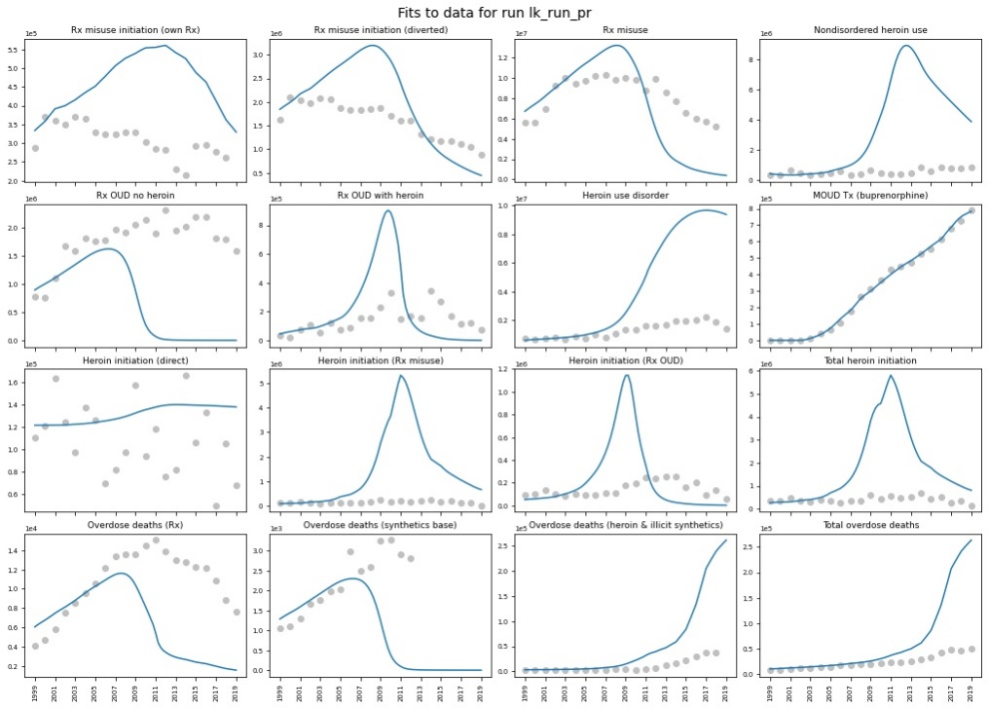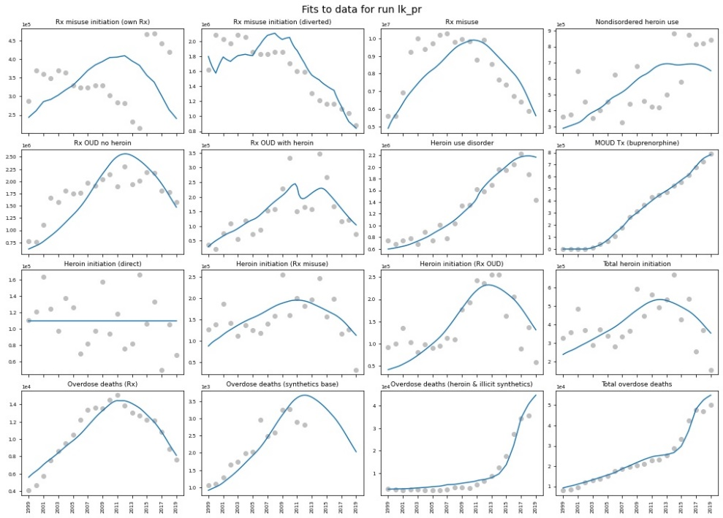

**Figure S17.** Model fit to data for loop knockout analyses, for all time-series data used in estimation

(simulated model output = blue, historical data = grey). Left panels show results of recalibration with loop knockout; right panels show impact of knockout with baseline parameter estimates. Focal loops deactivated, from top to bottom: availability effects, perceived risk, social influence.

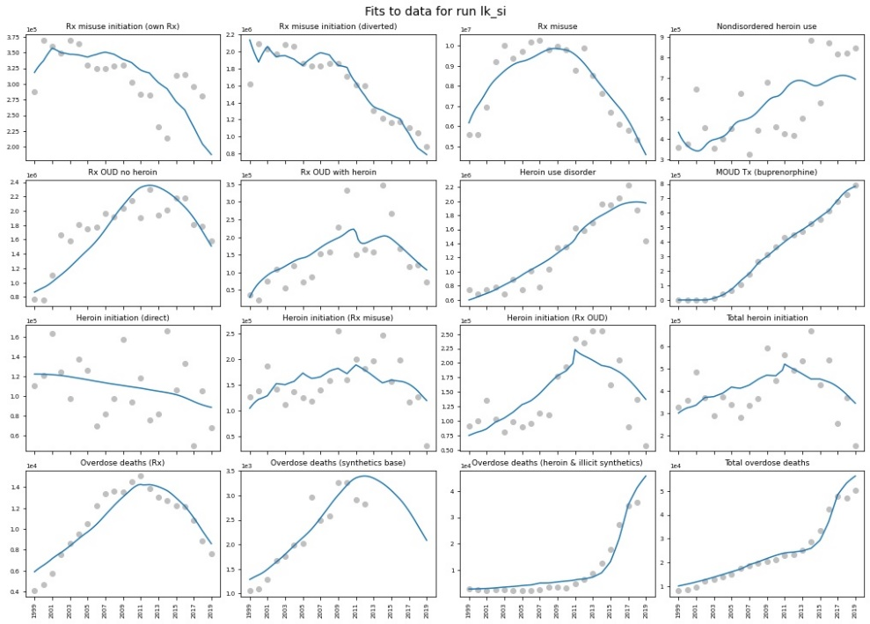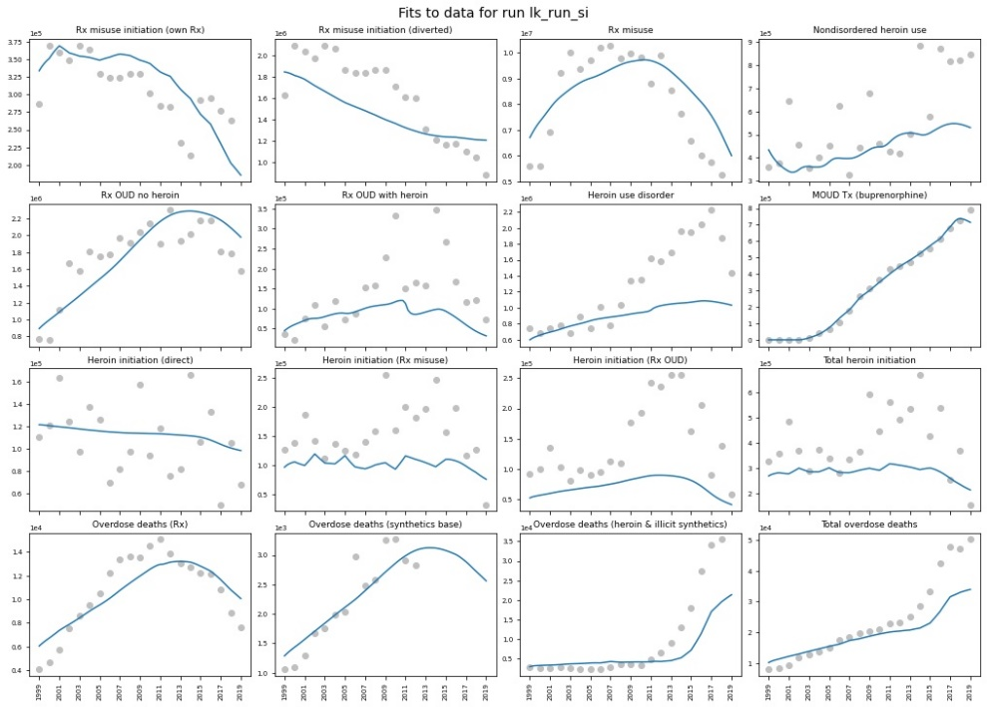

## Sensitivity of projections to exogenous input assumptions

[OSM] makes projections of potential future trajectories of the opioid crisis using some baseline assumptions about future trends in exogenous inputs $x_{jt}$. By default, we include two main sets of baseline assumptions about [OSM]’s inputs (see **Table S15**): 1) a ‘constant’ case where exogenous inputs do not change after their last data points in 2019, and 2) an ‘exogenous trends continue’ (ETC) case where present trends continue at decelerating rates, stabilising at plausible levels by 2031. Alternative sets of baseline assumptions can be specified by model users.

**Table S15.** Exogenous inputs with alternative base case assumptions for projections

|  |  |  |  |
| --- | --- | --- | --- |
| **Input** | **Source** | **2019** | **ETC 2031** |
| Patients receiving opioid prescription | IQVIA | 45.9 million | 29.3 million |
| Prescriptions per person | IQVIA | 3.37 | 3.34 |
| Average opioid MME per prescription | IQVIA | 779 | 531 |
| ADF fraction of prescribed opioids | IQVIA | 5.6% | 3.2% |
| Buprenorphine-waivered treatment providers | Various** | 66.8 thousand | 167.7 thousand |
| Methadone maintenance treatment capacity* | N-SSATS | 472 thousand | 583 thousand |
| Vivitrol® treatment capacity* | IQVIA | 36.6 thousand | 45.6 thousand |
| Naloxone kits distributed | IQVIA, various** | 1.93 million | 3.37 million |
| Heroin price index (1999 = 1) | UNODC, STRIDE | 0.54 | 0.54 |
| Fentanyl penetration | NFLIS | 47.3% | 70.7% |
| * Neither MMT nor Vivitrol capacity data are directly available; instead we calculate capacity based on treatment utilization data from the sources listed; see S3.c.iii)  ** See S3.c.iii) and S3.d.iv.(1) for full details of data sources & calculations | | | |

Different baseline assumptions for inputs will obviously have substantial effects on parts of the model directly driven by those inputs. For instance, switching between ETC and ‘constant’ assumptions about future opioid prescribing trends results in large differences in prescription opioid supply. However, major downstream outcomes are not very sensitive to the baseline case used. Switching from ETC to ‘constant’ assumptions changes total use disorder prevalence (measured in cumulative person-years from 2019-2031) by 9.7%, and total cumulative overdose deaths by -4.8%.

To assess the impacts of baseline assumptions about individual exogenous inputs on these downstream outcomes, we test each input variable *j* in two ways: 1) setting all input assumptions except *j* to their ETC trajectories but holding *j* constant after 2019; and 2) holding all input assumptions constant after 2019 but setting *j* to its ETC trajectory. We then calculate the percentage change in key outcomes (cumulative overdose deaths and person-years of use disorder from 2019-2031) from the all-inputs ETC case and constant case respectively, as well as the mean absolute percentage change for each input *j* and across all inputs. With the exception of fentanyl penetration in the illicit drug supply, these outcomes are not very sensitive to changes in input assumptions (see **Table S16**) – on average, switching each input between ETC and ‘constant’ assumptions individually results in changes of 1.1% and 2.6% in projected cumulative use disorder prevalence and overdose deaths respectively.

**Table S16.** Sensitivity of key projected outcomes to alternative base case assumptions.

|  |  |  |  |  |  |  |
| --- | --- | --- | --- | --- | --- | --- |
|  | Base Projected cumulative overdose deaths | Base Projected cumulative UD person years | Cnst Projected cumulative overdose deaths | Cnst Projected cumulative UD person years | Avg Projected cumulative overdose deaths | Avg Projected cumulative UD person years |
| Fent | -0.14078 | 0.007408 | 0.161002 | -0.00669 | -0.15089 | 0.007049 |
| HPI | 2.03E-06 | 0 | -2.14E-06 | 0 | 2.08E-06 | 0 |
| MME | 0.012142 | 0.033729 | -0.01849 | -0.04509 | 0.015318 | 0.039409 |
| BMDCap | 0.000643 | 7.70E-05 | -0.00091 | -0.00022 | 0.000776 | 0.000149 |
| MMTCap | 0.011912 | 0.002327 | -0.0126 | -0.00224 | 0.012253 | 0.002282 |
| VivCap | 0.002333 | 0.00154 | -0.00242 | -0.00128 | 0.002378 | 0.001408 |
| NxKD | 0.048595 | -0.00247 | -0.04187 | 0.001809 | 0.045231 | -0.00214 |
| PtRx | 0.026089 | 0.045623 | -0.03263 | -0.05508 | 0.029359 | 0.05035 |
| ADF | -6.51E-05 | 0 | 1.07E-05 | 0 | -3.79E-05 | 0 |
| RxPP | -0.00308 | -0.00458 | 0.005974 | 0.00997 | -0.00452 | -0.00728 |
| MAC | 0.024563 | 0.009775 | 0.027591 | 0.012237 | 0.026077 | 0.011006 |

For comparison, **Figure S18** shows projections for all time-series data used in model estimation under constant-input assumptions (see **Table S15**) (see **Table S8** in S4.b)). Two main sets of differences stand out. First, deaths fall more sharply than in the ETC case, as fentanyl prevalence does not continue to rise. Second, without continued declines in opioid prescribing, Rx opioid misuse, use disorder, and associated outcomes start to increase again within a few years, as the perceptions of risk associated with Rx misuse that drove its initial decline in the 2000s start to fade – highlighting the importance of continuing various ongoing efforts to reduce prescribing.

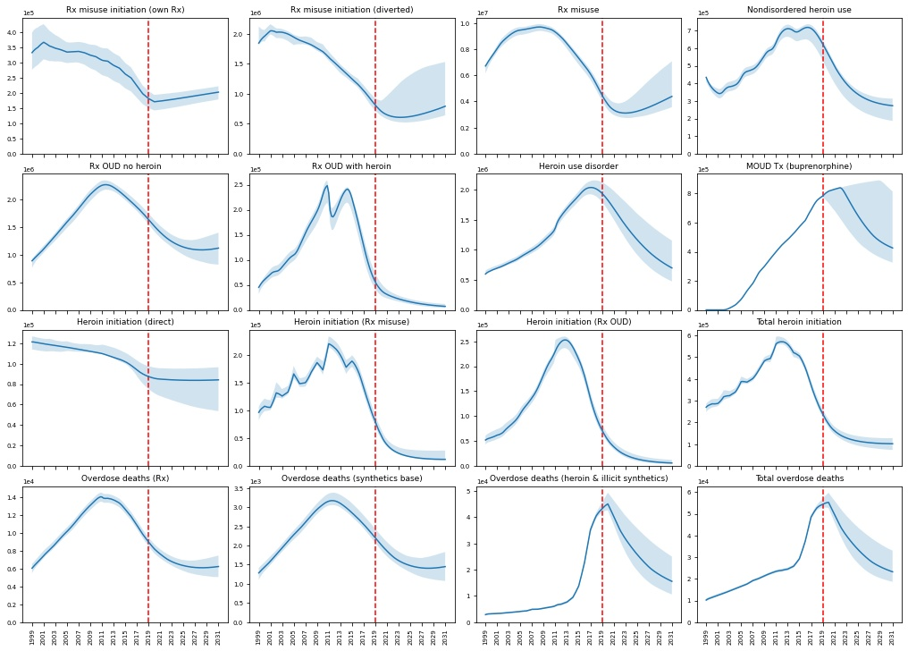

**Figure S18.** Constant-assumptions case projections for all time-series data used in estimation.

Shaded areas indicate 95% credible intervals, not accounting for measurement noise.

# Model Equations

A full listing of model equations is available online at [LINK].

[SDM-Doc model equations list]

# References

Algren, D. Adam, Carolyn P. Monteilh, Mohan Punja, Joshua G. Schier, Martin Belson, Bradford R. Hepler, Carl J. Schmidt, et al. 2013. “Fentanyl-Associated Fatalities Among Illicit Drug Users in Wayne County, Michigan (July 2005-May 2006).” *Journal of Medical Toxicology* 9 (1): 106–15. https://doi.org/10.1007/s13181-012-0285-4.

American Psychiatric Association. 2013. *Diagnostic and Statistical Manual of Mental Disorders*. 5th ed. Arlington, VA: American Psychiatric Association. https://doi.org/https://doi.org/10.1176/appi.books.9780890425596.

Amiri, Solmaz, Katherine Hirchak, Robert Lutz, Michael G. McDonell, Sterling M. McPherson, John M. Roll, and Ofer Amram. 2018. “Three-Year Retention in Methadone Opioid Agonist Treatment: A Survival Analysis of Clients by Dose, Area Deprivation, and Availability of Alcohol and Cannabis Outlets.” *Drug and Alcohol Dependence* 193 (December): 63–68. https://doi.org/10.1016/j.drugalcdep.2018.08.024.

Arens, Ann M., Xander M.R. van Wijk, Kathy T. Vo, Kara L. Lynch, Alan H.B. Wu, and Craig G. Smollin. 2016. “Adverse Effects from Counterfeit Alprazolam Tablets.” *JAMA Internal Medicine* 176 (10): 1554–55. https://doi.org/10.1001/jamainternmed.2016.4310.

Arria, Amelia M., Kimberly M. Caldeira, Kathryn B. Vincent, Kevin E. O’Grady, and Eric D. Wish. 2008. “Perceived Harmfulness Predicts Nonmedical Use of Prescription Drugs among College Students: Interactions with Sensation-Seeking.” *Prevention Science* 9 (3): 191–201. https://doi.org/10.1007/s11121-008-0095-8.

Ataiants, Janna, Silvana Mazzella, Alexis M. Roth, Randall L. Sell, Lucy F. Robinson, and Stephen E. Lankenau. 2020. “Overdose Response among Trained and Untrained Women with a History of Illicit Drug Use: A Mixed-Methods Examination.” *Drugs: Education, Prevention and Policy*. https://doi.org/10.1080/09687637.2020.1818691.

Bahji, A., B. Cheng, S. Gray, and H. Stuart. 2019. “Reduction in Mortality Risk with Opioid Agonist Therapy: A Systematic Review and Meta-Analysis.” *Acta Psychiatrica Scandinavica*. Blackwell Publishing Ltd. https://doi.org/10.1111/acps.13088.

Banjo, Oluwajenyo, D. Tzemis, D. Al-Qutub, A. Amlani, S. Kesselring, and J. A. Buxton. 2014. “A Quantitative and Qualitative Evaluation of the British Columbia Take Home Naloxone Program.” *CMAJ Open* 2 (3): E153–61. https://doi.org/10.9778/cmajo.20140008.

Barocas, Joshua A, Laura F White, Jianing Wang, Alexander Y Walley, Marc R LaRochelle, Dana Bernson, Thomas Land, Jake R Morgan, Jeffrey H Samet, and Benjamin P Linas. 2018. “Estimated Prevalence of Opioid Use Disorder in Massachusetts, 2011-2015: A Capture-Recapture Analysis.” *American Journal of Public Health* 108 (12): 1675–81. https://doi.org/10.2105/AJPH.2018.304673.

Basu, Sanjay, and Jason Andrews. 2013. “Complexity in Mathematical Models of Public Health Policies: A Guide for Consumers of Models.” *PLoS Medicine* 10 (10): 1–6. https://doi.org/10.1371/journal.pmed.1001540.

Becker, Gary S. 1968. “Crime and Punishment: An Economic Approach.” *Journal of Political Economy* 76 (2): 169–217. http://www.jstor.org/stable/1830482.

Beetham, Tamara, Brendan Saloner, Sarah E. Wakeman, Marema Gaye, and Michael L. Barnett. 2019. “Access to Office-Based Buprenorphine Treatment in Areas with High Rates of Opioid-Related Mortality: An Audit Study.” *Annals of Internal Medicine* 171 (1): 1–9. https://doi.org/10.7326/M18-3457.Access.

Bell, James. 2009. “Politics, Practice and Research into Treatment of Heroin Addiction.” In *Pharmacotherapies for the Treatment of Opioid Dependence*. https://doi.org/10.3109/9780203414088-11.

Bell, James, and Carolyn Mutch. 2006. “Treatment Retention in Adolescent Patients Treated with Methadone or Buprenorphine for Opioid Dependence: A File Review.” *Drug and Alcohol Review* 25 (2): 167–71. https://doi.org/10.1080/09595230500537670.

Belz, Daniel, Jacob Lieb, Tom Rea, and Mickey S. Eisenberg. 2006. “Naloxone Use in a Tiered-Response Emergency Medical Services System.” *Prehospital Emergency Care* 10 (4): 468–71. https://doi.org/10.1080/10903120600885134.

Bennett, Alex S., Alice Bell, Laura Tomedi, Eric G. Hulsey, and Alex H. Kral. 2011. “Characteristics of an Overdose Prevention, Response, and Naloxone Distribution Program in Pittsburgh and Allegheny County, Pennsylvania.” *Journal of Urban Health* 88 (6): 1020–30. https://doi.org/10.1007/s11524-011-9600-7.

Best, David, Michael Gossop, Lan-Ho Man Ba, Garry Stillwell, Research Sociologist, Ross Coomber, John Strang Frcpsych, Lan-Ho Man, and John Strang. 2009. “Peer Overdose Resuscitation: Multiple Intervention Strategies and Time to Response by Drug Users Who Witness Overdose.” https://doi.org/10.1080/0959523021000002732.

Bhatraju, Elenore Patterson, Ellie Grossman, Babak Tofighi, Jennifer McNeely, Danae DiRocco, Mara Flannery, Ann Garment, Keith Goldfeld, Marc N Gourevitch, and Joshua D Lee. 2017. “Public Sector Low Threshold Office-Based Buprenorphine Treatment: Outcomes at Year 7.” *Addiction Science & Clinical Practice* 12 (1): 7. https://doi.org/10.1186/s13722-017-0072-2.

Bohnert, Amy S.B., Melissa Tracy, and Sandro Galea. 2009. “Circumstances and Witness Characteristics Associated With Overdose Fatality.” *Annals of Emergency Medicine* 54 (4): 618–24. https://doi.org/10.1016/j.annemergmed.2009.05.004.

———. 2012. “Characteristics of Drug Users Who Witness Many Overdoses: Implications for Overdose Prevention.” *Drug and Alcohol Dependence* 120 (1–3): 168–73. https://doi.org/10.1016/j.drugalcdep.2011.07.018.

Bouchard, Martin. 2007. “On the Resilience of Illegal Drug Markets.” *Global Crime* 8 (4): 325–44. https://doi.org/10.1080/17440570701739702.

Carlson, Robert G., Ramzi W. Nahhas, Silvia S. Martins, and Raminta Daniulaityte. 2016. “Predictors of Transition to Heroin Use among Initially Non-Opioid Dependent Illicit Pharmaceutical Opioid Users: A Natural History Study.” *Drug and Alcohol Dependence* 160 (March): 127–34. https://doi.org/10.1016/j.drugalcdep.2015.12.026.

Carroll, Jennifer J., Brandon D.L. Marshall, Josiah D. Rich, and Traci C. Green. 2017. “Exposure to Fentanyl-Contaminated Heroin and Overdose Risk among Illicit Opioid Users in Rhode Island: A Mixed Methods Study.” *International Journal of Drug Policy* 46 (August): 136–45. https://doi.org/10.1016/j.drugpo.2017.05.023.

Caulkins, Jonathan P., and Peter Reuter. 2006. “Illicit Drug Markets and Economic Irregularities.” *Socio-Economic Planning Sciences* 40 (1): 1–14. https://doi.org/10.1016/j.seps.2004.08.002.

Center for Behavioral Health Statistics and Quality. 2015. “National Survey on Drug Use and Health: 2014 and 2015 Redesign Changes.” Rockville, MD.

———. 2016. “Impact of the DSM-IV to DSM-5 Changes on the National Survey on Drug Use and Health.” Rockville, MD. https://www.ncbi.nlm.nih.gov/books/NBK519697/.

Centers for Disease Control and Prevention. 2019. “2019 CDC Opioid NDC and Oral MME Conversion File.” https://www.cdc.gov/drugoverdose/resources/data.html.

Chang, Grace, Mitchell Crawford, Michelle Pitts, Abigail Z. Schein, Katherine Goodwin, and Justin L. Enggasser. 2018. “Adherence to Extended Release Naltrexone: Patient and Treatment Characteristics.” *American Journal on Addictions* 27 (6): 524–30. https://doi.org/10.1111/ajad.12786.

Ciccarone, Daniel. 2017. “US Heroin in Transition: Supply Changes, Fentanyl Adulteration and Consequences.” *International Journal of Drug Policy* 46: 107–11. https://doi.org/10.1016/j.drugpo.2017.06.010.Editorial.

———. 2019. “The Triple Wave Epidemic: Supply and Demand Drivers of the US Opioid Overdose Crisis.” *International Journal of Drug Policy* 71: 183–88. https://doi.org/10.1016/j.drugpo.2019.01.010.The.

Cicero, Theodore J., Matthew S. Ellis, and Zachary A. Kasper. 2017. “Relative Preferences in the Abuse of Immediate-Release versus Extended-Release Opioids in a Sample of Treatment-Seeking Opioid Abusers.” *Pharmacoepidemiology and Drug Safety* 26 (1): 56–62. https://doi.org/10.1002/pds.4078.

Cicero, Theodore J., Matthew S. Ellis, Hilary L. Surratt, and Steven P. Kurtz. 2014. “The Changing Face of Heroin Use in the United States: A Retrospective Analysis of the Past 50 Years.” *JAMA Psychiatry* 71 (7): 821–26. https://doi.org/10.1001/jamapsychiatry.2014.366.

Clark, Robin E., Jeffrey D. Baxter, Gideon Aweh, Elizabeth O’Connell, William H. Fisher, and Bruce A. Barton. 2015. “Risk Factors for Relapse and Higher Costs Among Medicaid Members with Opioid Dependence or Abuse: Opioid Agonists, Comorbidities, and Treatment History.” *Journal of Substance Abuse Treatment* 57 (October): 75–80. https://doi.org/10.1016/j.jsat.2015.05.001.

Clay, Emilie, Amine Khemiri, Vladimir Zah, Samuel Aballéa, Jane Ruby, and Carl V. Asche. 2014. “Persistence and Healthcare Utilization Associated with the Use of Buprenorphine/Naloxone Film and Tablet Formulation Therapy in Adults with Opioid Dependence.” *Journal of Medical Economics* 17 (9): 626–36. https://doi.org/10.3111/13696998.2014.925463.

Compton, Wilson M., Deborah a. Dawson, Risë B. Goldstein, and Bridget F. Grant. 2013. “Crosswalk between DSM-IV Dependence and DSM-5 Substance Use Disorders for Opioids, Cannabis, Cocaine and Alcohol.” *Drug and Alcohol Dependence* 132 (1–2): 387–90. https://doi.org/10.1016/j.drugalcdep.2013.02.036.

Compton, Wilson M., Deborah Dawson, Sarah Q. Duffy, and Bridget F. Grant. 2010. “The Effect of Inmate Populations on Estimates of DSM-IV Alcohol and Drug Use Disorders in the United States.” *The American Journal of Psychiatry* 167 (4): 473–74. https://doi.org/10.1176/appi.ajp.2009.09111622.

Compton, Wilson M, Yonette F Thomas, Frederick S Stinson, and Bridget F Grant. 2007. “Prevalence, Correlates, Disability, and Comorbidity of DSM-IV Drug Abuse and Dependence in the United States: Results from the National Epidemiologic Survey on Alcohol and Related Conditions.” *Archives of General Psychiatry* 64 (5): 566–76. https://doi.org/10.1001/archpsyc.64.5.566.

Congressional Research Service. 2018. “Buprenorphine and the Opioid Crisis: A Primer for Congress.”

Connery, Hilary S., and Roger D. Weiss. 2020. “Discontinuing Buprenorphine Treatment of Opioid Use Disorder: What Do We (Not) Know?” *American Journal of Psychiatry*. American Psychiatric Association. https://doi.org/10.1176/APPI.AJP.2019.19121245.

Darke, Shane, Richard P. Mattick, and Louisa Degenhardt. 2003. “The Ratio of Non-Fatal to Fatal Heroin Overdose.” *Addiction* 98 (8): 1169–71. https://doi.org/10.1046/j.1360-0443.2003.00474.x.

Darke, Shane, and Deborah Zador. 1996. “Fatal Heroin ‘Overdose’: A Review.” *Addiction* 91 (12): 1765–72. https://doi.org/10.1111/j.1360-0443.1996.tb03800.x.

Dasgupta, Nabarun, Yanning Wang, Jungjun Bae, Alan Kinlaw, Brooke Alison Chidgey, Toska Cooper, and Chris Delcher. 2021. “Inches, Centimeters, and Yards: Overlooked Definition Choices Inhibit Interpretation of Morphine Equivalence.” *The Clinical Journal of Pain* Publish Ah. https://doi.org/10.1097/AJP.0000000000000948.

Davidson, Peter J., Kristen C. Ochoa, Judith A. Hahn, Jennifer L. Evans, and Andrew R. Moss. 2002. “Witnessing Heroin-Related Overdoses: The Experiences of Young Injectors in San Francisco.” *Addiction* 97 (12): 1511–16. https://doi.org/10.1046/j.1360-0443.2002.00210.x.

Debeck, Kora, Evan Wood, Ruth Zhang, Jane Buxton, Julio Montaner, and Thomas Kerr. 2011. “A Dose-Dependent Relationship between Exposure to a Street-Based Drug Scene and Health-Related Harms among People Who Use Injection Drugs.” *Journal of Urban Health* 88 (4): 724–35. https://doi.org/10.1007/s11524-011-9575-4.

Degenhardt, Louisa, Chiara Bucello, Bradley Mathers, Christina Briegleb, Hammad Ali, Matt Hickman, Jennifer McLaren, et al. 2011. “Mortality among Regular or Dependent Users of Heroin and Other Opioids: A Systematic Review and Meta-Analysis of Cohort Studies.” *Addiction* 106 (1): 32–51. https://doi.org/10.1111/j.1360-0443.2010.03140.x.

Degenhardt, Louisa, Jason Grebely, Jack Stone, Matthew Hickman, Peter Vickerman, Brandon D.L. Marshall, Julie Bruneau, et al. 2019. “Global Patterns of Opioid Use and Dependence: Harms to Populations, Interventions, and Future Action.” *The Lancet* 394 (10208): 1560–79. https://doi.org/10.1016/S0140-6736(19)32229-9.

Doe-Simkins, Maya, Emily Quinn, Ziming Xuan, Amy Sorensen-Alawad, Holly Hackman, Al Ozonoff, and Alexander Y. Walley. 2014. “Overdose Rescues by Trained and Untrained Participants and Change in Opioid Use among Substance-Using Participants in Overdose Education and Naloxone Distribution Programs: A Retrospective Cohort Study.” *BMC Public Health* 14 (1). https://doi.org/10.1186/1471-2458-14-297.

Doe-Simkins, Maya, Alexander Y. Walley, Andy Epstein, and Peter Moyer. 2009. “Saved by the Nose: Bystander-Administered Intranasal Naloxone Hydrochloride for Opioid Overdose.” *American Journal of Public Health*. https://doi.org/10.2105/AJPH.2008.146647.

Drug Enforcement Administration. 2016a. “Counterfeit Prescription Pills Containing Fentanyls: A Global Threat.” *DEA Intelligence Brief*. Springfield, VA.

———. 2016b. “National Heroin Threat Assessment Summary - Updated.” *DEA Intelligence Report*. Springfield, VA. https://www.dea.gov/sites/default/files/divisions/hq/2016/hq062716_attach.pdf.

———. 2018. “The 2016 Heroin Signature Program Report.” *DEA Intelligence Report*. Springfield, VA. https://www.dea.gov/sites/default/files/2018-10/Heroin Signature Report FINAL.pdf.

———. 2021. “2020 National Drug Threat Assessment.” *NDTA*. Springfield, VA. https://doi.org/10.36548/jtcsst.2021.1.

Drug Enforcement Administration Diversion Control Division. 2017a. “NFLIS Brief: Fentanyl, 2001-2015.” *NFLIS Brief*. Springfield, VA.

———. 2017b. “NFLIS Brief: Fentanyl and Fentanyl-Related Substances Reported in NFLIS, 2015-2016.” *NFLIS Brief*. Springfield, VA.

Drug Enforcement Administration Office of Diversion Control. 2008. “NFLIS Special Report: Fentanyl, 2003-2006.” *NFLIS Special Report*. Washington, DC. https://doi.org/10.4135/9781544377230.n112.

Duncan, Alexandra, Jared Anderman, Travis Deseran, Ian Reynolds, and Bradley D. Stein. 2020. “Monthly Patient Volumes of Buprenorphine-Waivered Clinicians in the US.” *JAMA Network Open* 3 (8): e2014045. https://doi.org/10.1001/jamanetworkopen.2020.14045.

DuPont, Robert L., Wilson M. Compton, and A. Thomas McLellan. 2015. “Five-Year Recovery: A New Standard for Assessing Effectiveness of Substance Use Disorder Treatment.” *Journal of Substance Abuse Treatment* 58 (November): 1–5. https://doi.org/10.1016/j.jsat.2015.06.024.

Dwyer, Kristin, Alexander Y. Walley, Breanne K. Langlois, Patricia M. Mitchell, Kerrie P. Nelson, John Cromwell, and Edward Bernstein. 2015. “Opioid Education and Nasal Naloxone Rescue Kits in the Emergency Department.” *Western Journal of Emergency Medicine*. eScholarship. https://doi.org/10.5811/westjem.2015.2.24909.

Eastwood, Brian, John Strang, and John Marsden. 2017. “Effectiveness of Treatment for Opioid Use Disorder: A National, Five-Year, Prospective, Observational Study in England.” *Drug and Alcohol Dependence* 176 (July): 139–47. https://doi.org/10.1016/j.drugalcdep.2017.03.013.

Enteen, Lauren, Joanna Bauer, Rachel McLean, Eliza Wheeler, Emalie Huriaux, Alex H. Kral, and Joshua D. Bamberger. 2010. “Overdose Prevention and Naloxone Prescription for Opioid Users in San Francisco.” *Journal of Urban Health* 87 (6): 931–41. https://doi.org/10.1007/s11524-010-9495-8.

Fast, Danya, Will Small, Evan Wood, and Thomas Kerr. 2009. “Coming ‘down Here’: Young People’s Reflections on Becoming Entrenched in a Local Drug Scene.” *Social Science & Medicine* 69 (8): 1204–10. https://doi.org/10.1016/j.socscimed.2009.07.024.

Fatseas, M., and Marc Auriacombe. 2007. “Why Buprenorphine Is so Successful in Treating Opiate Addiction in France.” *Current Psychiatry Reports* 9 (5): 358–64. https://doi.org/10.1007/s11920-007-0046-2.

Fleury, M.-J., Akram Djouini, Christophe Huỳnh, Joël Tremblay, Francine Ferland, J.-M. Ménard, and Geneviève Belleville. 2016. “Remission from Substance Use Disorders: A Systematic Review and Meta-Analysis.” *Drug and Alcohol Dependence* 168: 293–306. https://doi.org/10.1016/j.drugalcdep.2016.08.625.

Ford, David N. 1999. “A Behavioral Approach to Feedback Loop Dominance Analysis.” *System Dynamics Review* 15 (1): 3–36. https://doi.org/10.1002/(SICI)1099-1727(199921)15:1<3::AID-SDR159>3.0.CO;2-P.

Friedman, Samuel R., Enrique R. Pouget, Sudip Chatterjee, Charles M. Cleland, Barbara Tempalski, Joanne E. Brady, and Hannah L.F. Cooper. 2011. “Drug Arrests and Injection Drug Deterrence.” *American Journal of Public Health* 101 (2): 344–49. https://doi.org/10.2105/AJPH.2010.191759.

Galea, Sandro, Nancy Worthington, Tinka Markham Piper, Vijay V. Nandi, Matt Curtis, and David M. Rosenthal. 2006. “Provision of Naloxone to Injection Drug Users as an Overdose Prevention Strategy: Early Evidence from a Pilot Study in New York City.” *Addictive Behaviors* 31 (5): 907–12. https://doi.org/10.1016/j.addbeh.2005.07.020.

Gaston, Romina L., David Best, Victoria Manning, and Ed Day. 2009. “Can We Prevent Drug Related Deaths by Training Opioid Users to Recognise and Manage Overdoses?” *Harm Reduction Journal* 6 (September): 26. https://doi.org/10.1186/1477-7517-6-26.

Gelman, Andrew, and Donald B. Rubin. 1992. “Inference from Iterative Simulation Using Multiple Sequences.” *Statistical Science* 7 (4): 457–511.

Gill, Andrew M., and Robert J. Michaels. 1991. “The Determinants of Illegal Drug Use.” *Contemporary Economic Policy* 9 (3): 93–105. https://doi.org/10.1111/j.1465-7287.1991.tb00345.x.

Gladden, R. Matt, Julie O’Donnell, Christine L. Mattson, and Puja Seth. 2019. “Changes in Opioid-Involved Overdose Deaths by Opioid Type and Presence of Benzodiazepines, Cocaine, and Methamphetamine - 25 States, July-December 2017 to January-June 2018.” *Morbidity and Mortality Weekly Report* 68 (34): 737–44. https://doi.org/10.15585/mmwr.mm6834a2.

GlobalRPh. 2019. “Opioid Conversions Calc (Single Agent) Equianalgesic.” 2019. https://globalrph.com/medcalcs/opioid-conversions-calc-original-single-agent/.

Green, Traci C., and Michael Gilbert. 2016. “Counterfeit Medications and Fentanyl.” *JAMA Internal Medicine* 176 (10): 1555–57. https://doi.org/10.1001/jamainternmed.2016.4310.

Grella, Christine E., Mitchell P. Karno, Umme S. Warda, Noosha Niv, and Alison A. Moore. 2009. “Gender and Comorbidity among Individuals with Opioid Use Disorders in the NESARC Study.” *Addictive Behaviors* 34 (6–7): 498–504. https://doi.org/10.1016/j.addbeh.2009.01.002.

Grucza, Richard A., Anna M. Abbacchi, Thomas R. Przybeck, and Joseph C. Gfroerer. 2007. “Discrepancies in Estimates of Prevalence and Correlates of Substance Use and Disorders between Two National Surveys.” *Addiction* 102 (4): 623–29. https://doi.org/10.1111/j.1360-0443.2007.01745.x.

Gryczynski, Jan, Jerome H. Jaffe, Robert P. Schwartz, Kristi A. Dušek, Nishan Gugsa, Cristin L. Monroe, Kevin E. O’Grady, Yngvild K. Olsen, and Shannon Gwin Mitchell. 2013. “Patient Perspectives on Choosing Buprenorphine over Methadone in an Urban, Equal-Access System.” *American Journal on Addictions* 22 (3): 285–91. https://doi.org/10.1111/j.1521-0391.2012.12004.x.

Gryczynski, Jan, Helen Nichols, Robert P. Schwartz, Shannon Gwin Mitchell, Paulette Hill, and Kim Wireman. 2019. “Fentanyl Exposure and Preferences among Individuals Starting Treatment for Opioid Use Disorder.” *Drug and Alcohol Dependence* 204 (November): 107515. https://doi.org/10.1016/j.drugalcdep.2019.06.017.

Guarino, Honoria, Pedro Mateu-Gelabert, Jennifer Teubl, and Elizabeth Goodbody. 2018. “Young Adults’ Opioid Use Trajectories: From Nonmedical Prescription Opioid Use to Heroin, Drug Injection, Drug Treatment and Overdose.” *Addictive Behaviors* 86 (September 2017): 118–23. https://doi.org/10.1016/j.addbeh.2018.04.017.

Hadland, Scott E., Sarah M. Bagley, Jonathan Rodean, Michael Silverstein, Sharon Levy, Marc R. Larochelle, Jeffrey H. Samet, and Bonnie T. Zima. 2018. “Receipt of Timely Addiction Treatment and Association of Early Medication Treatment with Retention in Care among Youths with Opioid Use Disorder.” *JAMA Pediatrics* 172 (11): 1029–37. https://doi.org/10.1001/jamapediatrics.2018.2143.

Han, Beth, Wilson M. Compton, Carlos Blanco, Elizabeth Crane, Jinhee Lee, and Christopher M. Jones. 2017. “Prescription Opioid Use, Misuse, and Use Disorders in U.S. Adults: 2015 National Survey on Drug Use and Health.” *Annals of Internal Medicine* 167 (5): 293–301. https://doi.org/10.7326/M17-0865.

Harocopos, Alex, Bennett Allen, and Denise Paone. 2016. “Circumstances and Contexts of Heroin Initiation Following Non-Medical Opioid Analgesic Use in New York City.” *International Journal of Drug Policy* 28: 106–12. https://doi.org/10.1016/j.drugpo.2015.12.021.

HHS. 2016. “Medication Assisted Treatment for Opioid Use Disorder.” 2016. https://www.federalregister.gov/documents/2016/03/30/2016-07128/medication-assisted-treatment-for-opioid-use-disorders.

Hickman, Matthew, Colin Steer, Kate Tilling, Aaron G. Lim, John Marsden, Tim Millar, John Strang, Maggie Telfer, Peter Vickerman, and John Macleod. 2018. “The Impact of Buprenorphine and Methadone on Mortality: A Primary Care Cohort Study in the United Kingdom.” *Addiction* 113 (8): 1461–76. https://doi.org/10.1111/add.14188.

Hoffman, Lauren A., Corrie Vilsaint, and John F. Kelly. 2019. “Recovery From Opioid Problems in the US Population.” *Journal of Addiction Medicine* 00 (00): 1. https://doi.org/10.1097/ADM.0000000000000561.

Homer, Jack B. 2012. “Partial-Model Testing as a Validation Tool for System Dynamics (1983).” *System Dynamics Review* 28 (3): 281–94. https://doi.org/10.1002/sdr.1478.

Homer, Jack, and Wayne Wakeland. 2020. “A Dynamic Model of the Opioid Drug Epidemic with Implications for Policy.” *American Journal of Drug and Alcohol Abuse*. https://doi.org/10.1080/00952990.2020.1755677.

Hser, Yih Ing, Elizabeth Evans, Christine Grella, Walter Ling, and Douglas Anglin. 2015. “Long-Term Course of Opioid Addiction.” *Harvard Review of Psychiatry* 23 (2): 76–89. https://doi.org/10.1097/HRP.0000000000000052.

Hser, Yih Ing, Elizabeth Evans, David Huang, Robert Weiss, Andrew Saxon, Kathleen M. Carroll, George Woody, et al. 2016. “Long-Term Outcomes after Randomization to Buprenorphine/Naloxone versus Methadone in a Multi-Site Trial.” *Addiction* 111 (4): 695–705. https://doi.org/10.1111/add.13238.

Irvine, Michael, Declan Oller, Brian Bishop, Jesse Boggis, Daniel Coombs, and Traci Green. 2020. “Modeling the Impact of Naloxone Distribution for Overdose Prevention through Community Programs, Prescriptions, and Pharmacy-Facilitated Channels in the US: Results from a 10-State Analysis.” In *Addiction Science & Clinical Practice*, 15:A98.

Jones, Christopher M, Melinda Campopiano, Grant Baldwin, and Elinore Mccance-Katz. 2015. “National and State Treatment Need and Capacity for Opioid Agonist Medication-Assisted Treatment.” https://doi.org/10.2105/AJPH.

Jones, Christopher W., Zachary Christman, Christopher M. Smith, Michelle R. Safferman, Matthew Salzman, Kaitlan Baston, and Rachel Haroz. 2018. “Comparison between Buprenorphine Provider Availability and Opioid Deaths among US Counties.” *Journal of Substance Abuse Treatment* 93 (October): 19–25. https://doi.org/10.1016/j.jsat.2018.07.008.

Jumbelic, Mary I. 2010. “Deaths With Transdermal Fentanyl Patches.” *American Journal of Forensic Medicine & Pathology* 31 (1): 18–21. https://doi.org/10.1097/PAF.0b013e31818738b8.

Katzman, Joanna G., Mikiko Y. Takeda, Nina Greenberg, Monica Moya Balasch, Amal Alchbli, William G. Katzman, Julie G. Salvador, and Snehal R. Bhatt. 2020. “Association of Take-Home Naloxone and Opioid Overdose Reversals Performed by Patients in an Opioid Treatment Program.” *JAMA Network Open* 3 (2): e200117. https://doi.org/10.1001/jamanetworkopen.2020.0117.

Kaya, Yoichi, and Keiichi Yokobori, eds. 1997. *Environment, Energy, and Economy: Strategies for Sustainability*. Tokyo, Japan: United Nations University Press.

Kelly, John F., Brandon Bergman, Bettina B. Hoeppner, Corrie Vilsaint, and William L. White. 2017. “Prevalence and Pathways of Recovery from Drug and Alcohol Problems in the United States Population: Implications for Practice, Research, and Policy.” *Drug and Alcohol Dependence* 181 (August): 162–69. https://doi.org/10.1016/j.drugalcdep.2017.09.028.

Kelly, Sharon M., Kevin E. O’Grady, Shannon Gwin Mitchell, Barry S. Brown, and Robert P. Schwartz. 2011. “Predictors of Methadone Treatment Retention from a Multi-Site Study: A Survival Analysis.” *Drug and Alcohol Dependence* 117 (2–3): 170–75. https://doi.org/10.1016/j.drugalcdep.2011.01.008.

Kelty, Erin, and Gary Hulse. 2017. “Fatal and Non-Fatal Opioid Overdose in Opioid Dependent Patients Treated with Methadone, Buprenorphine or Implant Naltrexone.” *International Journal of Drug Policy* 46 (August): 54–60. https://doi.org/10.1016/j.drugpo.2017.05.039.

Kelty, Erin, David Joyce, and Gary Hulse. 2019. “A Retrospective Cohort Study of Mortality Rates in Patients with an Opioid Use Disorder Treated with Implant Naltrexone, Oral Methadone or Sublingual Buprenorphine.” *American Journal of Drug and Alcohol Abuse* 45 (3): 285–91. https://doi.org/10.1080/00952990.2018.1545131.

Khemiri, Amine, Elizaveta Kharitonova, Vladimir Zah, Jane Ruby, and Mondher Toumi. 2014. “Analysis of Buprenorphine/Naloxone Dosing Impact on Treatment Duration, Resource Use and Costs in the Treatment of Opioid-Dependent Adults: A Retrospective Study of US Public and Private Health Care Claims.” *Postgraduate Medicine* 126 (5): 113–20. https://doi.org/10.3810/pgm.2014.09.2805.

Kilmer, B, S Everingham, J Caulkins, G Midgette, R Pacula, P Reuter, R Burns, B Han, and R Lundberg. 2014. “What America’s Users Spend on Illegal Drugs: 2000-2010.”

Kishner, Stephen, and Erik D. Schraga. 2018. “Opioid Equivalents and Conversions.” Medscape. 2018. https://emedicine.medscape.com/article/2138678-overview.

Koester, Stephen, Shane R. Mueller, Lisa Raville, Sig Langegger, and Ingrid A. Binswanger. 2017. “Why Are Some People Who Have Received Overdose Education and Naloxone Reticent to Call Emergency Medical Services in the Event of Overdose?” *International Journal of Drug Policy* 48 (October): 115–24. https://doi.org/10.1016/j.drugpo.2017.06.008.

Krupitsky, Evgeny, Edward V. Nunes, Walter Ling, David R. Gastfriend, Asli Memisoglu, and Bernard L. Silverman. 2013. “Injectable Extended-Release Naltrexone (XR-NTX) for Opioid Dependence: Long-Term Safety and Effectiveness.” *Addiction* 108 (9): 1628–37. https://doi.org/10.1111/add.12208.

Langabeer, James R., Anand Gourishankar, Kimberly A. Chambers, Sharmila Giri, Renita Madu, and Tiffany Champagne-Langabeer. 2019. “Disparities between US Opioid Overdose Deaths and Treatment Capacity: A Geospatial and Descriptive Analysis.” *Journal of Addiction Medicine* 13 (6): 476–82. https://doi.org/10.1097/ADM.0000000000000523.

Lankenau, Stephen E., Karla D. Wagner, Karol Silva, Aleksandar Kecojevic, Ellen Iverson, Miles McNeely, and Alex H. Kral. 2013. “Injection Drug Users Trained by Overdose Prevention Programs: Responses to Witnessed Overdoses.” *Journal of Community Health* 38 (1): 133–41. https://doi.org/10.1007/s10900-012-9591-7.

Larochelle, Marc R., Dana Bernson, Thomas Land, Thomas J. Stopka, Na Wang, Ziming Xuan, Sarah M. Bagley, Jane M. Liebschutz, and Alexander Y. Walley. 2018. “Medication for Opioid Use Disorder after Nonfatal Opioid Overdose and Association with Mortality: A Cohort Study.” *Annals of Internal Medicine* 169 (3): 137–45. https://doi.org/10.7326/M17-3107.

Lee, Joshua D., Edward V. Nunes, Patricia Novo, Ken Bachrach, Genie L. Bailey, Snehal Bhatt, Sarah Farkas, et al. 2018. “Comparative Effectiveness of Extended-Release Naltrexone versus Buprenorphine-Naloxone for Opioid Relapse Prevention (X:BOT): A Multicentre, Open-Label, Randomised Controlled Trial.” *The Lancet* 391 (10118): 309–18. https://doi.org/10.1016/S0140-6736(17)32812-X.

Leece, Pamela, Margaret Gassanov, Shaun Hopkins, Chantel Marshall, Peggy Millson, and Rita Shahin. 2016. “Process Evaluation of the Prevent Overdose in Toronto (POINT) Program.” *Canadian Journal of Public Health* 107 (3): e224–30. https://doi.org/10.17269/CJPH.107.5480.

Leece, Pamela N, Shaun Hopkins, Chantel Marshall, Aaron Orkin, Margaret A Gassanov, and Rita M Shahin. 2013. “Development and Implementation of an Opioid Overdose Prevention and Response Program in Toronto, Ontario.” *Canadian Journal of Public Health* 104 (3): e200–204.

Levy, Benjamin, Bridget Spelke, Leonard J. Paulozzi, Jeneita M. Bell, Kurt B. Nolte, Sarah Lathrop, David E. Sugerman, and Michael Landen. 2016. “Recognition and Response to Opioid Overdose Deaths—New Mexico, 2012.” *Drug and Alcohol Dependence* 167 (March): 29–35. https://doi.org/10.1016/j.drugalcdep.2016.07.011.

Li, Tianyi, Hazhir Rahmandad, and John D. Sterman. 2021. “Improving Parameter Estimation of Epidemic Models: Likelihood Functions and Kalman Filtering.” Private Communication.

Lim, Jamie K., Leah S. Forman, Sarah Ruiz, Ziming Xuan, Barry P. Callis, Kevin Cranston, and Alexander Y. Walley. 2019. “Factors Associated with Help Seeking by Community Responders Trained in Overdose Prevention and Naloxone Administration in Massachusetts.” *Drug and Alcohol Dependence* 204 (November): 107531. https://doi.org/10.1016/j.drugalcdep.2019.06.033.

Lo-Ciganic, Wei Hsuan, Walid F. Gellad, Adam J. Gordon, Gerald Cochran, Michael A. Zemaitis, Terri Cathers, David Kelley, and Julie M. Donohue. 2016. “Association between Trajectories of Buprenorphine Treatment and Emergency Department and In-Patient Utilization.” *Addiction* 111 (5): 892–902. https://doi.org/10.1111/add.13270.

Lovell, Anne M. 2002. “Risking Risk: The Influence of Types of Capital and Social Networks on the Injection Practices of Drug Users.” *Social Science & Medicine* 55 (5): 803–21. http://www.ncbi.nlm.nih.gov/pubmed/12190272.

Ma, Jun, Yan Ping Bao, Ru Jia Wang, Meng Fan Su, Mo Xuan Liu, Jin Qiao Li, Louisa Degenhardt, et al. 2019. “Effects of Medication-Assisted Treatment on Mortality among Opioids Users: A Systematic Review and Meta-Analysis.” *Molecular Psychiatry* 24 (12): 1868–83. https://doi.org/10.1038/s41380-018-0094-5.

MacCoun, Robert J. 1993. “Drugs and the Law: A Psychological Analysis of Drug Prohibition.” *Psychological Bulletin* 113 (3): 497–512. https://doi.org/10.1037/0033-2909.113.3.497.

Mackey, Katherine, Stephanie Veazie, Johanna Anderson, Donald Bourne, and Kim Peterson. 2020. “Barriers and Facilitators to the Use of Medications for Opioid Use Disorder: A Rapid Review.” *Journal of General Internal Medicine* 35 (S3): 954–63. https://doi.org/10.1007/s11606-020-06257-4.

Macmadu, Alexandria, Jennifer J. Carroll, Scott E. Hadland, Traci C. Green, and Brandon D.L. Marshall. 2017. “Prevalence and Correlates of Fentanyl-Contaminated Heroin Exposure among Young Adults Who Use Prescription Opioids Non-Medically.” *Addictive Behaviors* 68 (May): 35–38. https://doi.org/10.1016/j.addbeh.2017.01.014.

Manhapra, Ajay, Edeanya Agbese, Douglas L. Leslie, and Robert A. Rosenheck. 2018. “Three-Year Retention in Buprenorphine Treatment for Opioid Use Disorder among Privately Insured Adults.” *Psychiatric Services* 69 (7): 768–76. https://doi.org/10.1176/appi.ps.201700363.

Mars, Sarah G., Philippe Bourgois, George Karandinos, Fernando Montero, and Daniel Ciccarone. 2014. “‘Every “never” I Ever Said Came True’: Transitions from Opioid Pills to Heroin Injecting.” *International Journal of Drug Policy* 25 (2): 257–66. https://doi.org/10.1016/j.drugpo.2013.10.004.

Martinez-Moyano, Ignacio J., and George P. Richardson. 2013. “Best Practices in System Dynamics Modeling.” *System Dynamics Review* 29 (2): 102–23. https://doi.org/10.1002/sdr.1495.

Martins, Silvia S., Aaron Sarvet, Julian Santaella-Tenorio, Tulshi Saha, Bridget F. Grant, and Deborah S. Hasin. 2017. “Changes in US Lifetime Heroin Use and Heroin Use Disorder.” *JAMA Psychiatry* 74 (5): 445. https://doi.org/10.1001/jamapsychiatry.2017.0113.

Mattson, Christine L., Julie O’Donnell, Mbabazi Kariisa, Puja Seth, Lawrence Scholl, and R. Matthew Gladden. 2018. “Opportunities to Prevent Overdose Deaths Involving Prescription and Illicit Opioids, 11 States, July 2016–June 2017.” *MMWR. Morbidity and Mortality Weekly Report* 67 (34): 945–51. https://doi.org/10.15585/mmwr.mm6734a2.

McCabe, Sean Esteban, James A. Cranford, Carol J. Boyd, and Christian J. Teter. 2007. “Motives, Diversion and Routes of Administration Associated with Nonmedical Use of Prescription Opioids.” *Addictive Behaviors* 32 (3): 562–75. https://doi.org/10.1016/j.addbeh.2006.05.022.

Mcgregor, Catherine, Shane Darke, Robert Ali, and Paul Christie. 1998. “Experience of Non-Fatal Overdose among Heroin Users in Adelaide, Australia: Circumstances and Risk Perceptions.” *Addiction* 93 (5): 701–11. https://doi.org/10.1046/j.1360-0443.1998.9357016.x.

McPherson, Mary Lynn. 2018. *Demystifying Opioid Conversion Calculations: A Guide for Effective Dosing*. 2nd ed. Bethesda, MD: American Society of Health-System Pharmacists.

Meacham, Meredith C., Kara L. Lynch, Phillip O. Coffin, Amanda Wade, Eliza Wheeler, and Elise D. Riley. 2020. “Addressing Overdose Risk among Unstably Housed Women in San Francisco, California: An Examination of Potential Fentanyl Contamination of Multiple Substances.” *Harm Reduction Journal* 17 (1). https://doi.org/10.1186/s12954-020-00361-8.

Midgette, Gregory, Steven Davenport, Jonathan P. Caulkins, and Beau Kilmer. 2019. “What America’s Users Spend on Illegal Drugs, 2006-2016.” Santa Monica, CA. https://www.whitehouse.gov/sites/default/files/ondcp/policy-and-research/wausid_technical_report.pdf.

Mintzer, Ira L., Mark Eisenberg, Maria Terra, Casey MacVane, David U. Himmelstein, and Steffie Woolhandler. 2007. “Treating Opioid Addiction With Buprenorphine-Naloxone in Community-Based Primary Care Settings.” *The Annals of Family Medicine* 5 (2): 146–50. https://doi.org/10.1370/afm.665.

Moorman-Li, Robin, Carol A. Motycka, Lisa D. Inge, Jocelyn Myrand Congdon, Susan Hobson, and Brian Pokropski. 2012. “A Review of Abuse-Deterrent Opioids for Chronic Nonmalignant Pain.” *Pharmacy and Therapeutics* 37 (7): 412–21.

Morgan, Jake R., Bruce R. Schackman, Jared A. Leff, Benjamin P. Linas, and Alexander Y. Walley. 2018. “Injectable Naltrexone, Oral Naltrexone, and Buprenorphine Utilization and Discontinuation among Individuals Treated for Opioid Use Disorder in a United States Commercially Insured Population.” *Journal of Substance Abuse Treatment* 85 (February): 90–96. https://doi.org/10.1016/j.jsat.2017.07.001.

Morgan, Jake R., Bruce R. Schackman, Zoe M. Weinstein, Alexander Y. Walley, and Benjamin P. Linas. 2019. “Overdose Following Initiation of Naltrexone and Buprenorphine Medication Treatment for Opioid Use Disorder in a United States Commercially Insured Cohort.” *Drug and Alcohol Dependence* 200 (July): 34–39. https://doi.org/10.1016/j.drugalcdep.2019.02.031.

Mrvos, Rita, Alexander C. Feuchter, Kenneth D. Katz, Lynn F. Duback-Morris, Daniel E. Brooks, and Edward P. Krenzelok. 2012. “Whole Fentanyl Patch Ingestion: A Multi-Center Case Series.” *Journal of Emergency Medicine* 42 (5): 549–52. https://doi.org/10.1016/j.jemermed.2011.05.017.

Murphy, Sean M., Jake R. Morgan, Philip J. Jeng, and Bruce R. Schackman. 2019. “Will Converting Naloxone to Over-the-Counter Status Increase Pharmacy Sales?” *Health Services Research* 54 (4): 764–72. https://doi.org/10.1111/1475-6773.13125.

Musto, David F. 1999. *The American Disease: Origins of Narcotic Control*. 3rd ed. New York, NY: Oxford University Press.

Nagin, Daniel S., and Raymond Paternoster. 1991. “The Preventive Effects of the Perceived Risk of Arrest: Testing an Expanded Conception of Deterrence.” *Criminology* 29 (4): 561–87. https://doi.org/10.1111/j.1745-9125.1991.tb01080.x.

Neale, Joanne. 2003. “A Response to Darke et Al., ‘The Ratio of Non-Fatal to Fatal Heroin Overdose.’” *Addiction* 98 (8): 1171–1171. https://doi.org/10.1046/j.1360-0443.2003.00476.x.

Nosyk, Bohdan, Ying C. MacNab, Huiying Sun, Benedikt Fischer, David C. Marsh, Martin T. Schechter, and Aslam H. Anis. 2009. “Proportional Hazards Frailty Models for Recurrent Methadone Maintenance Treatment.” *American Journal of Epidemiology* 170 (6): 783–92. https://doi.org/10.1093/aje/kwp186.

NVSS, and Centers for Disease Control and Prevention (CDC). 2021. “Mortality Multiple Cause-of-Death.”

O’Donnell, Julie, R. Matt Gladden, Christine L Mattson, Calli T Hunter, and Nicole L Davis. 2020. “Morbidity and Mortality Weekly Report Vital Signs: Characteristics of Drug Overdose Deaths Involving Opioids and Stimulants-24 States and the District of Columbia.” https://www.cdc.gov/drugoverdose/od2a/index.html.

O’Donnell, Julie K., John Halpin, Christine L. Mattson, Bruce A. Goldberger, and R. Matthew Gladden. 2017. “Deaths Involving Fentanyl, Fentanyl Analogs, and U-47700 - 10 States, July-December 2016.” *Morbidity and Mortality Weekly Report* 66 (43): 1197–1202.

Ogeil, Rowan P., Jeremy Dwyer, Lyndal Bugeja, Cherie Heilbronn, Dan I. Lubman, and Belinda Lloyd. 2018. “Pharmaceutical Opioid Overdose Deaths and the Presence of Witnesses.” *International Journal of Drug Policy* 55 (May): 8–13. https://doi.org/10.1016/j.drugpo.2017.12.020.

Osgood, Nathaniel D., and Juxin Liu. 2015. “Combining Markov Chain Monte Carlo Approaches and Dynamic Modeling.” In *Analytical Methods for Dynamic Modelers*, edited by Hazhir Rahmandad, Rogelio Oliva, and Nathaniel D. Osgood, 125–70. Cambridge, MA: MIT Press.

Pardo, Bryce, Jirka Taylor, Jonathan P. Caulkins, Beau Kilmer, Peter Reuter, and Bradley D. Stein. 2019. “The Future of Fentanyl and Other Synthetic Opioids.” Vol. RR-3117-RC. Santa Monica, CA. www.rand.org/t/RR3117.

Park, Ji Yeun, and Li Tzy Wu. 2020. “Sources of Misused Prescription Opioids and Their Association with Prescription Opioid Use Disorder in the United States: Sex and Age Differences.” *Substance Use and Misuse* 55 (6): 928–36. https://doi.org/10.1080/10826084.2020.1713818.

Park, Ju Nyeong, Brian W Weir, Sean T Allen, Patrick Chaulk, and Susan G Sherman. 2018. “Fentanyl-Contaminated Drugs and Non-Fatal Overdose among People Who Inject Drugs in Baltimore, MD.” *Harm Reduction Journal* 15 (1): 1–8.

Pitt, Allison L., Keith Humphreys, and Margaret L. Brandeau. 2018. “Modeling Health Benefits and Harms of Public Policy Responses to the US Opioid Epidemic.” *American Journal of Public Health* 108 (10): 1394–1400. https://doi.org/10.2105/AJPH.2018.304590.

Pollini, Robin A, Lisa Mccall, Shruti H Mehta, David D Celentano, David Vlahov, and Steffanie A Strathdee. 2006. “Response to Overdose Among Injection Drug Users.” https://doi.org/10.1016/j.amepre.2006.04.002.

Potter, Jennifer Sharpe, Jessica A. Dreifuss, Elise N. Marino, Scott E. Provost, Dorian R. Dodd, Lindsay S. Rice, Garrett M. Fitzmaurice, Margaret L. Griffin, and Roger D. Weiss. 2015. “The Multi-Site Prescription Opioid Addiction Treatment Study: 18-Month Outcomes.” *Journal of Substance Abuse Treatment* 48 (1): 62–69. https://doi.org/10.1016/j.jsat.2014.07.009.

Proctor, Steven L., Amy L. Copeland, Albert M. Kopak, Philip L. Herschman, and Nadiya Polukhina. 2014. “A Naturalistic Comparison of the Effectiveness of Methadone and Two Sublingual Formulations of Buprenorphine on Maintenance Treatment Outcomes: Findings from a Retrospective Multisite Study.” *Experimental and Clinical Psychopharmacology* 22 (5): 424–33. https://doi.org/10.1037/a0037550.

Reisinger, Heather Schacht, Robert P. Schwartz, Shannon Gwin Mitchell, James A. Peterson, Sharon M. Kelly, Kevin E. O’Grady, Erica A. Marrari, Barry S. Brown, and Michael H. Agar. 2009. “Premature Discharge from Methadone Treatment: Patient Perspectives.” *Journal of Psychoactive Drugs* 41 (3): 285–96. https://doi.org/10.1080/02791072.2009.10400539.

Reuter, Peter, Jonathan P. Caulkins, and Greg Midgette. 2021. “Heroin Use Cannot Be Measured Adequately with a General Population Survey.” *Addiction*, March, add.15458. https://doi.org/10.1111/add.15458.

Robertson, Allison G., Michele M. Easter, Hsiu Ju Lin, Linda K. Frisman, Jeffrey W. Swanson, and Marvin S. Swartz. 2018. “Associations between Pharmacotherapy for Opioid Dependence and Clinical and Criminal Justice Outcomes among Adults with Co-Occurring Serious Mental Illness.” *Journal of Substance Abuse Treatment* 86: 17–25. https://doi.org/10.1016/j.jsat.2017.12.003.

Rowe, Christopher, Glenn Milo Santos, Eric Vittinghoff, Eliza Wheeler, Peter Davidson, and Philip O. Coffin. 2015. “Predictors of Participant Engagement and Naloxone Utilization in a Community-Based Naloxone Distribution Program.” *Addiction* 110 (8): 1301–10. https://doi.org/10.1111/add.12961.

Roy, Élise, Éva Nonn, and Nancy Haley. 2008. “Transition to Injection Drug Use among Street Youth-A Qualitative Analysis.” *Drug and Alcohol Dependence* 94 (1–3): 19–29. https://doi.org/10.1016/j.drugalcdep.2007.09.021.

Rydell, C. Peter, Jonathan P. Caulkins, and Susan S. Everingham. 1996. “Enforcement or Treatment? Modeling the Relative Efficacy of Alternatives for Controlling Cocaine.” *Operations Research* 44 (5): 687–95. https://www.jstor.org/stable/171559 REFER.

Saha, Tulshi D., Bradley T. Kerridge, Risë B. Goldstein, S. Patricia Chou, Haitao Zhang, Jeesun Jung, Roger P. Pickering, et al. 2016. “Nonmedical Prescription Opioid Use and DSM-5 Nonmedical Prescription Opioid Use Disorder in the United States.” *The Journal of Clinical Psychiatry* 77 (06): 772–80. https://doi.org/10.4088/JCP.15m10386.

Saloner, Brendan, Matthew Daubresse, and G. Caleb Alexander. 2017. “Patterns of Buprenorphine-Naloxone Treatment for Opioid Use Disorder in a Multistate Population.” *Medical Care* 55 (7): 669–76. https://doi.org/10.1097/MLR.0000000000000727.

Saloner, Brendan, Emma E McGinty, Leo Beletsky, Ricky Bluthenthal, Chris Beyrer, Michael Botticelli, and Susan G Sherman. 2018. “A Public Health Strategy for the Opioid Crisis.” *Public Health Reports* 133 (1_suppl): 24S-34S. https://doi.org/10.1177/0033354918793627.

SAMHSA. 2019. “Key Substance Use and Mental Health Indicators in the United States: Results from the 2018 National Survey on Drug Use and Health.” *HHS Publication No. PEP19-5068, NSDUH Series H-54* 170: 51–58.

———. 2020. “Practitioner and Program Data.” 2020.

Samples, Hillary, Arthur Robin Williams, Mark Olfson, and Stephen Crystal. 2018. “Risk Factors for Discontinuation of Buprenorphine Treatment for Opioid Use Disorders in a Multi-State Sample of Medicaid Enrollees.” *Journal of Substance Abuse Treatment* 95 (December): 9–17. https://doi.org/10.1016/j.jsat.2018.09.001.

Saxon, Andrew J., Sarah C. Akerman, Chih Chin Liu, Maria A. Sullivan, Bernard L. Silverman, and Frank J. Vocci. 2018. “Extended-Release Naltrexone (XR-NTX) for Opioid Use Disorder in Clinical Practice: Vivitrol’s Cost and Treatment Outcomes Registry.” *Addiction* 113 (8): 1477–87. https://doi.org/10.1111/add.14199.

Schiavon, Samantha, Kathleen Hodgin, Aaron Sellers, Margaret Word, James W. Galbraith, John Dantzler, and Karen L. Cropsey. 2018. “Medical, Psychosocial, and Treatment Predictors of Opioid Overdose among High Risk Opioid Users.” *Addictive Behaviors* 86 (November): 51–55. https://doi.org/10.1016/j.addbeh.2018.05.029.

Scholl, Lawrence, Puja Seth, Mbabazi Kariisa, Nana Wilson, and Grant Baldwin. 2019. “Drug and Opioid-Involved Overdose Deaths — United States, 2013–2017.” *MMWR. Morbidity and Mortality Weekly Report*. Vol. 67. https://doi.org/10.15585/mmwr.mm6751521e1.

Schulenberg, John E., Lloyd D. Johnston, Patrick M. O’Malley, Jerald G. Bachman, Richard A. Miech, and Megan E. Patrick. 2019. “Monitoring the Future: College Students & Adults Ages 19 – 55.” *Monitoring the Future* 2.

Schwartz, David G., Janna Ataiants, Alexis Roth, Gabriela Marcu, Inbal Yahav, Benjamin Cocchiaro, Michael Khalemsky, and Stephen Lankenau. 2020. “Layperson Reversal of Opioid Overdose Supported by Smartphone Alert: A Prospective Observational Cohort Study.” *EClinicalMedicine* 25 (August). https://doi.org/10.1016/j.eclinm.2020.100474.

Seal, Karen H., Moher Downing, Alex H. Kral, Shannon Singleton-Banks, Jon Paul Hammond, Jennifer Lorvick, Dan Ciccarone, and Brian R. Edlin. 2003. “Attitudes about Prescribing Take-Home Naloxone to Injection Drug Users for the Management of Heroin Overdose: A Survey of Street-Recruited Injectors in the San Francisco Bay Area.” *Journal of Urban Health* 80 (2): 291–301. https://doi.org/10.1093/jurban/jtg032.

Seal, Karen H., Robert Thawley, Lauren Gee, Joshua Bamberger, Alex H. Kral, Dan Ciccarone, Moher Downing, and Brian R. Edlin. 2005. “Naloxone Distribution and Cardiopulmonary Resuscitation Training for Injection Drug Users to Prevent Heroin Overdose Death: A Pilot Intervention Study.” *Journal of Urban Health* 82 (2): 303–11. https://doi.org/10.1093/jurban/jti053.

Sergeev, Boris, Andrey Karpets, Anya Sarang, and Mikhail Tikhonov. 2003. “Prevalence and Circumstances of Opiate Overdose Among Injection Drug Users in the Russian Federation.” *Journal of Urban Health: Bulletin of the New York Academy of Medicine*. Vol. 80.

Shcherbakova, Natalia, Gary Tereso, Jacqueline Spain, and Robert J. Roose. 2018. “Treatment Persistence Among Insured Patients Newly Starting Buprenorphine/Naloxone for Opioid Use Disorder.” *Annals of Pharmacotherapy* 52 (5): 405–14. https://doi.org/10.1177/1060028017751913.

Sherman, Susan G., Donald S. Gann, Gregory Scott, Suzanne Carlberg, Dan Bigg, and Robert Heimer. 2008. “A Qualitative Study of Overdose Responses among Chicago IDUs.” *Harm Reduction Journal* 5 (January). https://doi.org/10.1186/1477-7517-5-2.

Sherman, Susan G., Kenneth B. Morales, Ju Nyeong Park, Michelle McKenzie, Brandon D.L. Marshall, and Traci Craig Green. 2019. “Acceptability of Implementing Community-Based Drug Checking Services for People Who Use Drugs in Three United States Cities: Baltimore, Boston and Providence.” *International Journal of Drug Policy* 68: 46–53. https://doi.org/10.1016/j.drugpo.2019.03.003.

Somerville, Nicholas J, Julie O’Donnell, R Matthew Gladden, Jon E Zibbell, Traci C Green, Morgan Younkin, Sarah Ruiz, Hermik Babakhanlou-Chase, Miranda Chan, and Barry P Callis. 2017. “Characteristics of Fentanyl Overdose—Massachusetts, 2014–2016.” *MMWR. Morbidity and Mortality Weekly Report* 66 (14): 382.

Sordo, Luis, Gregorio Barrio, Maria J Bravo, B Iciar Indave, Louisa Degenhardt, Lucas Wiessing, Marica Ferri, and Roberto Pastor-Barriuso. 2017. “Mortality Risk during and after Opioid Substitution Treatment: Systematic Review and Meta-Analysis of Cohort Studies.” *BMJ* 357 (April): j1550. https://doi.org/10.1136/bmj.j1550.

Stein, Bradley D., Rosalie Liccardo Pacula, Adam J. Gordon, Rachel M. Burns, Douglas L. Leslie, Mark J. Sorbero, Sebastian Bauhoff, Todd W. Mandell, and Andrew W. Dick. 2015. “Where Is Buprenorphine Dispensed to Treat Opioid Use Disorders? The Role of Private Offices, Opioid Treatment Programs, and Substance Abuse Treatment Facilities in Urban and Rural Counties.” *Milbank Quarterly* 93 (3): 561–83. https://doi.org/10.1111/1468-0009.12137.

Sterman, John D. 2000. *Business Dynamics*. McGraw-Hill.

Strain, Eric C., George E. Bigelow, Ira A. Liebson, and Maxine L. Stitzer. 1999. “Moderate- vs High-Dose Methadone in the Treatment of Opioid Dependence: A Randomized Trial.” *Journal of the American Medical Association* 281 (11): 1000–1005. https://doi.org/10.1001/jama.281.11.1000.

Strang J, Powis B, Best D, Vingoe L, Griffiths P, Taylor C, Welch S, and M Gossop. 1999. “Preventing Opiate Overdose Fatalities with Take-Home Naloxone: Pre-Launch Study of Possible Impact and Acceptability.” *Addiction* 94 (2): 199–204.

Strang, John, Victoria Manning, Soraya Mayet, David Best, Emily Titherington, Laura Santana, Elizabeth Offor, and Claudia Semmler. 2008. “Overdose Training and Take-Home Naloxone for Opiate Users: Prospective Cohort Study of Impact on Knowledge and Attitudes and Subsequent Management of Overdoses.” *Addiction* 103 (10): 1648–57. https://doi.org/10.1111/j.1360-0443.2008.02314.x.

Struben, Jeroen, John D. Sterman, and David Keith. 2015. “Parameter Estimation through Maximum Likelihood and Bootstrapping Methods.” In *Analytical Methods for Dynamic Modelers*, edited by Hazhir Rahmandad, Rogelio Oliva, and Nathaniel D. Osgood, 1st ed., 3–38. Cambridge, MA: MIT Press.

Substance Abuse and Mental Health Services Administration. 2019. “2018-2019 National Survey on Drug Use and Health: Model-Based Prevalence Estimates (50 States and the District of Columbia).” 2019.

Suzuki, Joji, and Saria El-Haddad. 2017. “A Review: Fentanyl and Non-Pharmaceutical Fentanyls.” *Drug and Alcohol Dependence*. Elsevier Ireland Ltd. https://doi.org/10.1016/j.drugalcdep.2016.11.033.

Theil, Henri. 1966. *Applied Economic Forecasting*. Amsterdam: North Holland Publishing Company.

Thomas, Cindy Parks, Erin Doyle, Peter W. Kreiner, Christopher M. Jones, Joel Dubenitz, Alexis Horan, and Bradley D. Stein. 2017. “Prescribing Patterns of Buprenorphine Waivered Physicians.” *Drug and Alcohol Dependence* 181 (December): 213–18. https://doi.org/10.1016/j.drugalcdep.2017.10.002.

Tierney, Matthew, Katerina Melino, Adebowale Adeniji, Martha Shumway, Isabel E. Allen, and Catherine M. Waters. 2019. “Two Different Buprenorphine Treatment Settings With Similar Retention Rates: Implications for Expanding Access to Treatment for Opioid Use Disorder.” *Journal of the American Psychiatric Nurses Association* 25 (4). https://doi.org/10.1177/1078390318805562.

Tobin, Karin E., Melissa A. Davey, and Carl A. Latkin. 2005. “Calling Emergency Medical Services during Drug Overdose: An Examination of Individual, Social and Setting Correlates.” *Addiction*. https://doi.org/10.1111/j.1360-0443.2005.00975.x.

Tobin, Karin E., Susan G. Sherman, Peter Beilenson, Christopher Welsh, and Carl A. Latkin. 2009. “Evaluation of the Staying Alive Programme: Training Injection Drug Users to Properly Administer Naloxone and Save Lives.” *International Journal of Drug Policy* 20 (2): 131–36. https://doi.org/10.1016/j.drugpo.2008.03.002.

Tracy, Melissa, Tinka Markham Piper, Danielle Ompad, Angela Bucciarelli, Phillip O. Coffin, David Vlahov, and Sandro Galea. 2005. “Circumstances of Witnessed Drug Overdose in New York City: Implications for Intervention.” *Drug and Alcohol Dependence* 79 (2): 181–90. https://doi.org/10.1016/j.drugalcdep.2005.01.010.

U.S. Food and Drug Administration. 2021. “Morphine Milligram Equivalents: Current Applications and Knowledge Gaps, Research Opportunities, and Future Directions.” 2021. https://www.fda.gov/drugs/news-events-human-drugs/morphine-milligram-equivalents-current-applications-and-knowledge-gaps-research-opportunities-and.

UNODC. 2018. “Heroin and Cocaine Prices in Europe and USA | DataUNODC.” World Drug Report. United Nations Office on Drugs and Crime. 2018.

US Congress. 2000. *Drug Addiction Treatment Act of 2000*. USA. https://www.govinfo.gov/content/pkg/PLAW-106publ310/pdf/PLAW-106publ310.pdf.

———. 2005. *Drug Addiction Treatment Expansion Act*. USA. https://www.govinfo.gov/content/pkg/PLAW-109publ56/pdf/PLAW-109publ56.pdf.

———. 2016. *Comprehensive Addiction and Recovery Act of 2016*. USA. https://www.govinfo.gov/content/pkg/PLAW-114publ198/pdf/PLAW-114publ198.pdf.

Vo, Kathy T., Xander M.R. van Wijk, Kara L. Lynch, Alan H.B. Wu, and Craig G. Smollin. 2016. “Counterfeit Norco Poisoning Outbreak - San Francisco Bay Area, California, March 25-April 5, 2016.” *Morbidity and Mortality Weekly Report* 65 (16): 420–23. https://doi.org/10.15585/mmwr.mm6516e1.

Vrugt, Jasper A., C.J.F. Ter Braak, C.G.H. Diks, Bruce A. Robinson, James M. Hyman, and Dave Higdon. 2009. “Accelerating Markov Chain Monte Carlo Simulation by Differential Evolution with Self-Adaptive Randomized Subspace Sampling.” *International Journal of Nonlinear Sciences and Numerical Simulation* 10 (3): 271–88. https://doi.org/10.1515/IJNSNS.2009.10.3.273.

Wagner, Karla D., Lin Liu, Peter J. Davidson, Jazmine Cuevas-Mota, Richard F. Armenta, and Richard S. Garfein. 2015. “Association between Non-Fatal Opioid Overdose and Encounters with Healthcare and Criminal Justice Systems: Identifying Opportunities for Intervention.” *Drug and Alcohol Dependence* 153 (August): 215–20. https://doi.org/10.1016/j.drugalcdep.2015.05.026.

Wagner, Karla D, Thomas W Valente, Mark Casanova, Susan M Partovi, Brett M Mendenhall, James H Hundley, Mario Gonzalez, and Jennifer B Unger. 2010. “Evaluation of an Overdose Prevention and Response Training Programme for Injection Drug Users in the Skid Row Area of Los Angeles, CA.” *The International Journal on Drug Policy* 21 (3): 186–93. https://doi.org/10.1016/j.drugpo.2009.01.003.

Wakeland, Wayne, Alexandra Nielsen, and Peter Geissert. 2015. “Dynamic Model of Nonmedical Opioid Use Trajectories and Potential Policy Interventions.” *American Journal of Drug and Alcohol Abuse* 41 (6): 508–18. https://doi.org/10.3109/00952990.2015.1043435.

Walley, Alexander Y., Ziming Xuan, H. Holly Hackman, Emily Quinn, Maya Doe-Simkins, Amy Sorensen-Alawad, Sarah Ruiz, and Al Ozonoff. 2013. “Opioid Overdose Rates and Implementation of Overdose Education and Nasal Naloxone Distribution in Massachusetts: Interrupted Time Series Analysis.” *BMJ* 346 (7894): 1–13. https://doi.org/10.1136/bmj.f174.

Wan, Xiang, Wenqian Wang, Jiming Liu, and Tiejun Tong. 2014. “Estimating the Sample Mean and Standard Deviation from the Sample Size, Median, Range and/or Interquartile Range.” *BMC Medical Research Methodology* 14 (1): 1–13.

Wheeler, Eliza, Peter J. Davidson, T. Stephen Jones, Kevin S. Irwin, T. Stephen Wheeler, Eliza; Davidson, Peter J.; Jones, and Centers for Disease Control and Prevention (CDC). 2012. “Community-Based Opioid Overdose Prevention Programs Providing Naloxone — United States, 2010.” *Morbidity and Mortality Weekly Report* 61 (6): 101–5.

Wheeler, Eliza, and Maya Doe-Simkins. 2020. “Harm Reduction Programs Distribute One Million Doses of Naloxone in 2019 | by Eliza Wheeler | Medium.” *Medium*, 2020. https://medium.com/@ejwharmreduction/harm-reduction-programs-distribute-one-million-doses-of-naloxone-in-2019-4884d3535256.

Wheeler, Eliza, T. Stephen Jones, Michael K. Gilbert, and Peter J. Davidson. 2015. “Opioid Overdose Prevention Programs Providing Naloxone to Laypersons - United States, 2014.” *Morbidity and Mortality Weekly Report* 64 (23): 631–35.

Wilson, Nana, Mbabazi Kariisa, Puja Seth, Herschel Smith IV, and Nicole L. Davis. 2020. “Drug and Opioid-Involved Overdose Deaths — United States, 2017–2018.” *Morbidity and Mortality Weekly Report* 69 (11): 290–97. https://doi.org/10.15585/mmwr.mm6911a4.

Woods, Corinne, Grace Chai, Tamra Meyer, Judy Staffa, and Gerald Dal Pan. 2021. “Patterns of Opioid Analgesic Use in the U.S., 2009 to 2018.” *Pain* 162 (4): 1060–67. https://doi.org/10.1097/j.pain.0000000000002101.

Wu, Li-Tzy, George Woody, Chongming Yang, Paolo Mannelli, and Blazer. 2011. “Differences in Onset and Abuse/Dependence Episodes between Prescription Opioids and Heroin: Results from the National Epidemiologic Survey on Alcohol and Related Conditions.” *Substance Abuse and Rehabilitation*, May, 77. https://doi.org/10.2147/SAR.S18969.

Yarborough, Bobbi Jo H., Scott P. Stumbo, Dennis McCarty, Jennifer Mertens, Constance Weisner, and Carla A. Green. 2016. “Methadone, Buprenorphine and Preferences for Opioid Agonist Treatment: A Qualitative Analysis.” *Drug and Alcohol Dependence* 160: 112–18. https://doi.org/10.1016/j.drugalcdep.2015.12.031.

Yokell, Michael A, Sarah Bowman, and Warren Alpert. 2011. “Opioid Overdose Prevention and Naloxone Distribution in Rhode Island.”

1. The growing presence of illicit fentanyl in the heroin supply complicates identification of ‘heroin use’, with heroin almost completely displaced by fentanyl in some parts of the country (Pardo et al. 2019). To our knowledge, few if any people self-identify as users of fentanyl as distinct from heroin, and use behaviours are similar in any case. As such we use ‘heroin’ to refer more accurately to illicit opioids, typically not in pill form, that may contain illicitly manufactured fentanyl in addition to or instead of heroin; this includes any powder-form drug that users reasonably think contains heroin or fentanyl, as well as non-powder-form (e.g. black tar) heroin.
2. Note that the distinction between use disorder states is based on substance[s] of use and use behaviours, not the sources of those substances. See S3.a) for details.
3. Specifically, among Monitoring The Future respondents aged 18-30, the fraction perceiving ‘great risk’ of taking narcotics other than heroin just once or twice has risen from approximately 40% in 2011 (when the question was first asked) to 46% in 2018 (Schulenberg et al. 2019). The fraction reporting the same for trying heroin once or twice has risen from 60% in 1999 to 66% in 2018. In NSDUH, among those with an Rx OUD who had not yet used heroin, the fraction perceiving “great risk” in using heroin once or twice rose from 70% in 2011 to 81% in 2018 (SAMHSA 2019).
4. Symphony Health IDV data were intentionally limited to patients with no past-year opioid analgesic prescriptions, but with at least one prescription transaction other than an opioid analgesic at any time during the 3-12 months prior to their incident opioid analgesic prescription. This criterion served to limit the study to patients with prior prescription activity at a pharmacy captured in IDV. Patients with a single day’s supply or prescribed quantities of zero recorded were excluded.
5. 2019 is the first year that NSDUH queries MOUD receipt specifically, as opposed to general treatment receipt. The calculated ratio of ~5 nonetheless accords with with consistent data from both NSDUH and TEDS indicating people with HUD seek or receive treatment at far higher rates than people with Rx OUD.
6. Specifically, (Eastwood, Strang, and Marsden 2017) records that 28.8% of patients are successful, 36% drop out, and 18% are unsuccessfully transferred after median treatment durations of 39.5 weeks, 22.9 weeks, and 32.4 weeks respectively.
7. We examined several other potential explanations, including the roles of drug availability, prevalence of injection drug use, prevalence of polysubstance use, and a ‘naivete’ effect with new initiates being more vulnerable to overdose; none of these were able to account for the skew, or more precisely, the divergence between trends in use disorder prevalence and overdose mortality, which are generally otherwise closely correlated.